City of Boise
ADA Assessment

Appendix A –James Castle House

11/20/2020
Report #TO20-B003

Prepared by:
 | ID:  3544 | Facility:  James Castle House

Location: Accessible Parking
Schedule: 2022
Estimated Cost: $1,000.00

Priority Score 5
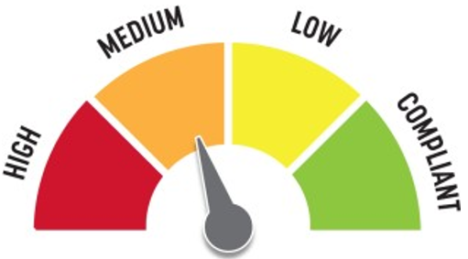
Quick Fix: No
Built before ADA: Yes

VIOLATIONS
2010 ADA Standards for Accessible Design Codes: §303.2
There is a change in level of 1" from the access aisle to the accessible route.

RECOMMENDATIONS
Repave the pathway to reduce the change in level to less than 0.25".

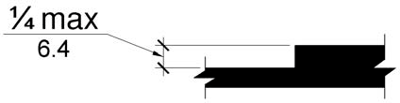

PHOTOGRAPH(S) OF THIS LOCATION

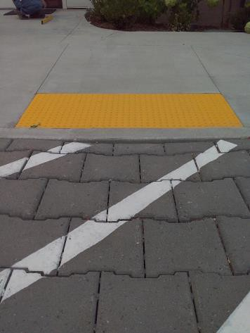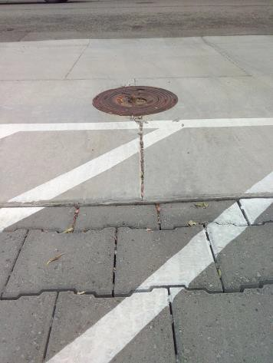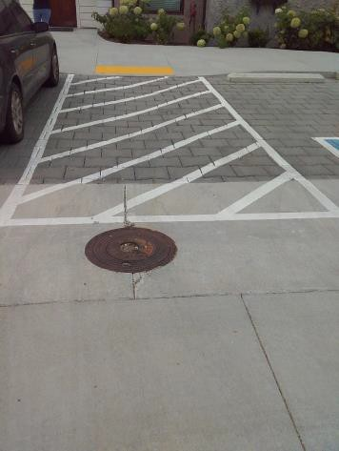

 | ID:  3098 | Facility:  James Castle House

Location: Closet/Laundry Space
Schedule: 2022
Estimated Cost: $100.00

Priority Score 8
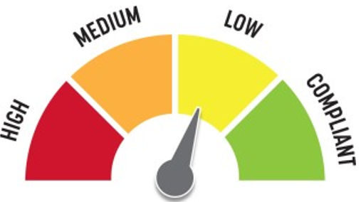
Quick Fix: Yes
Built before ADA: No

VIOLATIONS
2010 ADA Standards for Accessible Design Codes: §404.2.4.3
The closet/laundry space is 59" wide and 63" deep therefore, the turning space is not large enough.

RECOMMENDATIONS
Remove the trunk from the closet or push the washing machine and dryer back 1" to allow for a 60" wide turning space.

PHOTOGRAPH(S) OF THIS LOCATION

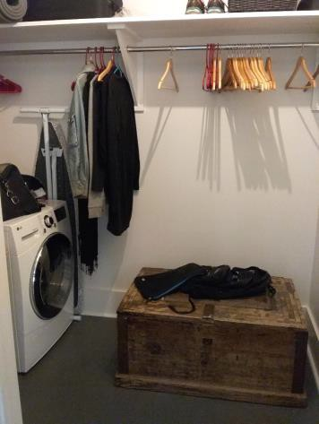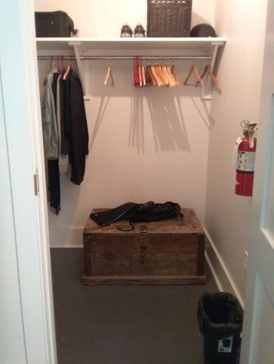

 | ID:  3550 | Facility:  James Castle House

Location: Drinking Fountain
Schedule: 2023
Estimated Cost: $500.00

Priority Score 10
Quick Fix: Yes
Built before ADA: Yes

VIOLATIONS
2010 ADA Standards for Accessible Design Codes: §602, §307.2
The drinking fountains protrude into the circulation space and do not have cane detectability.

RECOMMENDATIONS
Place a drinking fountain skirt at this location to provide cane detectability or place an object under the fountains.

PHOTOGRAPH(S) OF THIS LOCATION

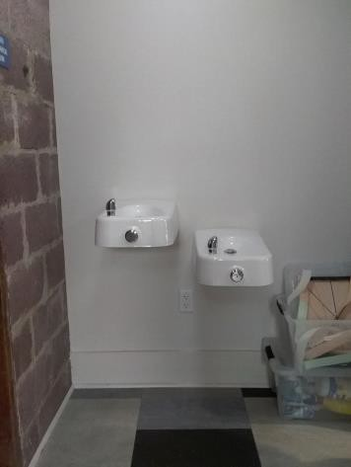

 | ID:  3147 | Facility:  James Castle House

Location: Entrance
Schedule: 2023
Estimated Cost: $1,000.00

Priority Score 8
Quick Fix: No
Built before ADA: Yes

VIOLATIONS
2010 ADA Standards for Accessible Design Codes: §308.2.1
The building safety buttons are outside of the unobstructed forward reach range at 50" above the floor. The alarm controls are outside of the unobstructed forward reach range at 58" above the floor.

RECOMMENDATIONS
Lower the building safety buttons and alarm controls to meet the accessible reach range of 15" minimum and 48" maximum above the floor.

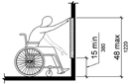

PHOTOGRAPH(S) OF THIS LOCATION

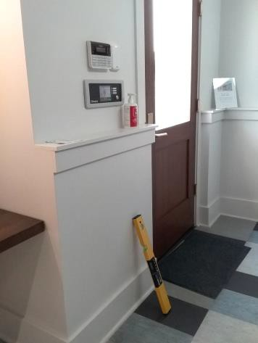

 | ID: | Facility:  James Castle House

Location: Gallery
Schedule: 2021
Estimated Cost: $500.00

Priority Score 3
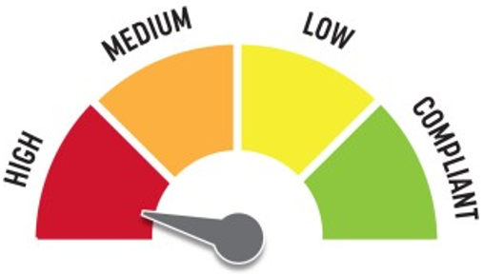
Quick Fix: Yes
Built before ADA: Yes

VIOLATIONS
2010 ADA Standards for Accessible Design Codes: §216.2, §703
There is no tactile sign identifying five permanent rooms in the gallery space.

RECOMMENDATIONS
Install tactile signage on the latch side of the doorway at a height of 48” minimum to 60” maximum above the floor, identifying room by name or room number.
Signs shall be Braille with raised lettering and should be placed on the wall in the center of an 18"x18" clear floor space.

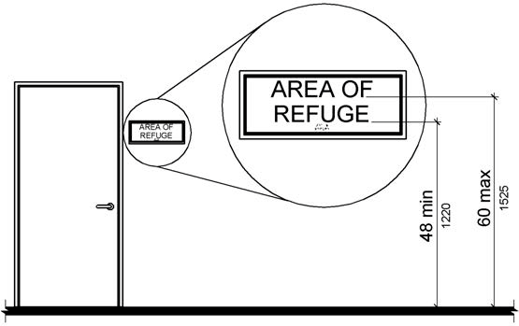

PHOTOGRAPH(S) OF THIS LOCATION

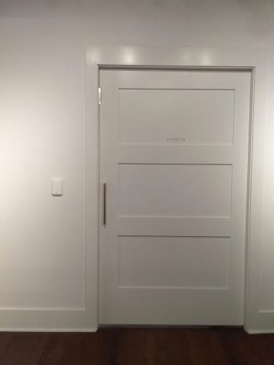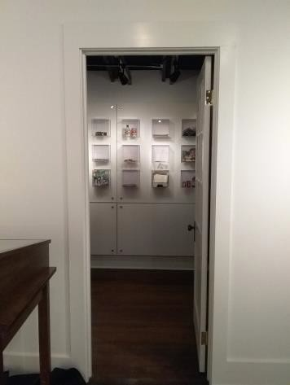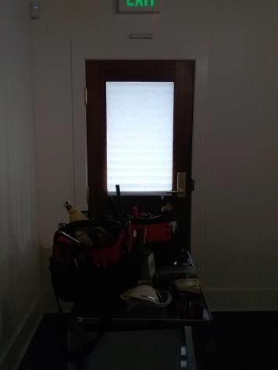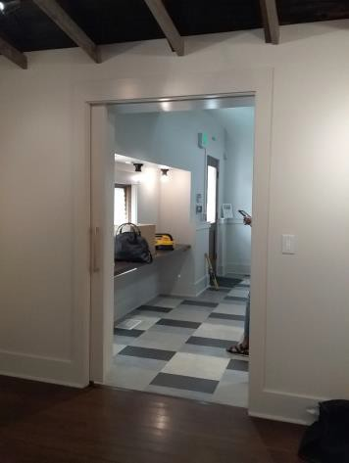

 | ID:  3019 | Facility:  James Castle House

Location: Gift Shop Entrance
Schedule: 2021
Estimated Cost: $1,000.00

Priority Score 3
Quick Fix: No
Built before ADA: Yes

VIOLATIONS
2010 ADA Standards for Accessible Design Codes: §404.2.4.4
The entryway maneuvering clearance has a 7.2% slope.

RECOMMENDATIONS
Reconstruct the cement walkway so that the slope is a maximum of 2% in all directions for 60" perpendicular to the doorway.

PHOTOGRAPH(S) OF THIS LOCATION

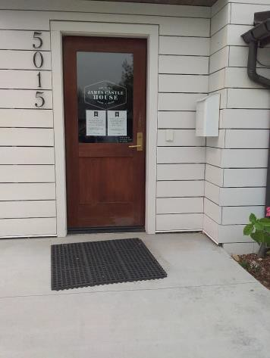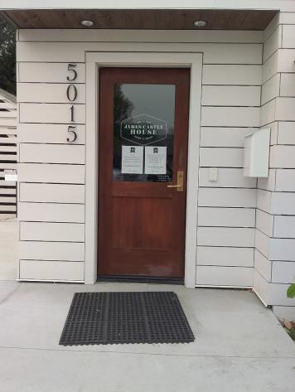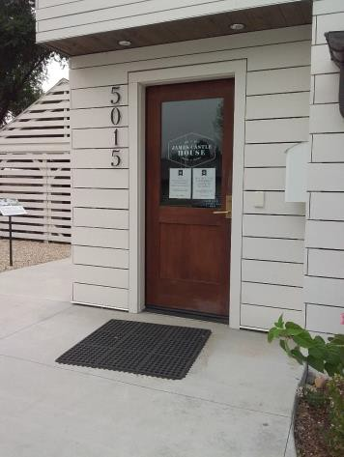

 | ID:  3777 | Facility:  James Castle House

Location: Gift Shop Entrance
Schedule: 2021
Estimated Cost: $1,000.00

Priority Score 3
Quick Fix: No
Built before ADA: Yes

VIOLATIONS
2010 ADA Standards for Accessible Design Codes: §406.4
The ramp's landing area has a slope ranging from 2.5% to 3%.

RECOMMENDATIONS
Repave the landing area to make sure the turning space has a maximum slope of 2% in all directions.

PHOTOGRAPH(S) OF THIS LOCATION

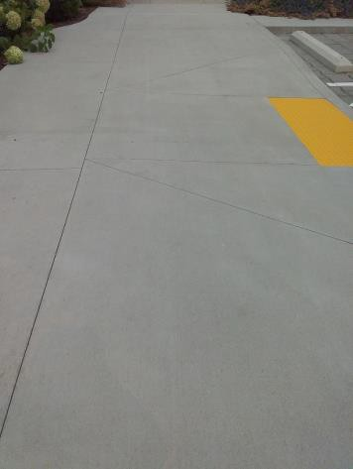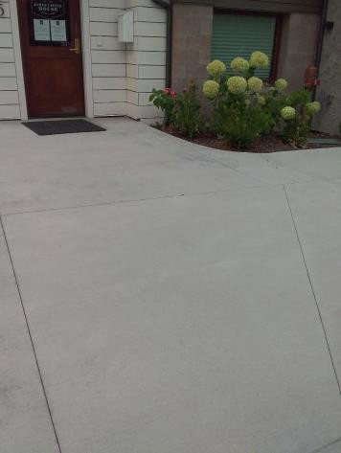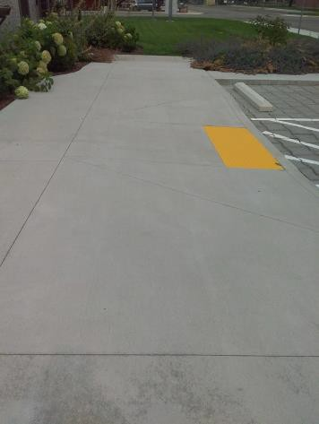

 | ID:  3576 | Facility:  James Castle House

Location: Historic Artifacts Area
Schedule: 2022
Estimated Cost: $100.00

Priority Score 7
Quick Fix: Yes
Built before ADA: Yes

VIOLATIONS
2010 ADA Standards for Accessible Design Codes: §309.4
The door knob requires twisting of the wrist.

RECOMMENDATIONS
Replace the door knob with a lever handle that can be operated with a closed fist and without twisting the wrist.

PHOTOGRAPH(S) OF THIS LOCATION

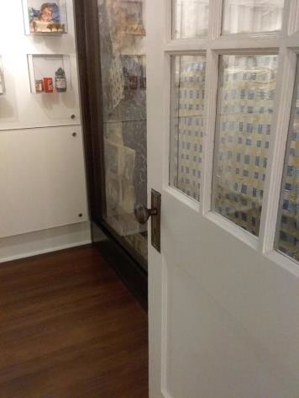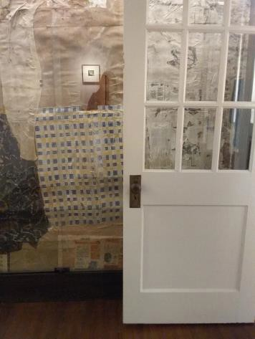

 | ID:  3234 | Facility:  James Castle House

Location: Inaccessible Entrance
Schedule: 2022
Estimated Cost: $100.00

Priority Score 6
Quick Fix: Yes
Built before ADA: Yes

VIOLATIONS
2010 ADA Standards for Accessible Design Codes: §703.5.5, §703.5.6
There is no signage at the inaccessible entrance directing patrons to the nearby accessible entrance.

RECOMMENDATIONS
Install a visual sign at the front entrance directing patrons to the accessible entrance complying with §703.5.5 and §703.5.6 at a minimum height of 40" above the floor.

PHOTOGRAPH(S) OF THIS LOCATION

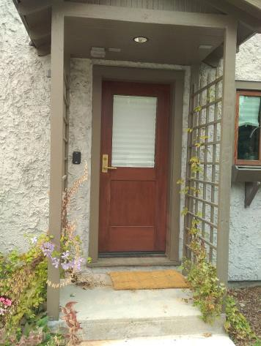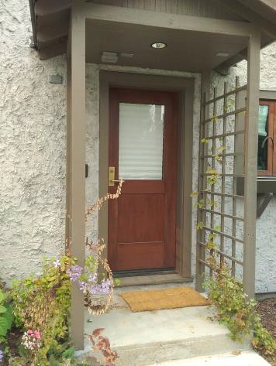

 | ID:  3078 | Facility:  James Castle House

Location: Mailbox
Schedule: 2023
Estimated Cost: $100.00

8

Priority Score 8
Quick Fix: Yes
Built before ADA: Yes

VIOLATIONS
2010 ADA Standards for Accessible Design Codes: §308.2.1
The mailbox is outside of the unobstructed forward reach range at 59" above the floor.

RECOMMENDATIONS
Lower the mailbox by 11" to meet the accessible reach range of 15" minimum and 48" maximum above the floor.

PHOTOGRAPH(S) OF THIS LOCATION

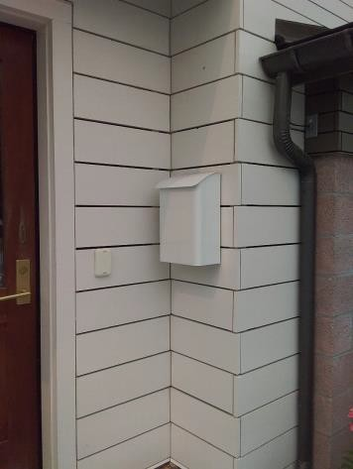

 | ID:  3047 | Facility:  James Castle House

Location: Mailbox
Schedule: 2023
Estimated Cost: $100.00

Priority Score 8
Quick Fix: Yes
Built before ADA: Yes

VIOLATIONS
2010 ADA Standards for Accessible Design Codes: §308.2.1
The lock is outside of the unobstructed forward reach range at 50" above the floor.

RECOMMENDATIONS
Lower the lock by 2" to meet the accessible reach range of 15" minimum and 48" maximum above the floor.

PHOTOGRAPH(S) OF THIS LOCATION

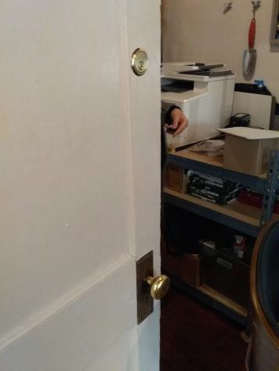

 | ID:  3046 | Facility:  James Castle House

Location: Office Door
Schedule: 2022
Estimated Cost: $100.00

Priority Score 7
Quick Fix: Yes
Built before ADA: Yes

VIOLATIONS
2010 ADA Standards for Accessible Design Codes: §309.4
The door knob requires twisting of the wrist.

RECOMMENDATIONS
Replace the door knob with a lever handle that can be operated with a closed fist and without twisting the wrist.

PHOTOGRAPH(S) OF THIS LOCATION

 | ID:  3239 | Facility:  James Castle House

Location: Parking
Schedule: 2023
Estimated Cost: $100.00

Priority Score 9
Quick Fix: Yes
Built before ADA: Yes

VIOLATIONS
2010 ADA Standards for Accessible Design Codes: §502.6
There is no signage present identifying the accessible parking spaces.

RECOMMENDATIONS
Install an accessible parking sign at each accessible space at a minimum height of 60" above the ground.

PHOTOGRAPH(S) OF THIS LOCATION

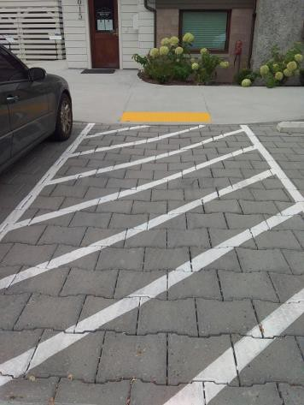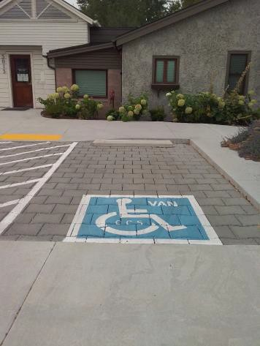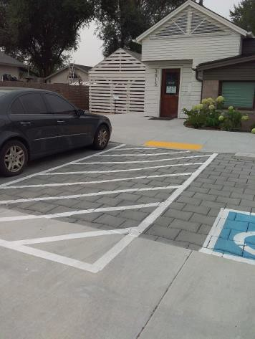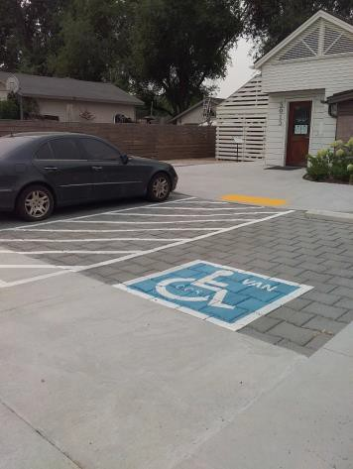

 | ID:  3238 | Facility:  James Castle House

Location: Parking
Schedule: 2021
Estimated Cost: $2,500.00

Priority Score 3
Quick Fix: No
Built before ADA: Yes

VIOLATIONS
2010 ADA Standards for Accessible Design Codes: §502.4
The access aisle has a 5.5% slope.

RECOMMENDATIONS
Reconstruct the access aisle to reduce the slope to a maximum of 2% in all directions.

PHOTOGRAPH(S) OF THIS LOCATION

 | ID:  3348 | Facility:  James Castle House

Location: Resident Deck
Schedule: 2023
Estimated Cost: $1,000.00

Priority Score 0
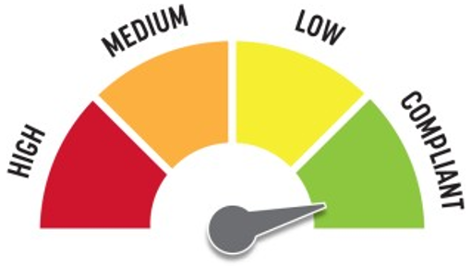
Quick Fix: No
Built before ADA: No

VIOLATIONS
2010 ADA Standards for Accessible Design Codes: §405
The deck facing Castle Drive is only accessible via a step from the exterior.

RECOMMENDATIONS
Consider adding a vertical access to this amenity by constructing a ramp.
If a ramp is added, ensure that the slope does not exceed 8.3%, handrails are provided, and there is sufficient room for a level landing at the top and bottom of the ramp.

PHOTOGRAPH(S) OF THIS LOCATION

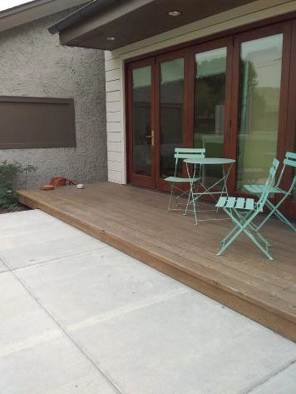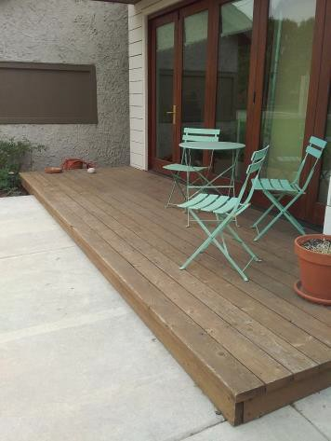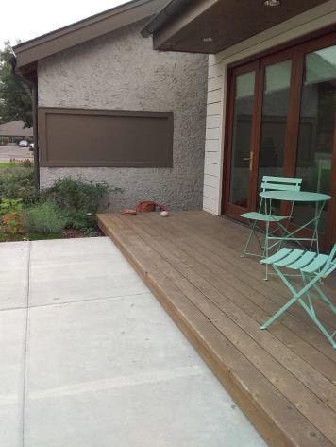

 | ID:  3262 | Facility:  James Castle House

Location: Resident Entrance
Schedule: 2023
Estimated Cost: $100.00

Priority Score 8
Quick Fix: Yes
Built before ADA: No

VIOLATIONS
2010 ADA Standards for Accessible Design Codes: §308.2.1
The gate latch is outside of the unobstructed forward reach range at 58" above the floor.

RECOMMENDATIONS
Lower the gate latch by 10" to meet the accessible reach range of 15" minimum and 48" maximum above the floor. Ensure the gate latch can be opened from both ends.

PHOTOGRAPH(S) OF THIS LOCATION

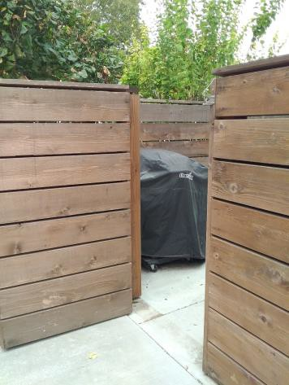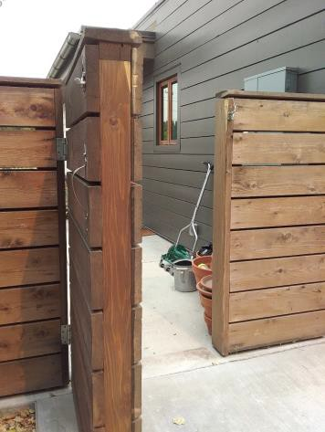

 | ID:  3421 | Facility:  James Castle House

Location: Resident Entrance
Schedule: 2021
Estimated Cost: $100.00

Priority Score 3
Quick Fix: Yes
Built before ADA: No

VIOLATIONS
2010 ADA Standards for Accessible Design Codes: §216.2, §703
There is no tactile sign identifying the permanent room.

RECOMMENDATIONS
Install tactile signage on the latch side of the doorway at a height of 48” minimum to 60” maximum above the floor, identifying room by name or room number.
Signs shall be Braille with raised lettering and should be placed on the wall in the center of an 18"x18" clear floor space.

PHOTOGRAPH(S) OF THIS LOCATION

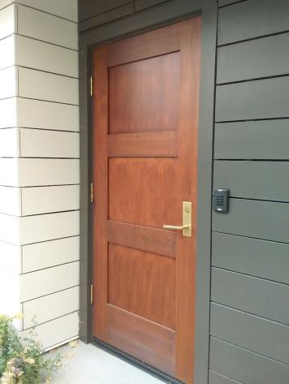

 | ID:  3263 | Facility:  James Castle House

Location: Resident Entrance
Schedule: 2022
Estimated Cost: $1,000.00

Priority Score 5
Quick Fix: No
Built before ADA: Yes

VIOLATIONS
2010 ADA Standards for Accessible Design Codes: §404.2.3
The gate is not wide enough to allow wheelchair accessibility at only 29" wide.

RECOMMENDATIONS
Increase the gate width to a minimum of 32”.

PHOTOGRAPH(S) OF THIS LOCATION

 | ID:  3780 | Facility:  James Castle House

Location: Resident Kitchen
Schedule: 2022
Estimated Cost: $100.00

Priority Score 7
Quick Fix: Yes
Built before ADA: No

VIOLATIONS
2010 ADA Standards for Accessible Design Codes: §606.5
The pipes under the sink are not covered.

RECOMMENDATIONS
Wrap the pipes beneath the sink with soft protective wrap or plastic.

PHOTOGRAPH(S) OF THIS LOCATION

(No pictures available)

 | ID:  3779 | Facility:  James Castle House

Location: Resident Kitchen
Schedule: 2023
Estimated Cost: $1,000.00

Priority Score 8
Quick Fix: No
Built before ADA: No

VIOLATIONS
2010 ADA Standards for Accessible Design Codes: §804.3.2
The height of the kitchen work surface is 35.5" above the floor

RECOMMENDATIONS
Lower the kitchen work surface to meet the compliant height of 34" above the floor for a horizontal distance of 36"

PHOTOGRAPH(S) OF THIS LOCATION

(No pictures available)

 | ID:  3052 | Facility:  James Castle House

Location: Resident Restroom
Schedule: 2022
Estimated Cost: $100.00

Priority Score 5
Quick Fix: Yes
Built before ADA: No

VIOLATIONS
2010 ADA Standards for Accessible Design Codes: §604.7
The toilet paper dispenser is not located in an accessible position at 12" in front of the

RECOMMENDATIONS
Remount the toilet paper dispenser so that the centerline is located 7" minimum to 9" maximum in front of the toilet.
Ensure that the height is within the accessible reach range of 15" minimum to 48" maximum above the floor.

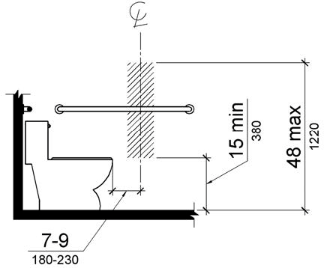

PHOTOGRAPH(S) OF THIS LOCATION

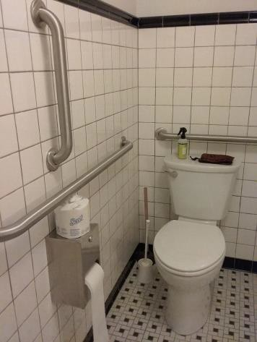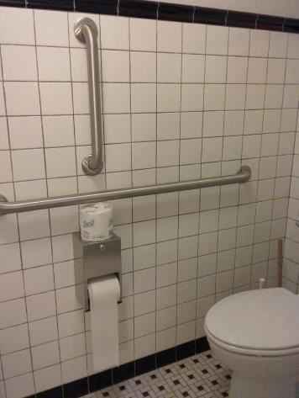

 | ID:  3054 | Facility:  James Castle House

Location: Resident Restroom
Schedule: 2022
Estimated Cost: $100.00

Priority Score 7
Quick Fix: Yes
Built before ADA: No

VIOLATIONS
2010 ADA Standards for Accessible Design Codes: §606.5
The pipes under the sink are not covered.

RECOMMENDATIONS
Wrap the pipes beneath the sink with soft protective wrap or plastic.

PHOTOGRAPH(S) OF THIS LOCATION

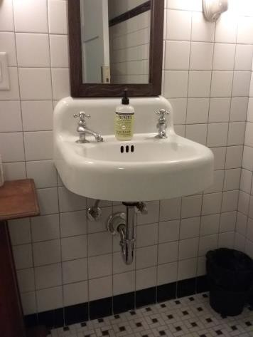

 | ID:  3053 | Facility:  James Castle House

Location: Resident Restroom
Schedule: 2022
Estimated Cost: $1,000.00

Priority Score 5
Quick Fix: No
Built before ADA: No

VIOLATIONS
2010 ADA Standards for Accessible Design Codes: §604.6
The flush control is located on the wall side of the toilet.

RECOMMENDATIONS
Relocate the flush control to be operated on the open side of the toilet or make the toilet flush automatically.

PHOTOGRAPH(S) OF THIS LOCATION

 | ID:  3746 | Facility:  James Castle House

Location: Resident Studio
Schedule: 2022
Estimated Cost: $100.00

Priority Score 7
Quick Fix: Yes
Built before ADA: No

VIOLATIONS
2010 ADA Standards for Accessible Design Codes: §606.5
The sink located in the resident studio has no pipes covers underneath.

RECOMMENDATIONS
Wrap the pipes beneath the sink with soft protective wrap or plastic.

PHOTOGRAPH(S) OF THIS LOCATION

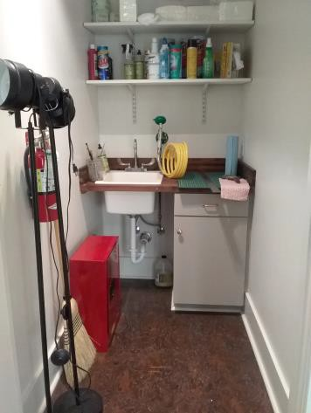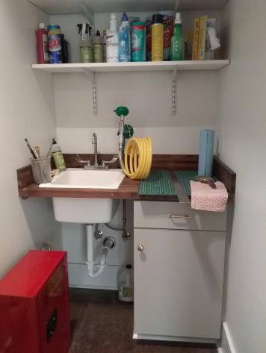

 | ID:  3287 | Facility:  James Castle House

Location: Resident Studio
Schedule: 2023
Estimated Cost: $1,000.00

Priority Score 8
Quick Fix: No
Built before ADA: No

VIOLATIONS
2010 ADA Standards for Accessible Design Codes: §902.3
The work surface counter is 36" above the floor.

RECOMMENDATIONS
Ensure a 36" wide portion of the work surface is no higher than 34" above the floor.

PHOTOGRAPH(S) OF THIS LOCATION

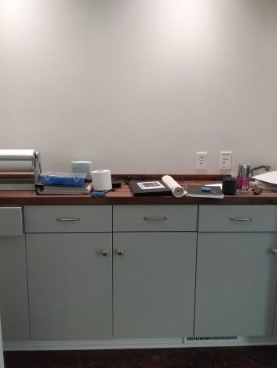

 | ID:  3288 | Facility:  James Castle House

Location: Resident Studio
Schedule: 2023
Estimated Cost: $1,000.00

Priority Score 8
Quick Fix: No
Built before ADA: No

VIOLATIONS
2010 ADA Standards for Accessible Design Codes: §902.3
The work table is 38" above the floor.

RECOMMENDATIONS
Lower the table to ensure a 36" wide portion of the work surface is no higher than 34" above the floor.

PHOTOGRAPH(S) OF THIS LOCATION

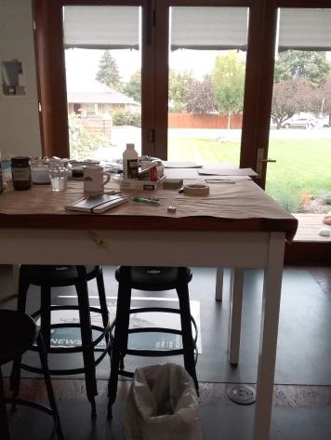

 | ID:  3745 | Facility:  James Castle House

Location: Resident Studio
Schedule: 2023
Estimated Cost: $1,000.00

Priority Score 8
Quick Fix: No
Built before ADA: No

VIOLATIONS
2010 ADA Standards for Accessible Design Codes: §902.3
The sink and work surface counter is 35.5" above the floor.

RECOMMENDATIONS
Lower the counter to ensure a 36" wide portion of the work surface is no higher than 34" above the floor.

PHOTOGRAPH(S) OF THIS LOCATION

 | ID:  3747 | Facility:  James Castle House

Location: Resident Studio
Schedule: 2022
Estimated Cost: $1,000.00

Priority Score 5
Quick Fix: No
Built before ADA: No

VIOLATIONS
2010 ADA Standards for Accessible Design Codes: §404.2.4.3
The studio cleaning space is 44.5" wide, leaving no turning space.

RECOMMENDATIONS
Reconstruct the resident studio to provide a Circular or T-Shaped turning space. The circular turning space shall have a minimum diameter of 60".
The T-Shaped space shall be 60" square minimum with arms and base 36" wide minimum. Each arm shall be clear of obstructions 12" minimum in each direction. The base shall be clear of obstruction 24" minimum.

PHOTOGRAPH(S) OF THIS LOCATION

 | ID:  3462 | Facility:  James Castle House

Location: Residential Space Alarm
Schedule: 2023
Estimated Cost: $100.00

Priority Score 8
Quick Fix: Yes
Built before ADA: No

VIOLATIONS
2010 ADA Standards for Accessible Design Codes: §308.2.1
The alarm is outside of the unobstructed forward reach range at 55" above the floor.

RECOMMENDATIONS
Lower the alarm by 7" to meet the accessible reach range of 15" minimum and 48" maximum above the floor.

PHOTOGRAPH(S) OF THIS LOCATION

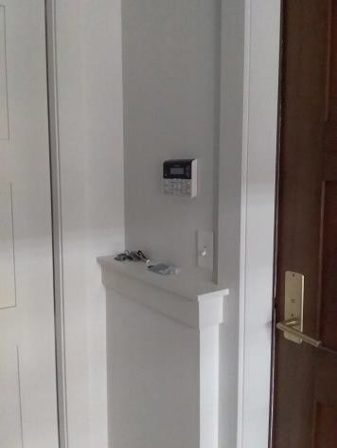

 | ID:  3463 | Facility:  James Castle House

Location: Residential Space Hooks
Schedule: 2023
Estimated Cost: $300.00

Priority Score 8
Quick Fix: Yes
Built before ADA: No

VIOLATIONS
2010 ADA Standards for Accessible Design Codes: §308.2.1
The coat hooks are outside of the unobstructed forward reach range at 68" above the floor.

RECOMMENDATIONS
Lower at least one coat hooks by 20" to meet the accessible reach range of 15" minimum and 48" maximum above the floor.

PHOTOGRAPH(S) OF THIS LOCATION

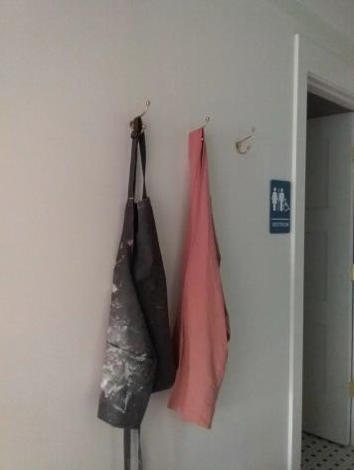

 | ID:  3616 | Facility:  James Castle House

Location: Residential Studio Space
Schedule: 2021
Estimated Cost: $600.00

Priority Score 3
Quick Fix: Yes
Built before ADA: No

VIOLATIONS
2010 ADA Standards for Accessible Design Codes: §216.2, §703
There is no tactile sign identifying six permanent rooms in the residential studio space.

RECOMMENDATIONS
Install tactile signage on the latch side of the doorway at a height of 48” minimum to 60” maximum above the floor, identifying room by name or room number.
Signs shall be Braille with raised lettering and should be placed on the wall in the center of an 18"x18" clear floor space.

PHOTOGRAPH(S) OF THIS LOCATION

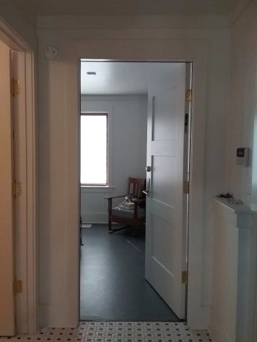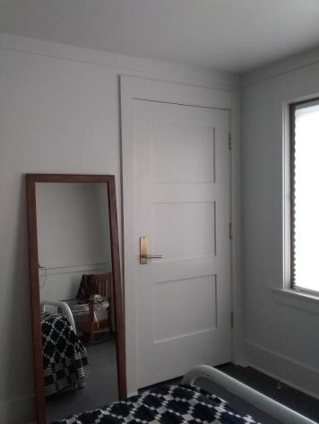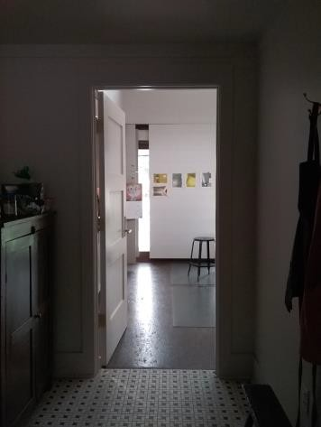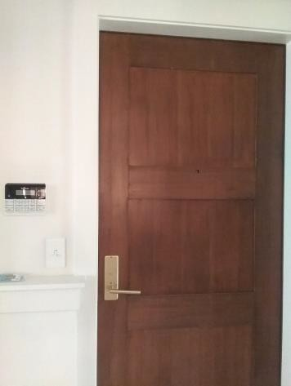

 | ID:  3373 | Facility:  James Castle House

Location: Riser Room
Schedule: 2021
Estimated Cost: $100.00

Priority Score 3
Quick Fix: Yes
Built before ADA: Yes

VIOLATIONS
2010 ADA Standards for Accessible Design Codes: §216.2, §703
There is no braille sign identifying the permanent room.

RECOMMENDATIONS
Install braille signage on the latch side of the doorway at a height of 48” minimum to 60” maximum above the floor, identifying room by name or room number.
The sign shall have raised lettering and should be placed on the wall in the center of an 18"x18" clear floor space.

PHOTOGRAPH(S) OF THIS LOCATION

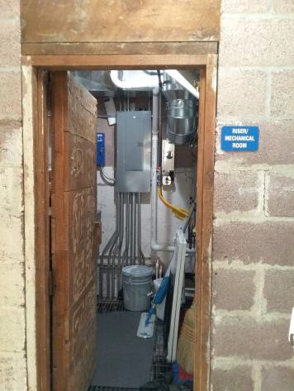

 | ID:  3232 | Facility:  James Castle House

Location: Water Meter
Schedule: 2021
Estimated Cost: $1,000.00

Priority Score 3
Quick Fix: No
Built before ADA: Yes

VIOLATIONS
2010 ADA Standards for Accessible Design Codes: §302.3
There is a 1" open grate in the pathway posing a tripping hazard.

RECOMMENDATIONS
Replace the hole cover with one that has a gap less than 0.5”.

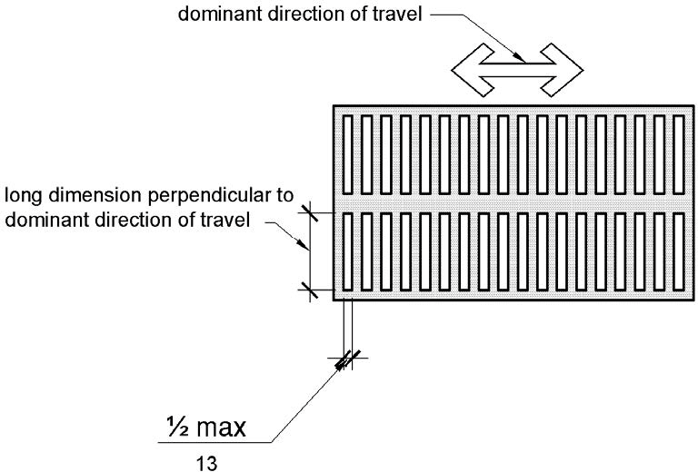

PHOTOGRAPH(S) OF THIS LOCATION

