City of Boise ADA Assessment

Appendix A –Fort Boise Community Center

1/8/2021
Report #TO20-B012

Prepared by:
 | ID:  2251 | Facility:  Fort Boise Community Center

Location: 2nd Floor Men's Restroom
Schedule: 2021
Estimated Cost: $100.00

Priority Score 5
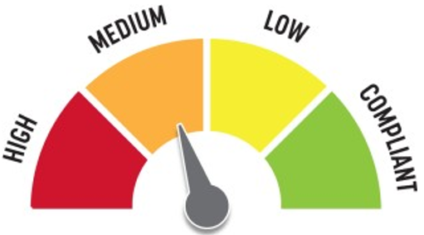
Quick Fix: Yes
Built before ADA: Yes

VIOLATIONS
2010 ADA Standards for Accessible Design Codes: §604.7
The toilet paper dispenser is located out of the accessible reach range at 4" in front of the rim.

RECOMMENDATIONS
Remount the toilet paper dispenser to 7” minimum and 9” maximum in front of the water closet measured to the centerline of the dispenser.
The outlet of the dispenser shall be 15” minimum and 48” maximum above the floor and shall not be located behind.

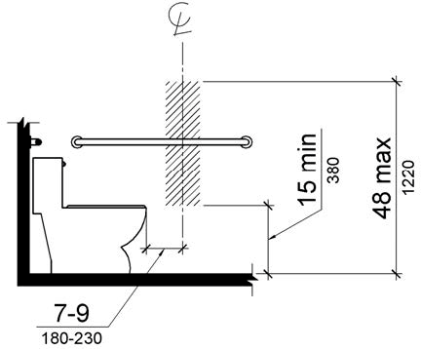

PHOTOGRAPH(S) OF THIS LOCATION

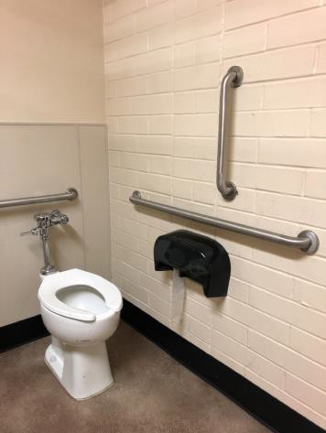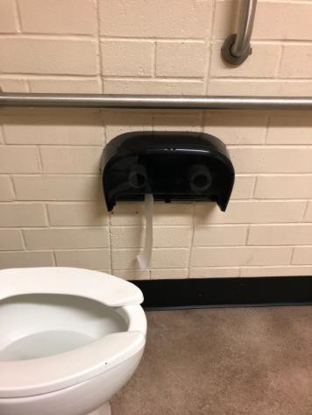

 | ID:  2253 | Facility:  Fort Boise Community Center

Location: 2nd Floor Men's Restroom
Schedule: 2021
Estimated Cost: $100.00

Priority Score 5
Quick Fix: Yes
Built before ADA: Yes

VIOLATIONS
2010 ADA Standards for Accessible Design Codes: §604.8.1.2
The door to the accessible water closet is not self closing. Either self-closing hinges are not installed on the door or if installed, they are defective.

RECOMMENDATIONS
Install or reinstall self-closing hinges on the door to ensure that the door is self-closing per the ADA requirements.

PHOTOGRAPH(S) OF THIS LOCATION

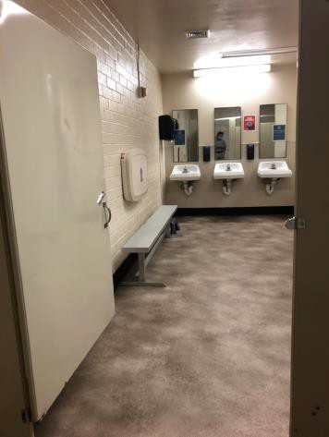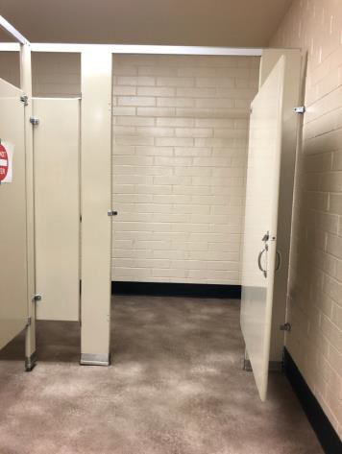

 | ID:  2254 | Facility:  Fort Boise Community Center

Location: 2nd Floor Men's Restroom
Schedule: 2021
Estimated Cost: $100.00

Priority Score 5
Quick Fix: Yes
Built before ADA: Yes

VIOLATIONS
2010 ADA Standards for Accessible Design Codes: §307.2
The paper towel dispenser protrudes 9" into the circulation space at 33" above the floor.

RECOMMENDATIONS
Recess the paper towel dispenser so it protrudes a maximum of 4" or place a cane detectable object beneath it.

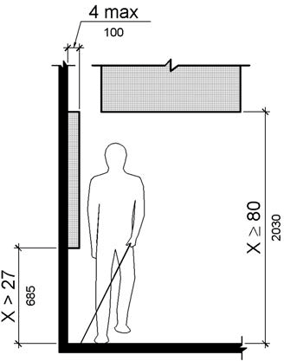

PHOTOGRAPH(S) OF THIS LOCATION

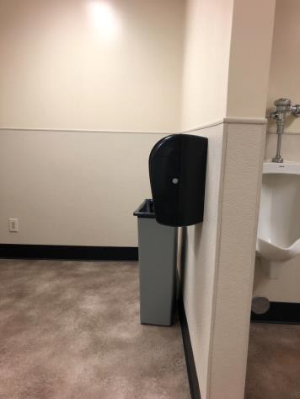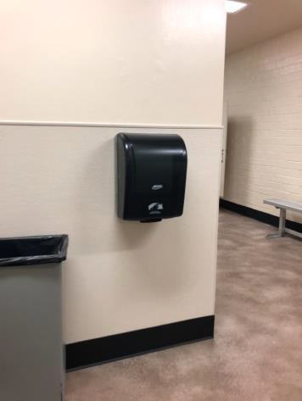

 | ID:  2778 | Facility:  Fort Boise Community Center

Location: Art Center
Schedule: 2021
Estimated Cost: $100.00

Priority Score 5
Quick Fix: Yes
Built before ADA: Yes

VIOLATIONS
2010 ADA Standards for Accessible Design Codes: §307.2
The art protrudes 5.25" into the circulation space at 39.5" above the floor.

RECOMMENDATIONS
Recess the art so it protrudes a maximum of 4", lower it so the bottom edge is 27" maximum above the floor, or place a cane detectable object beneath it.

PHOTOGRAPH(S) OF THIS LOCATION

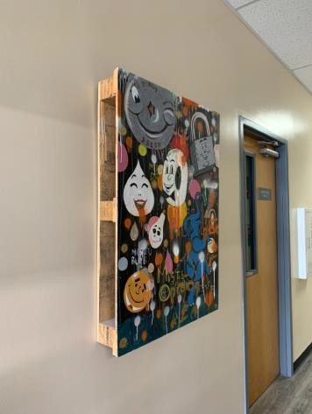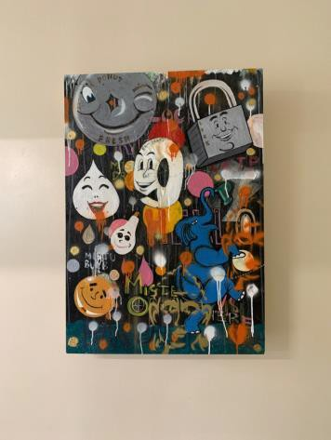

 | ID:  2776 | Facility:  Fort Boise Community Center

Location: Art Studio
Schedule: 2021
Estimated Cost: $100.00

Priority Score 5
Quick Fix: Yes
Built before ADA: Yes

VIOLATIONS
2010 ADA Standards for Accessible Design Codes: §307.2
The TV protrudes 13" into the circulation space at 57" above the floor.

RECOMMENDATIONS
Recess the TV so it protrudes a maximum of 4", raise it so the bottom edge is 80" maximum above the floor, or place a cane detectable object beneath it.

PHOTOGRAPH(S) OF THIS LOCATION

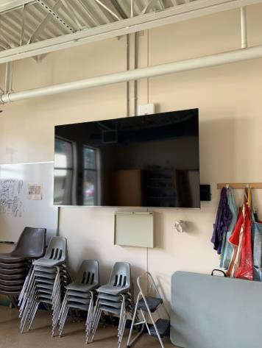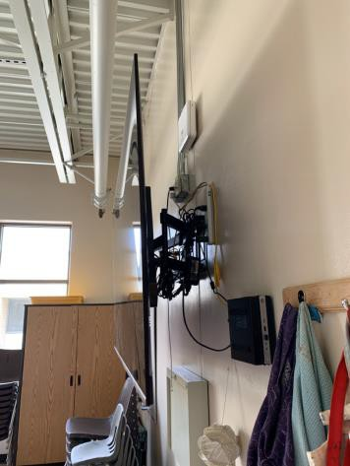

 | ID: | Facility:  Fort Boise Community Center

Location: Art Studio
Schedule: 2023
Estimated Cost: $2,000.00

Priority Score 8
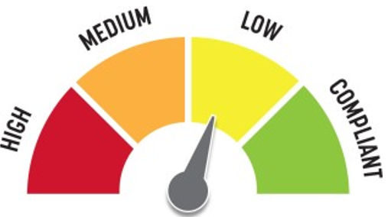
Quick Fix: No
Built before ADA: Yes

VIOLATIONS
2010 ADA Standards for Accessible Design Codes: §902.3, §306.3.3, §606.3
The sink is 34.75" above the floor. There is no knee clearance underneath the sink. The work surface counter and sink is 34.75" above the floor.

RECOMMENDATIONS
Lower the sink to the maximum height of 34" above the floor. Provide knee clearance underneath the counter at the sink that is a minimum of 11" deep at 9" above the floor and 8" deep at 27" above the floor.
A 30" portion of the work surface must be no higher than 34” above the floor.

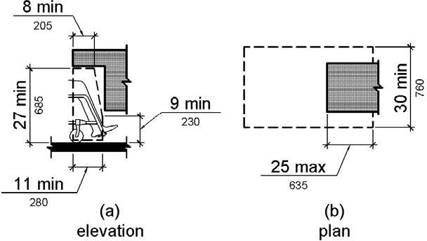

PHOTOGRAPH(S) OF THIS LOCATION

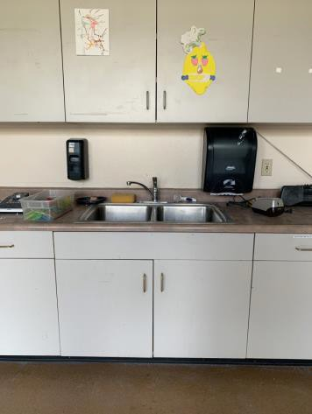

 | ID:  2731 | Facility:  Fort Boise Community Center

Location: Back Parking
Schedule: 2021
Estimated Cost: $100.00

Priority Score 9
Quick Fix: Yes
Built before ADA: Yes

VIOLATIONS
2010 ADA Standards for Accessible Design Codes: §502.6
The accessible parking sign is 52.75" above the ground.

RECOMMENDATIONS
Remount the accessible parking sign at a minimum height of 60" above the ground.

PHOTOGRAPH(S) OF THIS LOCATION

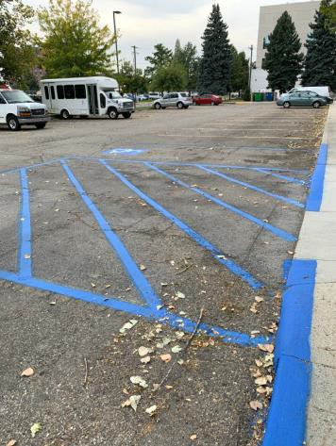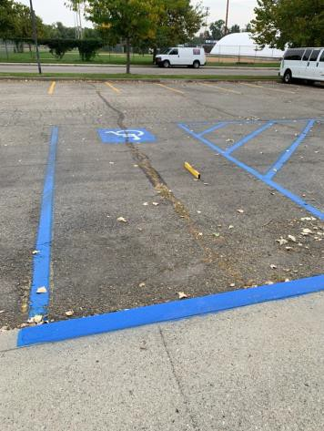

 | ID:  2733 | Facility:  Fort Boise Community Center

Location: Back Parking
Schedule: 2021
Estimated Cost: $100.00

Priority Score 5
Quick Fix: Yes
Built before ADA: Yes

VIOLATIONS
2010 ADA Standards for Accessible Design Codes: §216.6
There is no sign directing customers to the nearest accessible entrance.

RECOMMENDATIONS
Install a directional sign at all non-accessible entrances directing patrons to the nearest accessible entrance.
The directional sign will comply with §703.5 and be between 48" and 60" above the floor, measured to the bottom of the sign.

PHOTOGRAPH(S) OF THIS LOCATION

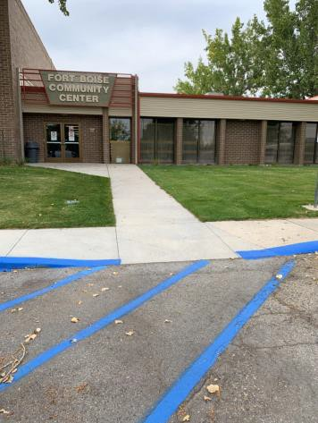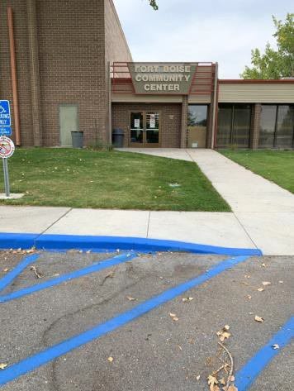

 | ID:  2732 | Facility:  Fort Boise Community Center

Location: Back Parking
Schedule: 2021
Estimated Cost: $1,000.00

Priority Score 3
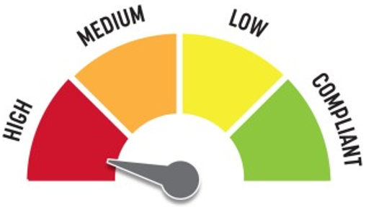
Quick Fix: No
Built before ADA: Yes

VIOLATIONS
2010 ADA Standards for Accessible Design Codes: §502.4
The parking space has a 4.2% slope.

RECOMMENDATIONS
Resurface the parking space to reduce the slope to a maximum of 2% in all directions.

PHOTOGRAPH(S) OF THIS LOCATION

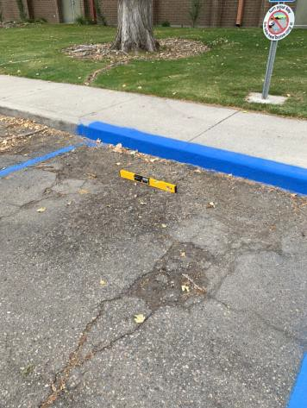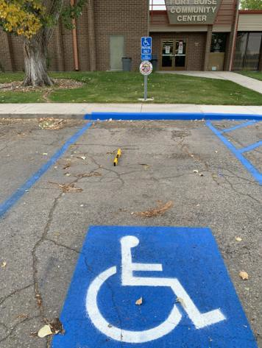

 | ID:  2736 | Facility:  Fort Boise Community Center

Location: Back Parking
Schedule: 2022
Estimated Cost: $2,500.00

Priority Score 7
Quick Fix: No
Built before ADA: Yes

VIOLATIONS
2010 ADA Standards for Accessible Design Codes: §405.2, §405.3
The running slope of the ramp is 12.7%. The cross slope of the ramp is 3.2%.

RECOMMENDATIONS
Reconstruct the ramp to reduce the running slope to less than 8.3% and the cross slope to less than 2%.

PHOTOGRAPH(S) OF THIS LOCATION

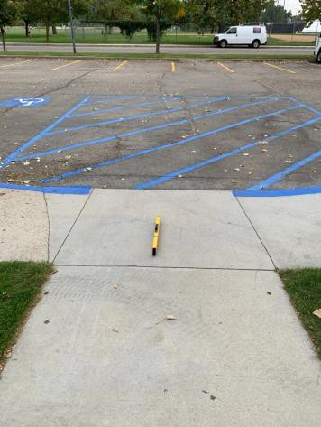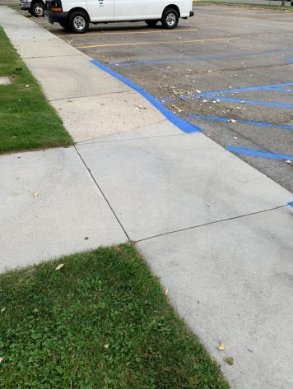

 | ID:  2730 | Facility:  Fort Boise Community Center

Location: Back Parking
Schedule: 2021
Estimated Cost: $2,500.00

3

Priority Score 5
Quick Fix: No
Built before ADA: Yes

VIOLATIONS
2010 ADA Standards for Accessible Design Codes: §502.4
The parking spaces have a 3% running slope.

RECOMMENDATIONS
Reconstruct the parking spaces to reduce the slope to a maximum of 2% in all directions.

PHOTOGRAPH(S) OF THIS LOCATION

 | ID:  2264 | Facility:  Fort Boise Community Center

Location: Basement Men's Restroom
Schedule: 2022
Estimated Cost: $100.00

Priority Score 7
Quick Fix: Yes
Built before ADA: Yes

VIOLATIONS
2010 ADA Standards for Accessible Design Codes: §603.3
The mirror is too high to be accessible at 54" above the floor.

RECOMMENDATIONS
Lower the mirror its bottom edge is a maximum height of 40" above the floor.

PHOTOGRAPH(S) OF THIS LOCATION

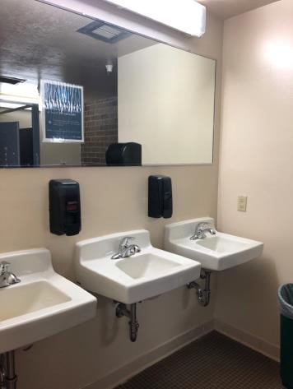

 | ID:  2261 | Facility:  Fort Boise Community Center

Location: Basement Men's Restroom
Schedule: 2021
Estimated Cost: $100.00

Priority Score 8
Quick Fix: Yes
Built before ADA: Yes

VIOLATIONS
2010 ADA Standards for Accessible Design Codes: §308.2.1
The soap holder is outside of the unobstructed forward reach range at 49" above the floor.

RECOMMENDATIONS
Lower the soap holder by 1" to meet the accessible reach range of 15" minimum and 48" maximum above the floor.

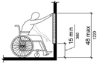

PHOTOGRAPH(S) OF THIS LOCATION

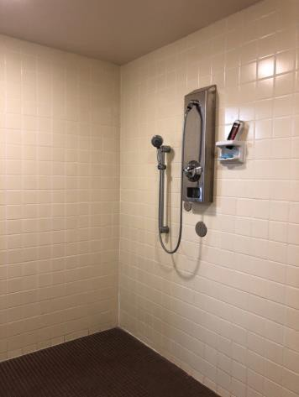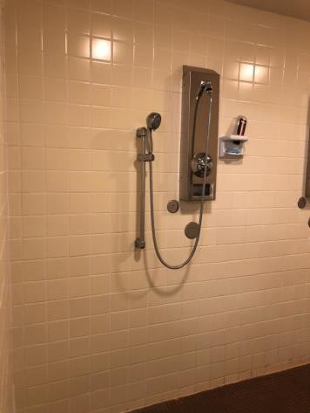

 | ID:  2263 | Facility:  Fort Boise Community Center

Location: Basement Men's Restroom
Schedule: 2021
Estimated Cost: $100.00

Priority Score 5
Quick Fix: Yes
Built before ADA: Yes

VIOLATIONS
2010 ADA Standards for Accessible Design Codes: §307.2
The paper towel dispenser protrudes 9" into the circulation space at 44" above the floor.

RECOMMENDATIONS
Recess the paper towel dispenser so it protrudes a maximum of 4" or place a cane detectable object beneath it.

PHOTOGRAPH(S) OF THIS LOCATION

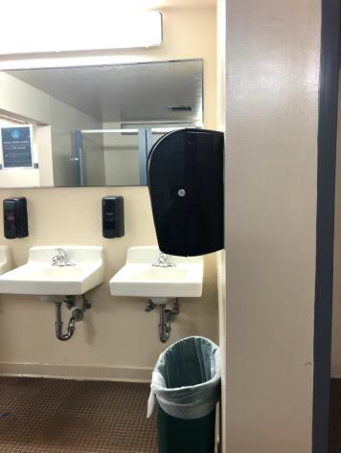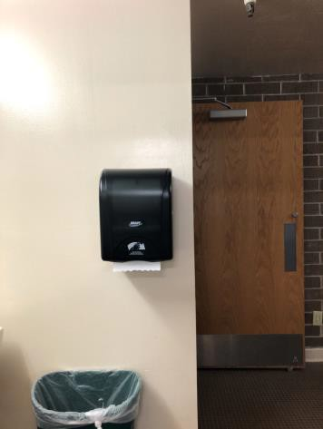

 | ID:  2265 | Facility:  Fort Boise Community Center

Location: Basement Men's Restroom
Schedule: 2021
Estimated Cost: $300.00

Priority Score 7
Quick Fix: Yes
Built before ADA: Yes

VIOLATIONS
2010 ADA Standards for Accessible Design Codes: §606.5
The pipes under the sinks are not covered.

RECOMMENDATIONS
Wrap the pipes beneath the sinks with soft protective wrap or plastic.

PHOTOGRAPH(S) OF THIS LOCATION

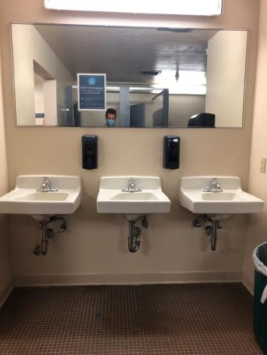

 | ID:  2260 | Facility:  Fort Boise Community Center

Location: Basement Men's Restroom
Schedule: 2021
Estimated Cost: $500.00

Priority Score 6
Quick Fix: Yes
Built before ADA: Yes

VIOLATIONS
2010 ADA Standards for Accessible Design Codes: §608.5.1
The shower controls are 54" above the floor.

RECOMMENDATIONS
Adjust the height of shower controls to a minimum height of 38" and a maximum height of 48" above the floor.

PHOTOGRAPH(S) OF THIS LOCATION

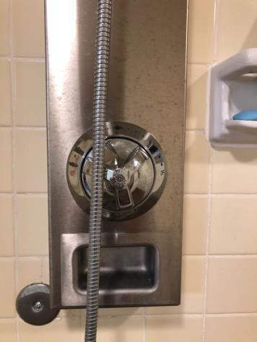

 | ID:  2266 | Facility:  Fort Boise Community Center

Location: Basement Men's Restroom
Schedule: 2022
Estimated Cost: $1,000.00

Priority Score 5
Quick Fix: No
Built before ADA: Yes

VIOLATIONS
2010 ADA Standards for Accessible Design Codes: §605.2
The urinals are 24" above the floor.

RECOMMENDATIONS
Lower at least one of the urinals to a maximum height of 17" above the floor.

PHOTOGRAPH(S) OF THIS LOCATION

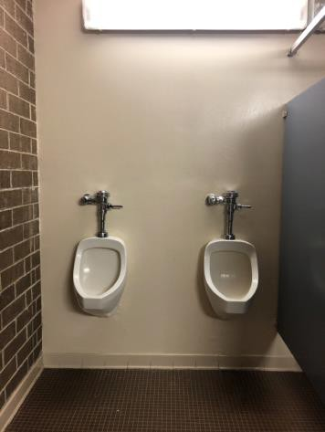

 | ID:  2259 | Facility:  Fort Boise Community Center

Location: Basement Men's Restroom
Schedule: 2022
Estimated Cost: $2,000.00

Priority Score 5
Quick Fix: No
Built before ADA: Yes

VIOLATIONS
2010 ADA Standards for Accessible Design Codes: §608.3.2
There are no grab bars in the roll-in type shower.

RECOMMENDATIONS
Install grab bars on the control wall, side wall, and back wall at 6" maximum from the adjacent walls. Ensure the grab bars are installed at a minimum height of 33" to a maximum height of 36" above the floor.

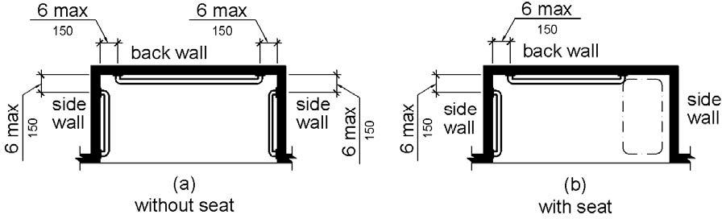

PHOTOGRAPH(S) OF THIS LOCATION

 | ID:  2258 | Facility:  Fort Boise Community Center

Location: Basement Men's Restroom
Schedule: 2022
Estimated Cost: $2,500.00

Priority Score 5
Quick Fix: No
Built before ADA: Yes

VIOLATIONS
2010 ADA Standards for Accessible Design Codes: §403.3
The running slope to the showers is 5.4%.

RECOMMENDATIONS
Reconstruct the route to ensure the slope is a maximum of 2% outside of the shower's threshold.

PHOTOGRAPH(S) OF THIS LOCATION

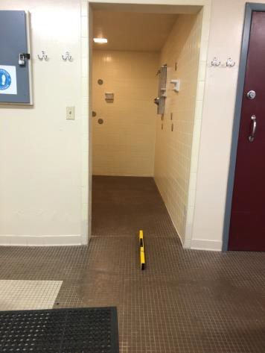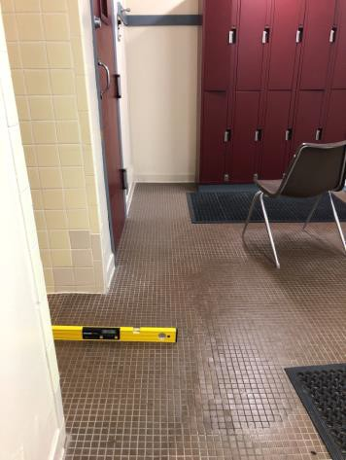

 | ID:  2794 | Facility:  Fort Boise Community Center

Location: Basement Women's Restroom
Schedule: 2022
Estimated Cost: $100.00

Priority Score 7
Quick Fix: Yes
Built before ADA: Yes

VIOLATIONS
2010 ADA Standards for Accessible Design Codes: §603.3
The mirror is too high to be accessible at 53.25" above the floor.

RECOMMENDATIONS
Lower the mirror its bottom edge is a maximum height of 40" above the floor.

PHOTOGRAPH(S) OF THIS LOCATION

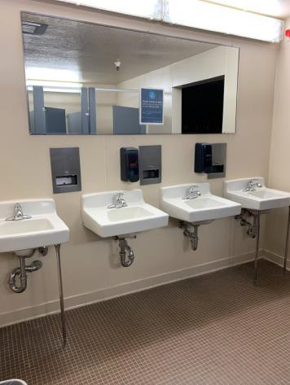

 | ID:  2782 | Facility:  Fort Boise Community Center

Location: Basement Women's Restroom
Schedule: 2021
Estimated Cost: $100.00

Priority Score 5
Quick Fix: Yes
Built before ADA: Yes

VIOLATIONS
2010 ADA Standards for Accessible Design Codes: §308.2.1
The hooks are outside of the unobstructed forward reach range at 66" above the floor.

RECOMMENDATIONS
Lower at least one hook by 18" to meet the accessible reach range of 48" maximum above the floor.

PHOTOGRAPH(S) OF THIS LOCATION

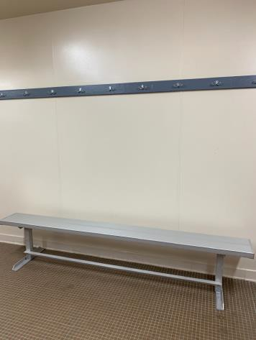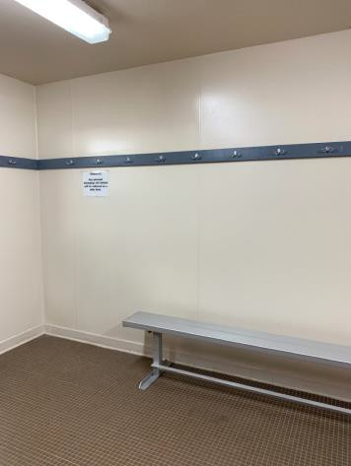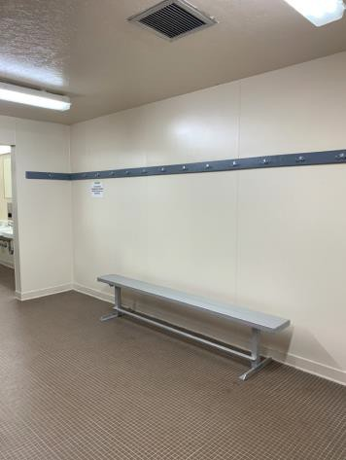

 | ID:  2786 | Facility:  Fort Boise Community Center

Location: Basement Women's Restroom
Schedule: 2021
Estimated Cost: $100.00

Priority Score 6
Quick Fix: Yes
Built before ADA: Yes

VIOLATIONS
2010 ADA Standards for Accessible Design Codes: §608.5.1
The shower controls are 56" above the floor.

RECOMMENDATIONS
Adjust the height of shower controls to a minimum height of 38" and a maximum height of 48" above the floor.

PHOTOGRAPH(S) OF THIS LOCATION

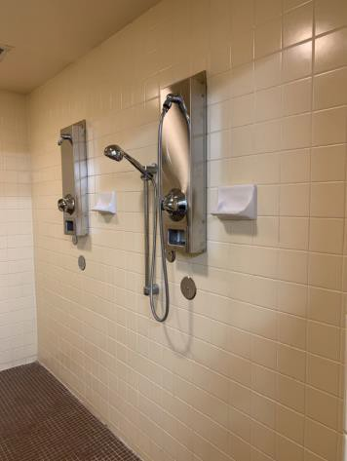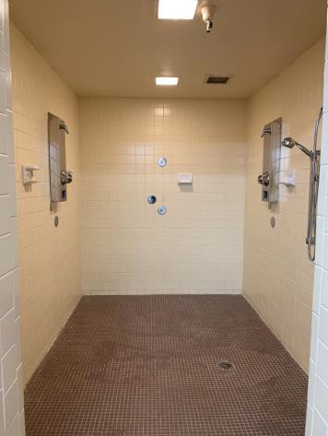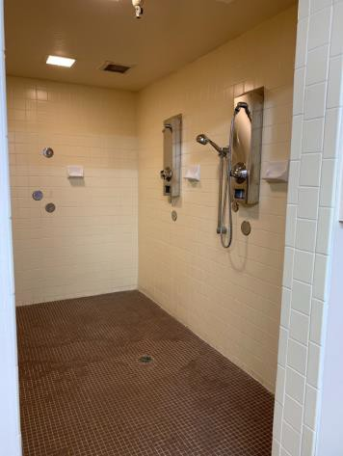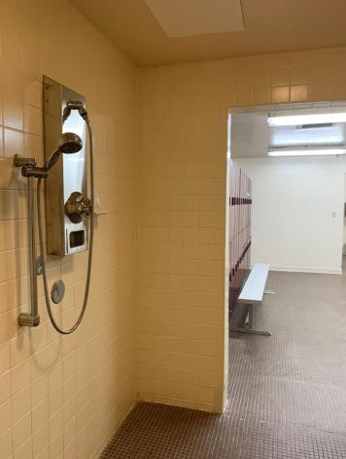

 | ID:  2795 | Facility:  Fort Boise Community Center

Location: Basement Women's Restroom
Schedule: 2021
Estimated Cost: $100.00

Priority Score 5
Quick Fix: Yes
Built before ADA: Yes

VIOLATIONS
2010 ADA Standards for Accessible Design Codes: §307.2
The paper towel dispenser protrudes 8" into the circulation space at 43" above the floor.

RECOMMENDATIONS
Recess the paper towel dispenser so it protrudes a maximum of 4" or place a cane detectable object beneath it.

PHOTOGRAPH(S) OF THIS LOCATION

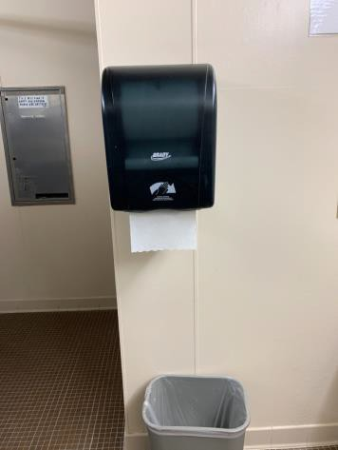

 | ID:  2793 | Facility:  Fort Boise Community Center

Location: Basement Women's Restroom
Schedule: 2021
Estimated Cost: $400.00

Priority Score 7
Quick Fix: Yes
Built before ADA: Yes

VIOLATIONS
2010 ADA Standards for Accessible Design Codes: §606.5
The pipes under the sinks are not covered.

RECOMMENDATIONS
Wrap the pipes beneath the sinks with soft protective wrap or plastic.

PHOTOGRAPH(S) OF THIS LOCATION

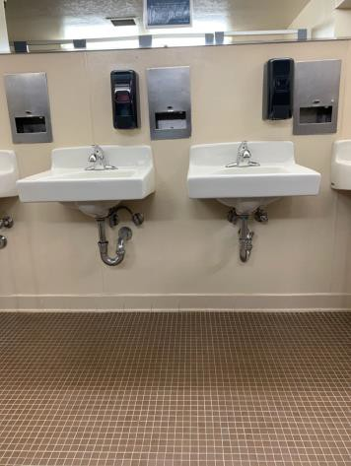

 | ID:  2787 | Facility:  Fort Boise Community Center

Location: Basement Women's Restroom
Schedule: 2021
Estimated Cost: $500.00

Priority Score 6
Quick Fix: Yes
Built before ADA: Yes

VIOLATIONS
2010 ADA Standards for Accessible Design Codes: §607.6
The shower head is installed at 61" above the floor.

RECOMMENDATIONS
Install a secondary shower head with a 59" long minimum hose to allow for a user to sit or stand that is a maximum of 48" above the floor.

PHOTOGRAPH(S) OF THIS LOCATION

 | ID:  2789 | Facility:  Fort Boise Community Center

Location: Basement Women's Restroom
Schedule: 2021
Estimated Cost: $500.00

Priority Score 5
Quick Fix: Yes
Built before ADA: Yes

VIOLATIONS
2010 ADA Standards for Accessible Design Codes: §609.4
The ambulatory stall restroom side and rear grab bars are installed at 32.5" above the floor.

RECOMMENDATIONS
As a temporary fix until which time when a wheelchair accessible stall is installed, raise the side and rear grab bars to a minimum height of 33” and 36” maximum above the floor measured to the top of gripping surface.

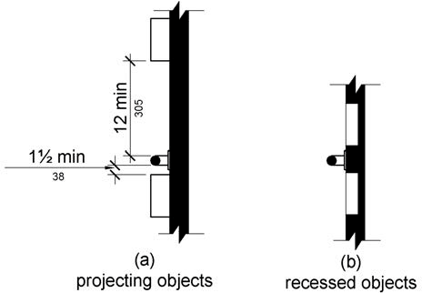

PHOTOGRAPH(S) OF THIS LOCATION

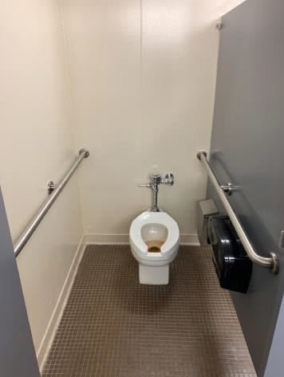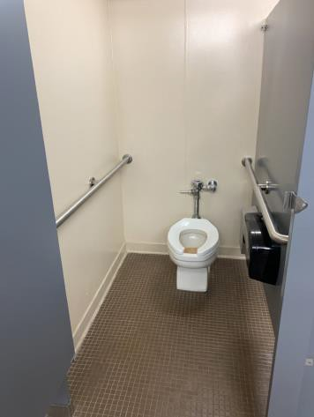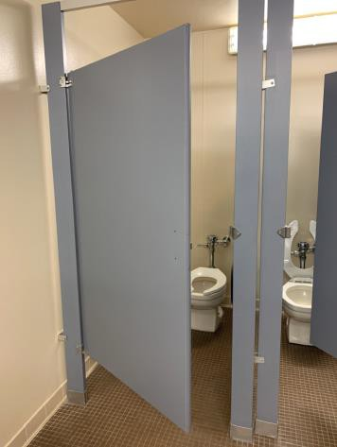

 | ID:  2785 | Facility:  Fort Boise Community Center

Location: Basement Women's Restroom
Schedule: 2022
Estimated Cost: $2,000.00

Priority Score 6
Quick Fix: No
Built before ADA: Yes

VIOLATIONS
2010 ADA Standards for Accessible Design Codes: §608.3.2
There are no grab bars in the roll-in type shower.

RECOMMENDATIONS
Install grab bars on the control wall, side wall, and back wall at 6" maximum from the adjacent walls. Ensure the grab bars are installed at a minimum height of 33" to a maximum height of 36" above the floor.

PHOTOGRAPH(S) OF THIS LOCATION

 | ID:  2788 | Facility:  Fort Boise Community Center

Location: Basement Women's Restroom
Schedule: 2022
Estimated Cost: $2,500.00

Priority Score 5
Quick Fix: No
Built before ADA: Yes

VIOLATIONS
2010 ADA Standards for Accessible Design Codes: §403.3
The running slope is 6.8%.

RECOMMENDATIONS
Reconstruct the route to ensure the slope is a maximum of 2% outside of the shower's threshold.

PHOTOGRAPH(S) OF THIS LOCATION

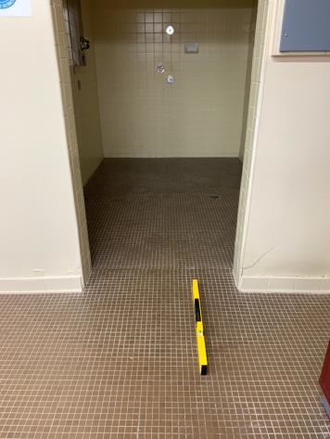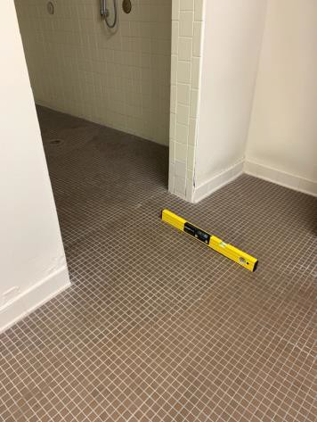

 | ID:  4479 | Facility:  Fort Boise Community Center

Location: Basement Women's Restroom
Schedule: 2022
Estimated Cost: $5,000.00

Priority Score 5
Quick Fix: No
Built before ADA: Yes

VIOLATIONS
2010 ADA Standards for Accessible Design Codes: §213.3.1, §604.8.1.1
There is not a wheelchair accessible restroom stall in the Women's Basement Restroom.

RECOMMENDATIONS
Expand the existing ambulatory stall to create a wheelchair accessible toilet compartment a minimum of 60" wide and 56" deep.

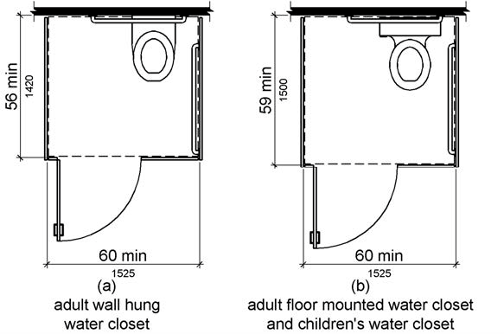

PHOTOGRAPH(S) OF THIS LOCATION

 | ID:  2800 | Facility:  Fort Boise Community Center

Location: Cardio Machines
Schedule: 2021
Estimated Cost: $500.00

Priority Score 5
Quick Fix: Yes
Built before ADA: Yes

VIOLATIONS
2010 ADA Standards for Accessible Design Codes: §305.3
There is not adequate clear floor space to access the cardio machines.

RECOMMENDATIONS
Shift the equipment to ensure that there is a minimum of a 30"x48" space adjacent to the transfer location at each type of machine.

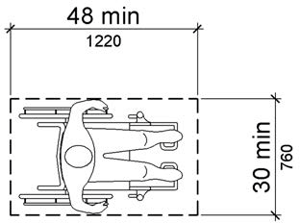

PHOTOGRAPH(S) OF THIS LOCATION

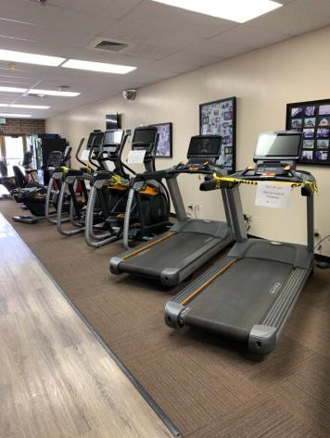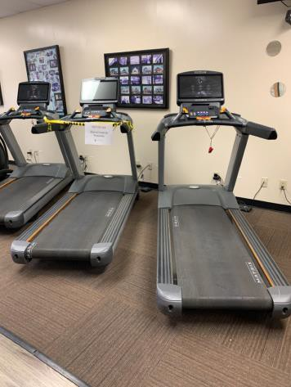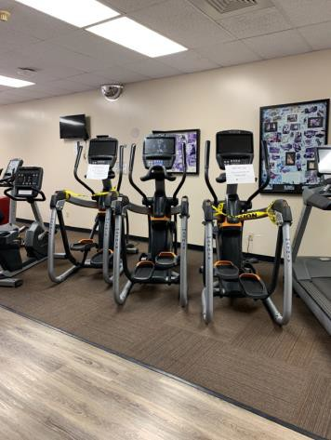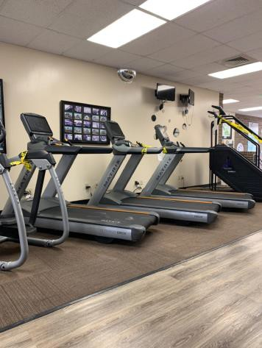

 | ID:  2804 | Facility:  Fort Boise Community Center

Location: Dance Room
Schedule: 2021
Estimated Cost: $1,000.00

Priority Score 3
Quick Fix: No
Built before ADA: Yes

VIOLATIONS
2010 ADA Standards for Accessible Design Codes: §404.2.4.4
The entrance has a 2.9%-3.8% slope.

RECOMMENDATIONS
Resurface the entryway to reduce the running slope to a maximum of 2% in all directions.

PHOTOGRAPH(S) OF THIS LOCATION

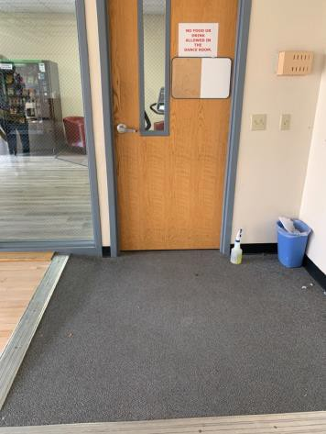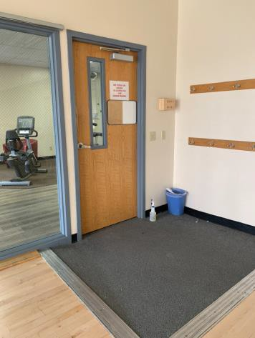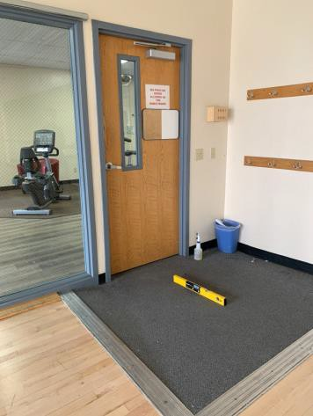

 | ID:  2770 | Facility:  Fort Boise Community Center

Location: Drawing and Painting Studio
Schedule: 2021
Estimated Cost: $100.00

Priority Score 5
Quick Fix: Yes
Built before ADA: Yes

VIOLATIONS
2010 ADA Standards for Accessible Design Codes: §307.2
The TV stand protrudes 20.75" into the circulation space at 71.5" above the floor.

RECOMMENDATIONS
Recess the TV stand so it protrudes a maximum of 4", raise it so the bottom edge is 80" maximum above the floor, or place a cane detectable object beneath it.

PHOTOGRAPH(S) OF THIS LOCATION

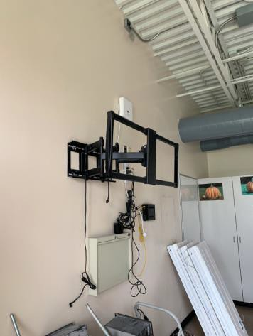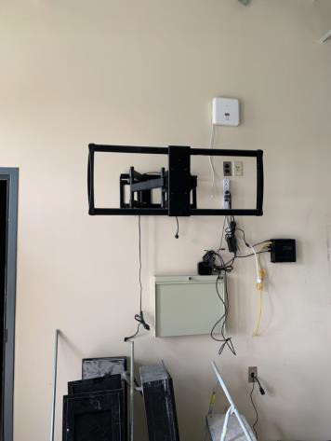

 | ID:  2255 | Facility:  Fort Boise Community Center

Location: Elevator
Schedule: 2021
Estimated Cost: $100.00

Priority Score 3
Quick Fix: Yes
Built before ADA: Yes

VIOLATIONS
2010 ADA Standards for Accessible Design Codes: §407.2.3.1
There is no tactile star on the door jambs of the main entry level.

RECOMMENDATIONS
Replace the tactile signage on the door jambs of the main entry level with tactile signage containing a tactile star indicating the main entry level.

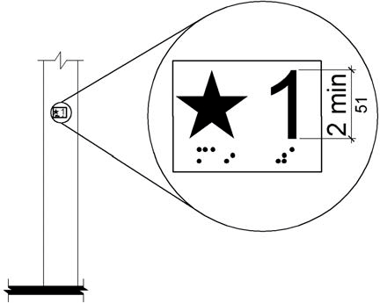

PHOTOGRAPH(S) OF THIS LOCATION

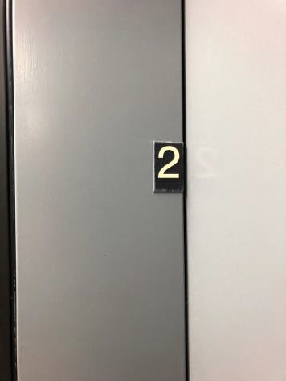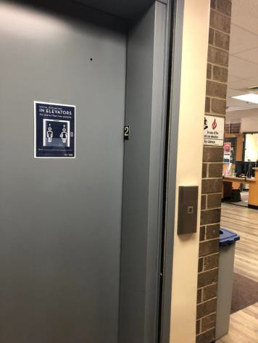

 | ID:  2268 | Facility:  Fort Boise Community Center

Location: Elevator
Schedule: 2021
Estimated Cost: $100.00

Priority Score 3
Quick Fix: Yes
Built before ADA: Yes

VIOLATIONS
2010 ADA Standards for Accessible Design Codes: §407.4.7.1.3
The tactile star is located on the first floor control button, not the second floor button, which is the main entry floor.

RECOMMENDATIONS
Replace the second floor control button with one that contains a tactile star and replace the first floor control button with one that indicates the floor with no tactile star.

PHOTOGRAPH(S) OF THIS LOCATION

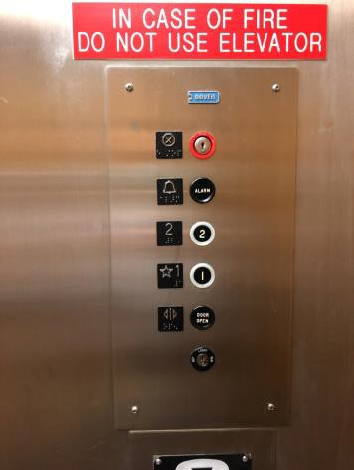

 | ID:  2267 | Facility:  Fort Boise Community Center

Location: Elevator
Schedule: 2023
Estimated Cost: $1,000.00

Priority Score 8
Quick Fix: No
Built before ADA: Yes

VIOLATIONS
2010 ADA Standards for Accessible Design Codes: §308.2.1, §407.2.1.1
The elevator call buttons are outside of the unobstructed forward reach range at 51" to 58" above the floor.

RECOMMENDATIONS
Lower the elevator call buttons by 3" to 10" to meet the accessible reach range of 15" minimum and 48" maximum above the floor.

PHOTOGRAPH(S) OF THIS LOCATION

 | ID:  2774 | Facility:  Fort Boise Community Center

Location: Facility
Schedule: 2021
Estimated Cost: $5,800.00

Priority Score 3
Quick Fix: No
Built before ADA: Yes

VIOLATIONS
2010 ADA Standards for Accessible Design Codes: §216.2, §703
There is no tactile sign identifying 58 permanent room.

RECOMMENDATIONS
Install tactile signage on the latch side of the doorway at a height of 48” minimum to 60” maximum above the floor, identifying room by name or room number.
Signs shall be Braille with raised lettering and should be placed on the wall in the center of an 18"x18" clear floor space.

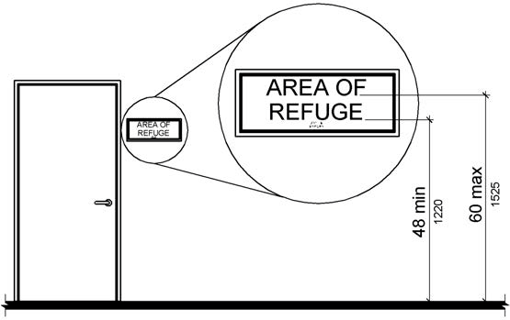

PHOTOGRAPH(S) OF THIS LOCATION

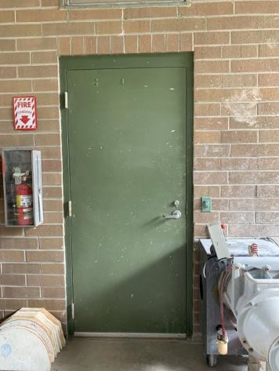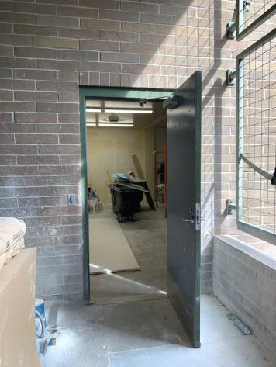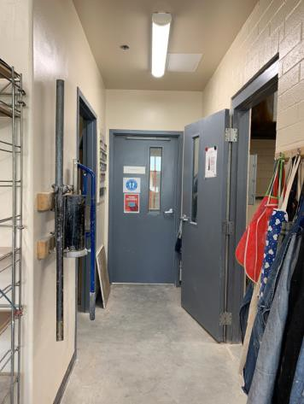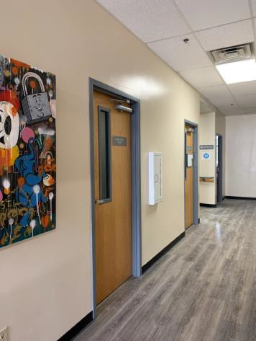

 | ID:  2758 | Facility:  Fort Boise Community Center

Location: Gym
Schedule: 2021
Estimated Cost: $100.00

Priority Score 4
Quick Fix: Yes
Built before ADA: Yes

VIOLATIONS
2010 ADA Standards for Accessible Design Codes: §404.2.9
The opening and closing force of the door is 6 to 8 pounds.

RECOMMENDATIONS
Adjust the resistance on the door so that it allows the doors to be continuously opened at a maximum force of 5 pounds.

PHOTOGRAPH(S) OF THIS LOCATION

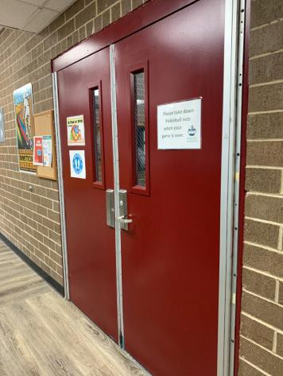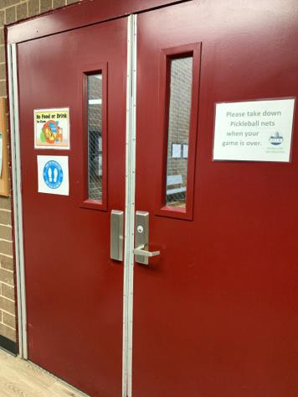

 | ID:  2759 | Facility:  Fort Boise Community Center

Location: Gym
Schedule: 2021
Estimated Cost: $100.00

Priority Score 5
Quick Fix: Yes
Built before ADA: Yes

VIOLATIONS
2010 ADA Standards for Accessible Design Codes: §307.2
The fire alarm protrudes into the circulation space.

RECOMMENDATIONS
Recess the fire alarm so it protrudes a maximum of 4" or place a cane detectable object beneath it.

PHOTOGRAPH(S) OF THIS LOCATION

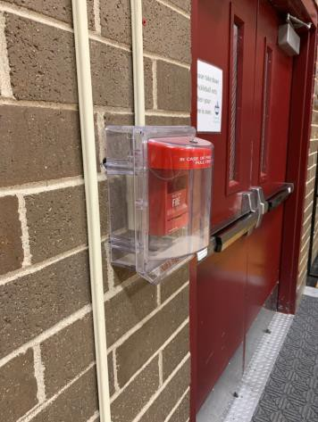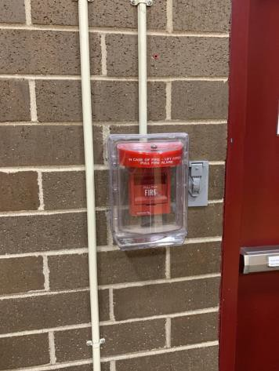

 | ID:  2762 | Facility:  Fort Boise Community Center

Location: Gym
Schedule: 2021
Estimated Cost: $200.00

Priority Score 5
Quick Fix: Yes
Built before ADA: Yes

VIOLATIONS
2010 ADA Standards for Accessible Design Codes: §307.2
The fire alarm and light switches protrude 5" and 6" into the circulation space at 46" above the floor.

RECOMMENDATIONS
Recess the fire alarm and light switches so they protrude a maximum of 4" or place a cane detectable object beneath them.

PHOTOGRAPH(S) OF THIS LOCATION

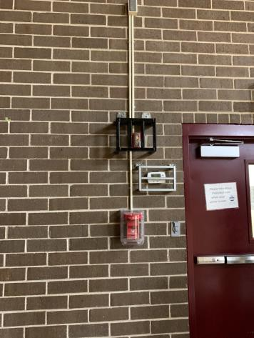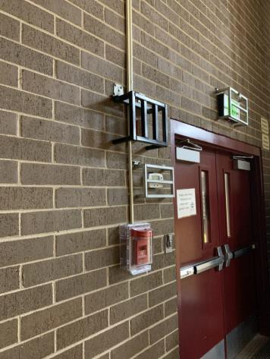

 | ID:  2764 | Facility:  Fort Boise Community Center

Location: Gym
Schedule: 2021
Estimated Cost: $200.00

Priority Score 5
Quick Fix: Yes
Built before ADA: Yes

VIOLATIONS
2010 ADA Standards for Accessible Design Codes: §307.2
The emergency light and thermostat protrude into the circulation space at 73" and 64" above the floor.

RECOMMENDATIONS
Recess the emergency light and thermostat so it protrudes a maximum of 4" or place a cane detectable object beneath it.

PHOTOGRAPH(S) OF THIS LOCATION

 | ID:  2767 | Facility:  Fort Boise Community Center

Location: Gym
Schedule: 2022
Estimated Cost: $2,000.00

Priority Score 6
Quick Fix: No
Built before ADA: Yes

VIOLATIONS
2010 ADA Standards for Accessible Design Codes: §602.7
There are two drinking fountains with a spout height of 35". One of the drinking fountains is broken.

RECOMMENDATIONS
Raise one of the drinking fountains to a minimum spout height of 38" above the floor and a maximum of 43" above the floor.
Repair the broken drinking fountain.

PHOTOGRAPH(S) OF THIS LOCATION

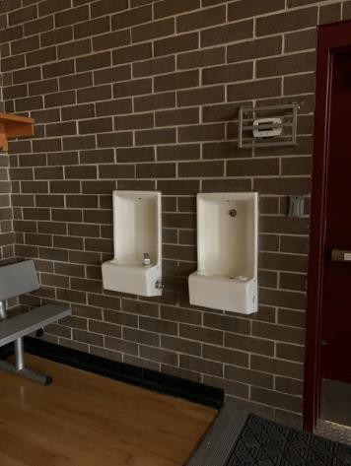

 | ID:  2760 | Facility:  Fort Boise Community Center

Location: Gym
Schedule: 2021
Estimated Cost: $2,000.00

Priority Score 3
Quick Fix: No
Built before ADA: Yes

VIOLATIONS
2010 ADA Standards for Accessible Design Codes: §404.2.4.4
The gym entrance has a 5.4% slope within the doorways maneuvering clearance.

RECOMMENDATIONS
Reconstruct the entryway's maneuvering clearance to reduce the slope to a maximum of 2% in all directions for the width of the double doors.

PHOTOGRAPH(S) OF THIS LOCATION

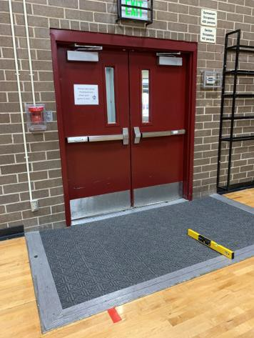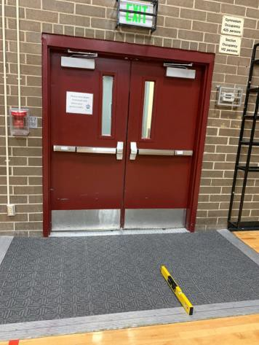

 | ID:  2761 | Facility:  Fort Boise Community Center

Location: Gym
Schedule: 2021
Estimated Cost: $2,000.00

Priority Score 3
Quick Fix: No
Built before ADA: Yes

VIOLATIONS
2010 ADA Standards for Accessible Design Codes: §404.2.4.4
The middle entrance has a slope exceeding 2% within the doorways maneuvering clearance.

RECOMMENDATIONS
Reconstruct the entryway's maneuvering clearance to reduce the slope to a maximum of 2% in all directions for the width of the double doors.

PHOTOGRAPH(S) OF THIS LOCATION

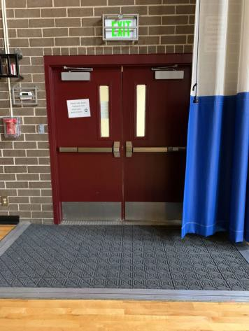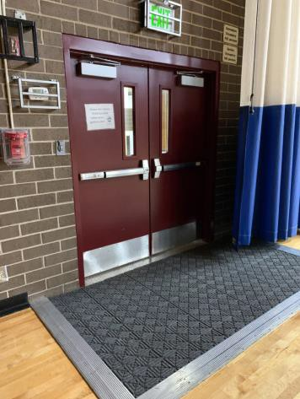

 | ID:  2765 | Facility:  Fort Boise Community Center

Location: Gym
Schedule: 2021
Estimated Cost: $2,000.00

Priority Score 3
Quick Fix: No
Built before ADA: Yes

VIOLATIONS
2010 ADA Standards for Accessible Design Codes: §404.2.4.1, §404.2.4.4
The gym entrance has a 7.8% slope within the doorway's maneuvering clearance.

RECOMMENDATIONS
Reconstruct the entryway's maneuvering clearance to reduce the slope to a maximum of 2% in all directions for the width of the double doors.

PHOTOGRAPH(S) OF THIS LOCATION

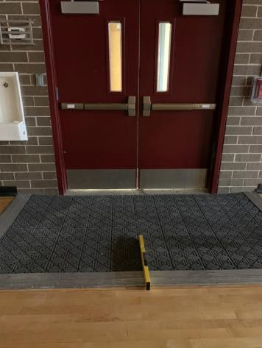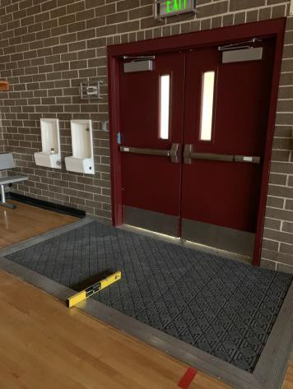

 | ID:  2850 | Facility:  Fort Boise Community Center

Location: Information Holder
Schedule: 2021
Estimated Cost: $100.00

Priority Score 3
Quick Fix: Yes
Built before ADA: Yes

VIOLATIONS
2010 ADA Standards for Accessible Design Codes: §308.2.1
The information holders are outside of the unobstructed forward reach range at 56.5" above the floor.

RECOMMENDATIONS
Lower the information holders by 8.5" to meet the accessible reach range of 15" minimum and 48" maximum above the floor.

PHOTOGRAPH(S) OF THIS LOCATION

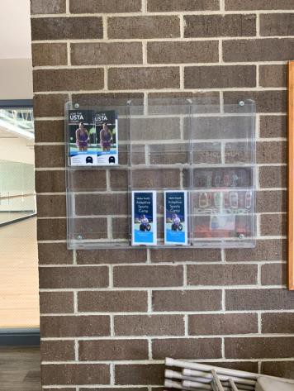

 | ID:  2805 | Facility:  Fort Boise Community Center

Location: Main Entrance
Schedule: 2022
Estimated Cost: $5,000.00

Priority Score 5
Quick Fix: No
Built before ADA: Yes

VIOLATIONS
2010 ADA Standards for Accessible Design Codes: §404.2.6
Between the two hinged or pivoted doors, the width is 40.5".

RECOMMENDATIONS
Expand the space to a minimum of 48" wide between the two doors to ensure adequate maneuvering clearance between the two doorways or remove the inside set of doors.

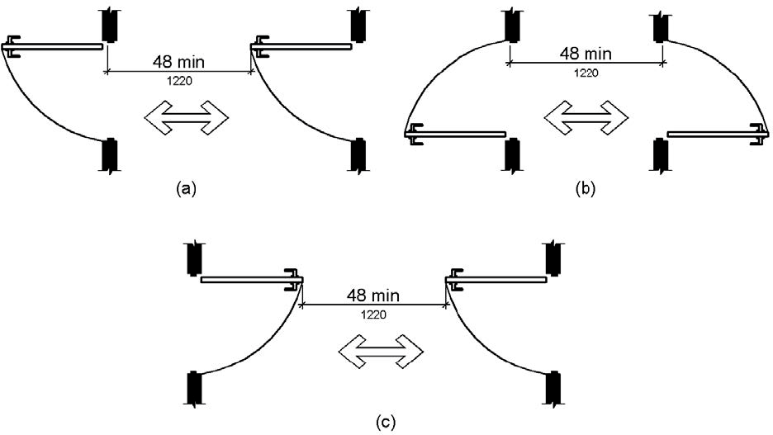

PHOTOGRAPH(S) OF THIS LOCATION

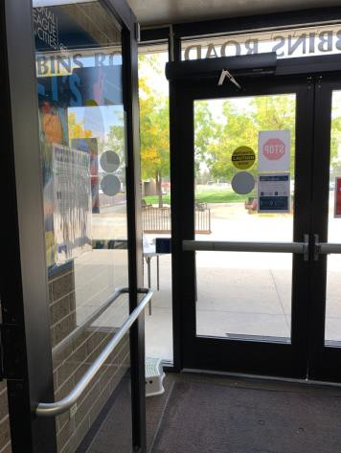

 | ID:  2801 | Facility:  Fort Boise Community Center

Location: Multipurpose Room
Schedule: 2021
Estimated Cost: $100.00

Priority Score 6
Quick Fix: Yes
Built before ADA: Yes

VIOLATIONS
2010 ADA Standards for Accessible Design Codes: §404.2.8.1
The time required for the door to shut is 3.03 seconds.

RECOMMENDATIONS
Adjust the closing speed to a minimum of 5 or more seconds.

PHOTOGRAPH(S) OF THIS LOCATION

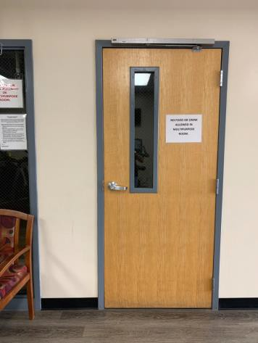

 | ID:  2802 | Facility:  Fort Boise Community Center

Location: Multipurpose Room
Schedule: 2021
Estimated Cost: $500.00

Priority Score 5
Quick Fix: Yes
Built before ADA: Yes

VIOLATIONS
2010 ADA Standards for Accessible Design Codes: §307.2
The sprinklers are 75" above the floor.

RECOMMENDATIONS
Raise the sprinklers so the bottom edge is 80" maximum above the floor.

PHOTOGRAPH(S) OF THIS LOCATION

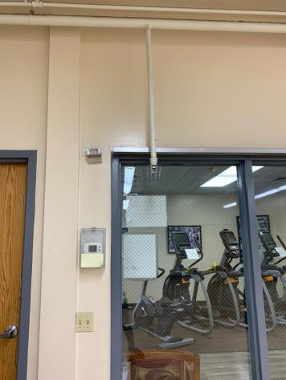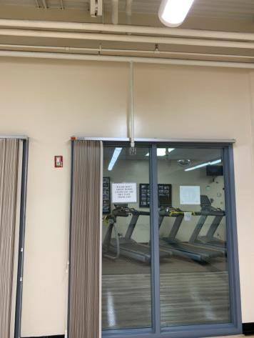

 | ID:  2803 | Facility:  Fort Boise Community Center

Location: Multipurpose Room
Schedule: 2021
Estimated Cost: $2,000.00

Priority Score 3
Quick Fix: No
Built before ADA: Yes

VIOLATIONS
2010 ADA Standards for Accessible Design Codes: §404.2.4.4
The entrance has a 2.2% slope and a 5.5% slope on the right side.

RECOMMENDATIONS
Reconstruct the entryway to reduce the slope to a maximum of 2% in all directions.

PHOTOGRAPH(S) OF THIS LOCATION

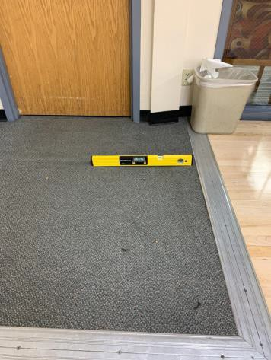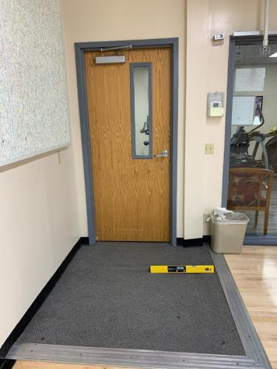

 | ID:  2738 | Facility:  Fort Boise Community Center

Location: Office Parking
Schedule: 2021
Estimated Cost: $1,000.00

Priority Score 3
Quick Fix: No
Built before ADA: Yes

VIOLATIONS
2010 ADA Standards for Accessible Design Codes: §502.3
The access aisles is not of sufficient width at 52" wide.

RECOMMENDATIONS
Repaint the accessible parking spaces and access aisles so that all accessible car parking spaces are a minimum of 96" wide, van parking spaces are a minimum of 132" wide, and their adjacent access aisles are a minimum of 60” wide.

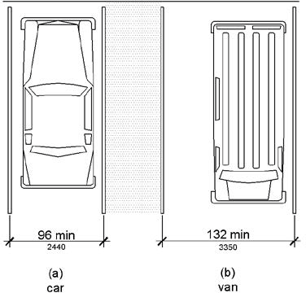

PHOTOGRAPH(S) OF THIS LOCATION

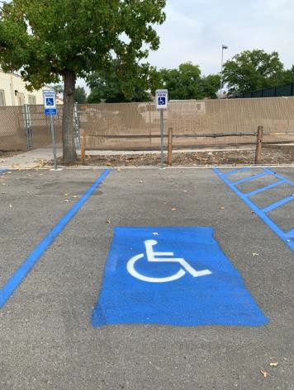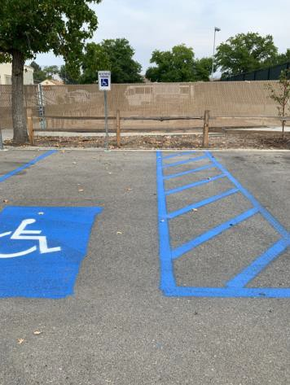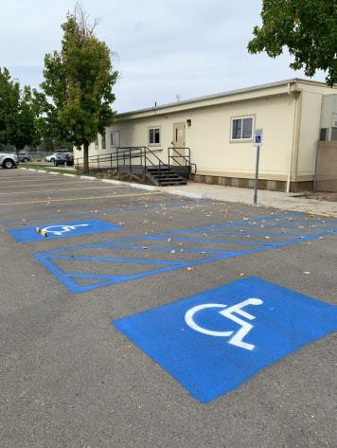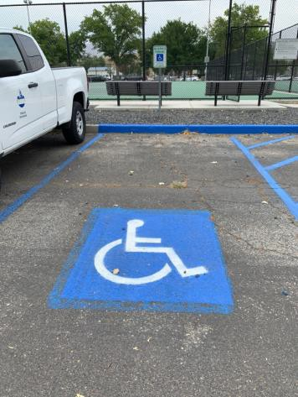

 | ID:  3435 | Facility:  Fort Boise Community Center

Location: Parking for the Fort Boise Community Center and Senior Center
Schedule: 2021
Estimated Cost: $5,000.00

Priority Score 9
Quick Fix: No
Built before ADA: Yes

VIOLATIONS
2010 ADA Standards for Accessible Design Codes: §208.2.4, §502.3, §502.4
The access aisles are not of sufficient width at 53" and 54" wide. The access aisle has a 2.2% slope. There are no marked "Van Accessible" spaces.

RECOMMENDATIONS
Repaint the access aisles so that all the access aisles are a minimum of 60” wide. Resurface the access aisle to reduce the slope to a maximum of 2% in all directions.
Add a 132" wide van accessible parking space for every six vehicle parking spaces. Add a “van accessible” parking sign at a minimum height of 60" above the ground.

PHOTOGRAPH(S) OF THIS LOCATION

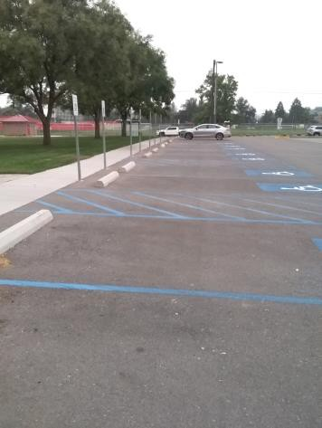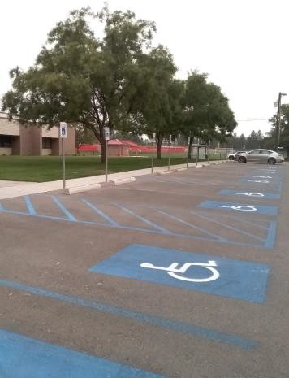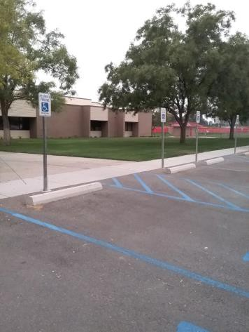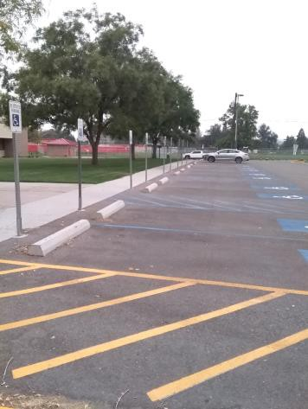

 | ID:  3584 | Facility:  Fort Boise Community Center

Location: Plaza
Schedule: 2021
Estimated Cost: $5,000.00

Priority Score 3
Quick Fix: No
Built before ADA: Yes

VIOLATIONS
2010 ADA Standards for Accessible Design Codes: §226.1, §902, §305, §306
The provided picnic tables do not have an accessible clear space for a wheelchair user.

RECOMMENDATIONS
Add/replace picnic tables so that at least 5% of the seating is wheelchair accessible.
Ensure that the wheelchair accessible seating has a clear floor space of 30" x 48" with a slope not steeper than 2% and that the tables have sufficient knee and toe clearance.

PHOTOGRAPH(S) OF THIS LOCATION

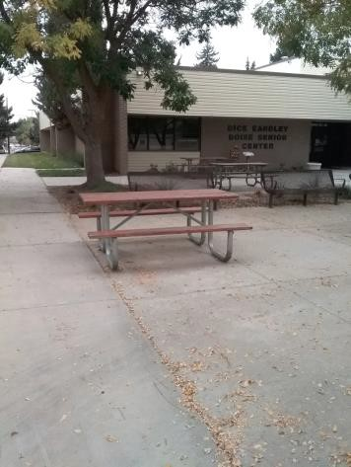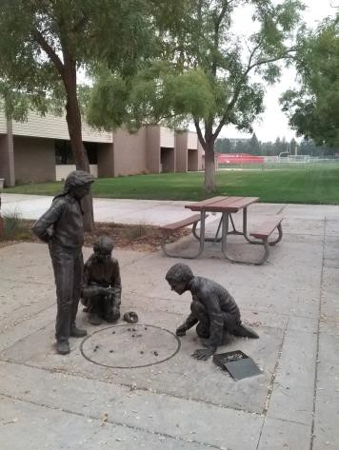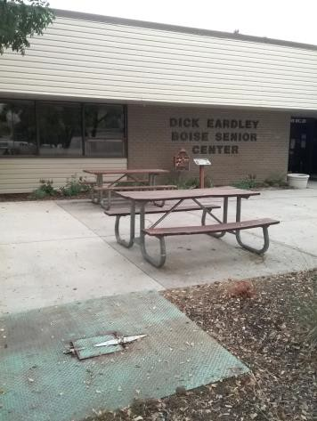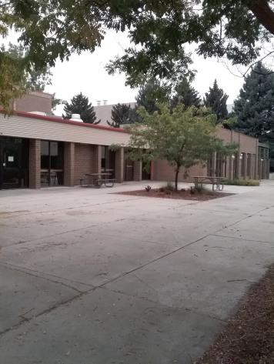

 | ID:  2256 | Facility:  Fort Boise Community Center

Location: Pottery
Schedule: 2022
Estimated Cost: $1,000.00

Priority Score 5
Quick Fix: No
Built before ADA: Yes

VIOLATIONS
2010 ADA Standards for Accessible Design Codes: §306.3.1
The knee clearance at the table has a height of 26" above the floor.

RECOMMENDATIONS
Replace one of the existing tables to allow for a maximum work surface height of 34" above the floor and maximum knee clearance under the element of 27" above the floor.

PHOTOGRAPH(S) OF THIS LOCATION

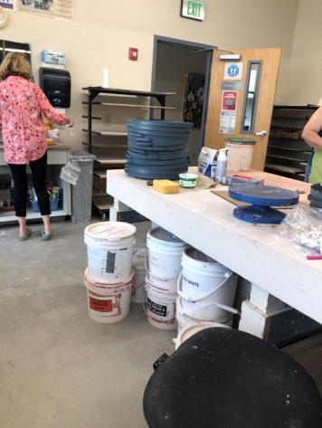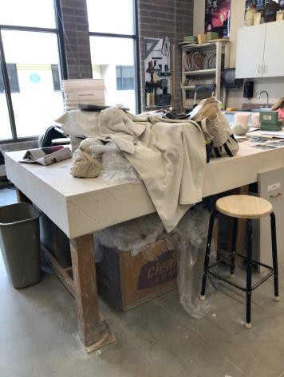

 | ID:  2775 | Facility:  Fort Boise Community Center

Location: Pottery Studio
Schedule: 2022
Estimated Cost: $1,000.00

Priority Score 7
Quick Fix: No
Built before ADA: Yes

VIOLATIONS
2010 ADA Standards for Accessible Design Codes: §306.3, §606.5
The height of the sink is compliant at 34" however, the wood at the base of the sink prevents the use of the provided knee clearance.
The pipes under the sink are not covered.

RECOMMENDATIONS
Provide knee clearance underneath the counter at the sink that is a minimum of 11" deep at 9" above the floor and 8" deep at 27" above the floor by removing the wood at the base of the sink.
Wrap the pipes beneath the sink with soft protective wrap or plastic.

PHOTOGRAPH(S) OF THIS LOCATION

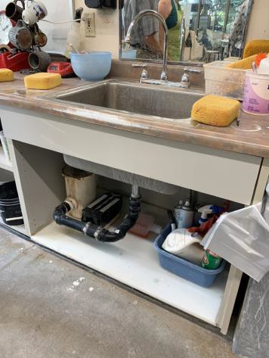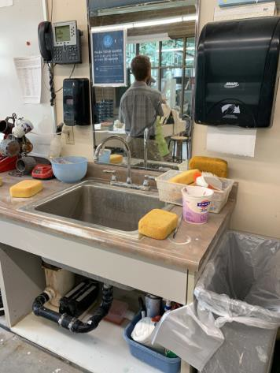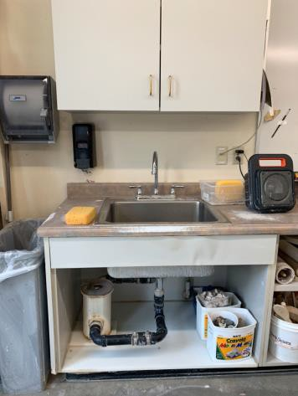

 | ID:  2780 | Facility:  Fort Boise Community Center

Location: Stairwell by Men’s Basement Restroom
Schedule: 2022
Estimated Cost: $1,000.00

Priority Score 5
Quick Fix: No
Built before ADA: Yes

VIOLATIONS
2010 ADA Standards for Accessible Design Codes: §505.10.3
There are no handrail extensions at the bottom of the stairs.

RECOMMENDATIONS
Install new handrails that have extensions at the slope of the stair flight for a horizontal distance at least equal to one tread depth beyond the last riser nosing.
Handrail extensions shall return the wall, guard or landing surface, or shall be continuous to the handrail of an adjacent stair flight.

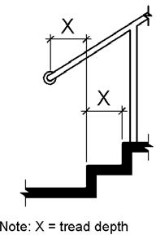

PHOTOGRAPH(S) OF THIS LOCATION

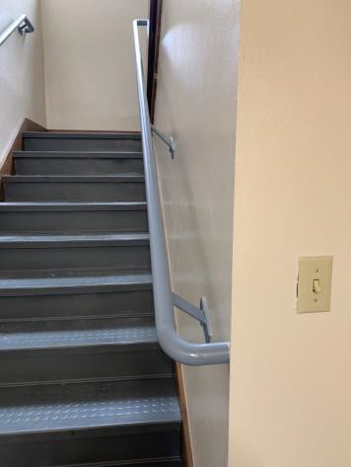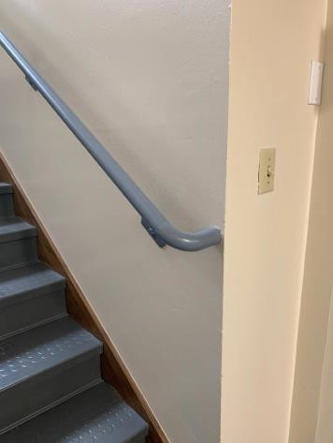

 | ID:  2779 | Facility:  Fort Boise Community Center

Location: Stairwell by Men’s Basement Restroom
Schedule: 2021
Estimated Cost: $2,000.00

Priority Score 3
Quick Fix: No
Built before ADA: Yes

VIOLATIONS
2010 ADA Standards for Accessible Design Codes: §302.1
The rubber on the stairwell is uplifting posing a tripping hazard.

RECOMMENDATIONS
Adhere the rubber to the stairwells.

PHOTOGRAPH(S) OF THIS LOCATION

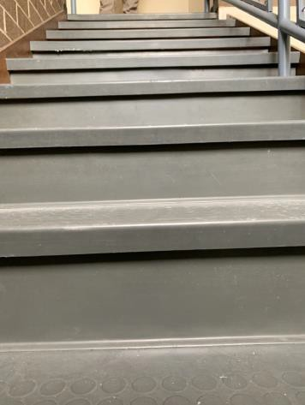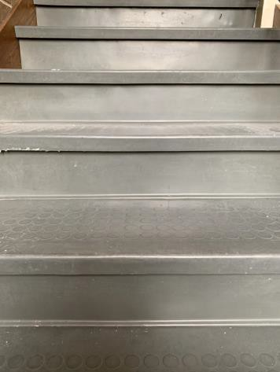

 | ID:  2797 | Facility:  Fort Boise Community Center

Location: Stairwell Extensions
Schedule: 2022
Estimated Cost: $1,000.00

Priority Score 5
Quick Fix: No
Built before ADA: Yes

VIOLATIONS
2010 ADA Standards for Accessible Design Codes: §505.10.3
There are no handrail extensions at the bottom of the stairs.

RECOMMENDATIONS
Install new handrails that have extensions at the slope of the stair flight for a horizontal distance at least equal to one tread depth beyond the last riser nosing.
Handrail extensions shall return the wall, guard or landing surface, or shall be continuous to the handrail of an adjacent stair flight.

PHOTOGRAPH(S) OF THIS LOCATION

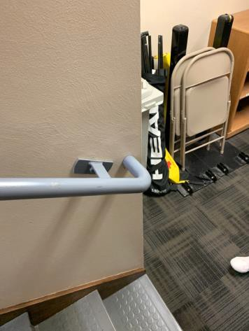

 | ID:  2798 | Facility:  Fort Boise Community Center

Location: Stairwell Extensions
Schedule: 2022
Estimated Cost: $1,000.00

Priority Score 5
Quick Fix: No
Built before ADA: Yes

VIOLATIONS
2010 ADA Standards for Accessible Design Codes: §505.10.2
There are no handrail extensions at the top of the stairs.

RECOMMENDATIONS
Install new handrails with extensions that extend at least 12" horizontally above the landing beginning directly above the first stair riser nosing.

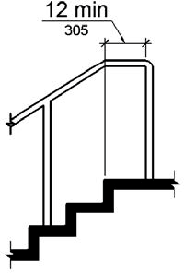

PHOTOGRAPH(S) OF THIS LOCATION

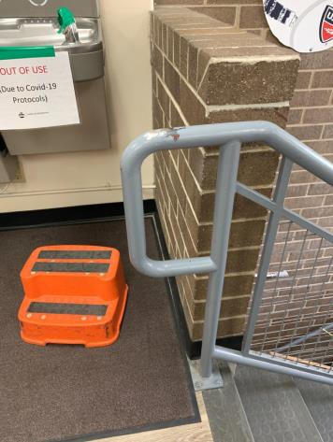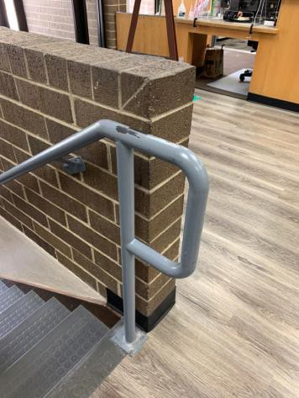

 | ID:  2755 | Facility:  Fort Boise Community Center

Location: Teen Center
Schedule: 2021
Estimated Cost: $100.00

Priority Score 8
Quick Fix: Yes
Built before ADA: Yes

VIOLATIONS
2010 ADA Standards for Accessible Design Codes: §308.2.2
The soap dispenser is outside of the obstructed forward reach range at 52" above the floor.

RECOMMENDATIONS
Lower the soap dispenser by 4" to meet the accessible reach range of 15" minimum and 48" maximum above the floor.

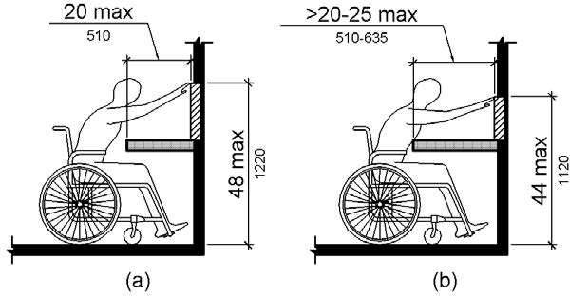

PHOTOGRAPH(S) OF THIS LOCATION

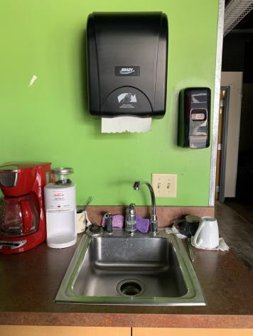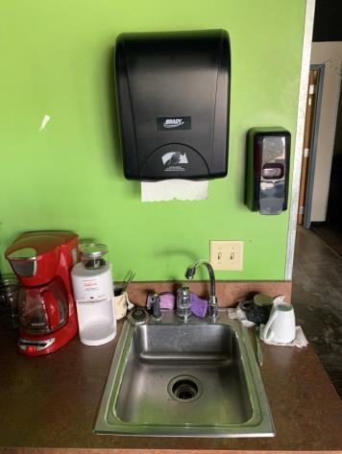

 | ID:  2756 | Facility:  Fort Boise Community Center

Location: Teen Center
Schedule: 2021
Estimated Cost: $100.00

Priority Score 8
Quick Fix: Yes
Built before ADA: Yes

VIOLATIONS
2010 ADA Standards for Accessible Design Codes: §308.2.2
The paper towel dispenser is outside of the obstructed forward reach range at 57" above the floor.

RECOMMENDATIONS
Lower the paper towel dispenser by 9" to meet the accessible reach range of 15" minimum and 48" maximum above the floor.

PHOTOGRAPH(S) OF THIS LOCATION

 | ID:  2757 | Facility:  Fort Boise Community Center

Location: Teen Center
Schedule: 2021
Estimated Cost: $1,000.00

Priority Score 8
Quick Fix: No
Built before ADA: Yes

VIOLATIONS
2010 ADA Standards for Accessible Design Codes: §902.3, §306.3.3, §606.3
The sink is 36.25" above the floor. The dining and work surface counter is 36.25" above the floor. There is no knee clearance underneath the sink.

RECOMMENDATIONS
Lower the sink to the maximum height of 34" above the floor. A 30" portion of the dining and work surface must be no higher than 34” above the floor.
Provide knee clearance underneath the counter at the sink that is a minimum of 11" deep at 9" above the floor and 8" deep at 27" above the floor.

PHOTOGRAPH(S) OF THIS LOCATION

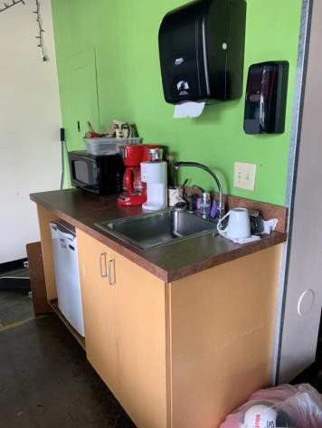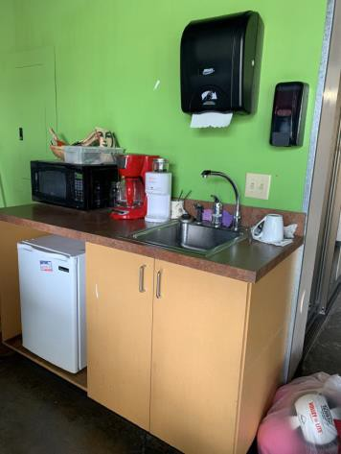

 | ID:  2740 | Facility:  Fort Boise Community Center

Location: Tennis Court
Schedule: 2021
Estimated Cost: $4,000.00

Priority Score 3
Quick Fix: No
Built before ADA: Yes

VIOLATIONS
2010 ADA Standards for Accessible Design Codes: §403.3, §404.2.4.1
There is not adequate maneuvering clearance to operate the gate. The running slope is 14.4%.

RECOMMENDATIONS
Change the direction that the gate swings or expand the area for which the gate opens by removing obstructions to provide adequate maneuvering clearance.
Reconstruct the route to reduce the running slope to a maximum of 5%.

PHOTOGRAPH(S) OF THIS LOCATION

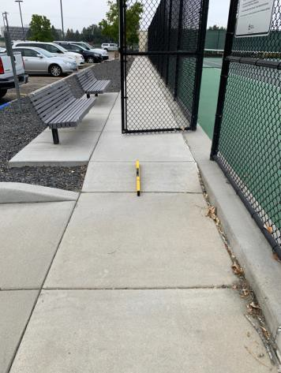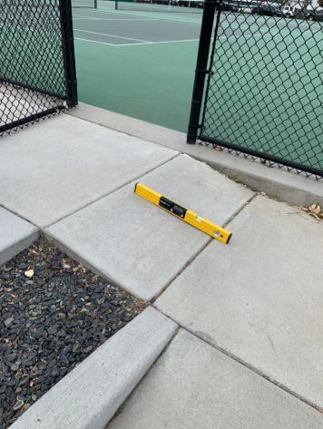

 | ID:  2742 | Facility:  Fort Boise Community Center

Location: Tennis Court Parking
Schedule: 2021
Estimated Cost: $100.00

Priority Score 8
Quick Fix: Yes
Built before ADA: Yes

VIOLATIONS
2010 ADA Standards for Accessible Design Codes: §502.6
There is no signage present identifying the accessible parking spaces.

RECOMMENDATIONS
Install an accessible parking sign at each accessible space at a minimum height of 60" above the ground.

PHOTOGRAPH(S) OF THIS LOCATION

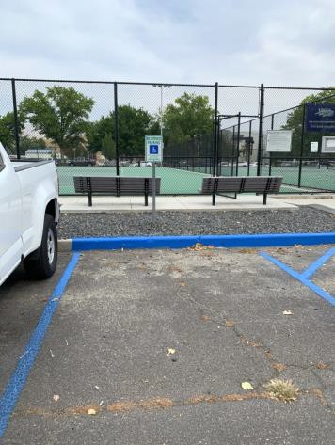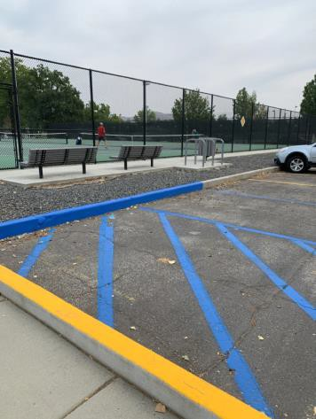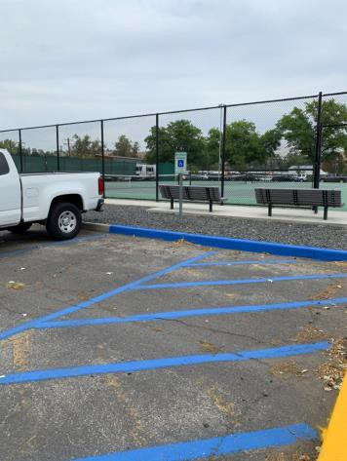

 | ID:  2739 | Facility:  Fort Boise Community Center

Location: Tennis Court Parking
Schedule: 2021
Estimated Cost: $1,000.00

Priority Score 3
Quick Fix: No
Built before ADA: Yes

VIOLATIONS
2010 ADA Standards for Accessible Design Codes: §405.7.1
The bottom landing of the ramp has a 3.7% slope.

RECOMMENDATIONS
Resurface the bottom landing to have slopes that are less than 2% in all directions.

PHOTOGRAPH(S) OF THIS LOCATION

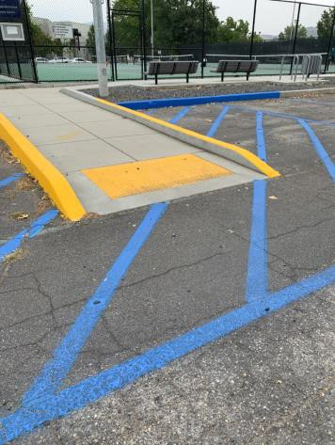

 | ID:  2737 | Facility:  Fort Boise Community Center

Location: Tennis Court Parking
Schedule: 2021
Estimated Cost: $3,000.00

Priority Score 3
Quick Fix: No
Built before ADA: Yes

VIOLATIONS
2010 ADA Standards for Accessible Design Codes: §502.4
The parking spaces and access aisle have slopes exceeding 2%.

RECOMMENDATIONS
Resurface the parking spaces and access aisle to reduce the slope to a maximum of 2% in all directions.

PHOTOGRAPH(S) OF THIS LOCATION

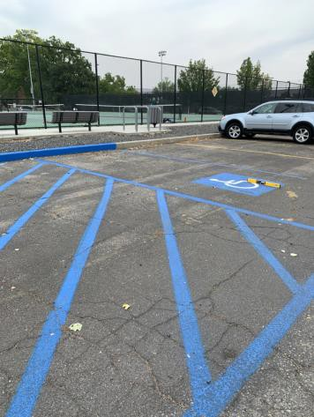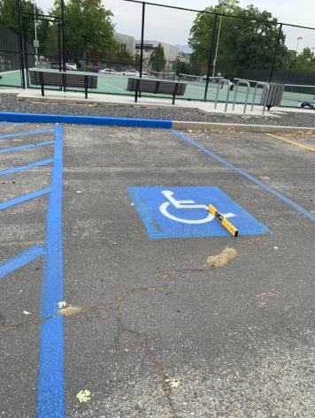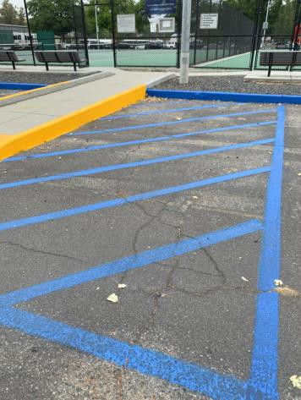

 | ID:  2851 | Facility:  Fort Boise Community Center

Location: Vending Machines
Schedule: 2023
Estimated Cost: $3,000.00

Priority Score 8
Quick Fix: No
Built before ADA: Yes

VIOLATIONS
2010 ADA Standards for Accessible Design Codes: §308.2.1
The Dasani vending machine buttons are outside of the unobstructed forward reach range at 54" above the floor.

RECOMMENDATIONS
Lower the Dasani vending machine buttons by 6" to meet the accessible reach range of 15" minimum and 48" maximum above the floor.
This may require replacing the vending machine.

PHOTOGRAPH(S) OF THIS LOCATION

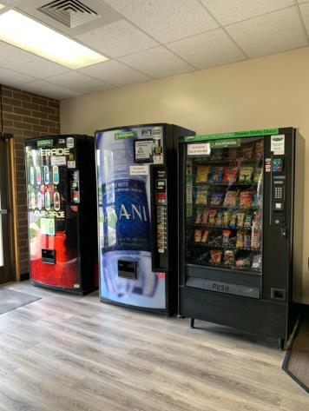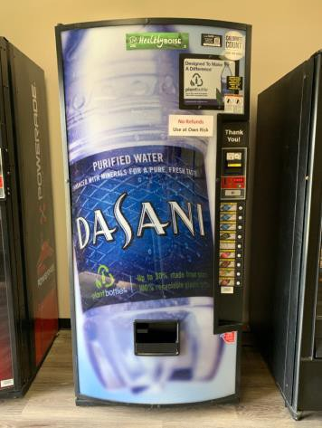

 | ID:  2852 | Facility:  Fort Boise Community Center

Location: Vending Machines
Schedule: 2023
Estimated Cost: $3,000.00

Priority Score 8
Quick Fix: No
Built before ADA: Yes

VIOLATIONS
2010 ADA Standards for Accessible Design Codes: §308.2.1
The Powerade vending machine buttons are outside of the unobstructed forward reach range at 53.5" above the floor.

RECOMMENDATIONS
Lower the Powerade vending machine buttons by 5.5" to meet the accessible reach range of 15" minimum and 48" maximum above the floor.
This may require replacing the vending machine.

PHOTOGRAPH(S) OF THIS LOCATION

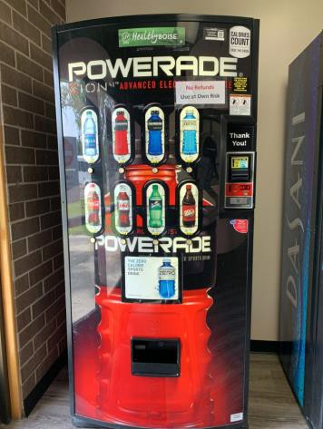

 | ID:  2853 | Facility:  Fort Boise Community Center

Location: Vending Machines
Schedule: 2023
Estimated Cost: $3,000.00

Priority Score 8
Quick Fix: No
Built before ADA: Yes

VIOLATIONS
2010 ADA Standards for Accessible Design Codes: §308.2.1
The snack vending machine buttons are outside of the unobstructed forward reach range at 63" above the floor.

RECOMMENDATIONS
Lower the snack vending machine buttons by 15" to meet the accessible reach range of 15" minimum and 48" maximum above the floor.
This may require replacing the vending machine.

PHOTOGRAPH(S) OF THIS LOCATION

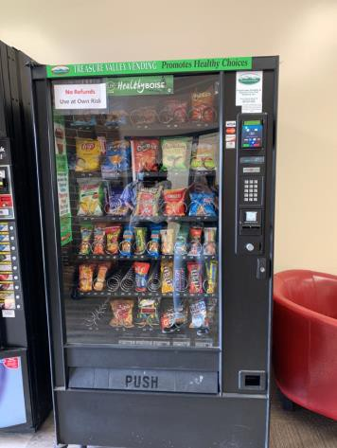

 | ID:  2799 | Facility:  Fort Boise Community Center

Location: Weight Room
Schedule: 2021
Estimated Cost: $500.00

Priority Score 3
Quick Fix: Yes
Built before ADA: Yes

VIOLATIONS
2010 ADA Standards for Accessible Design Codes: §305.2
The clear floor space between the exercise machines along the wall is 24" wide.

RECOMMENDATIONS
Reorganize the exercise machines to allow for a 30"x48" clear floor space adjacent to one of each type of exercise machine.

PHOTOGRAPH(S) OF THIS LOCATION

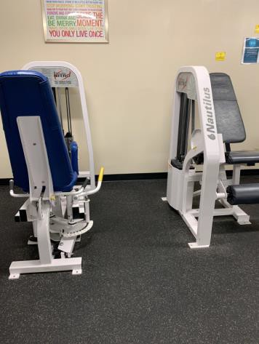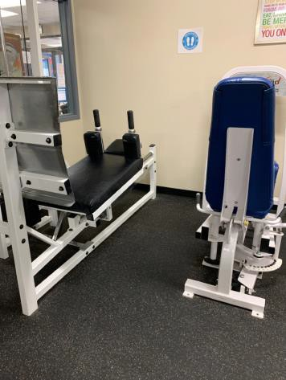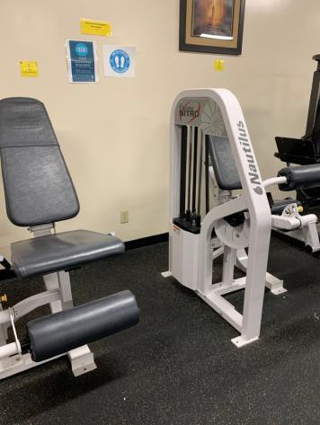

 | ID:  2754 | Facility:  Fort Boise Community Center

Location: Women’s and Men’s Restroom
Schedule: 2021
Estimated Cost: $200.00

Priority Score 6
Quick Fix: Yes
Built before ADA: Yes

VIOLATIONS
2010 ADA Standards for Accessible Design Codes: §703.4
The tactile signs identifying the rooms are not in the correct location.

RECOMMENDATIONS
Reinstall the sign on the latch side of the door at 48" minimum above the floor measured from the baseline of the lowest character and 60" maximum measured from the baseline of the highest character.

PHOTOGRAPH(S) OF THIS LOCATION

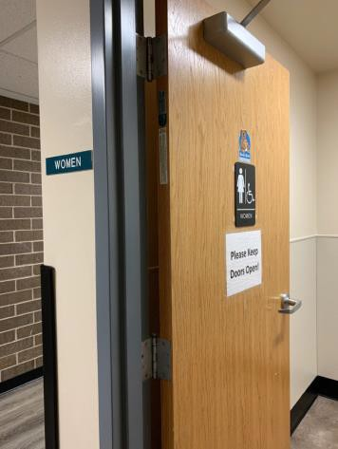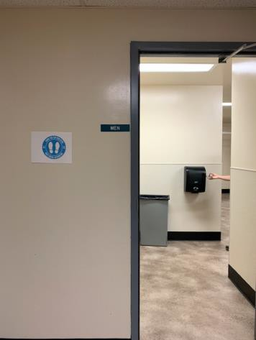

 | ID:  2746 | Facility:  Fort Boise Community Center

Location: Women’s Restroom
Schedule: 2021
Estimated Cost: $100.00

Priority Score 5
Quick Fix: Yes
Built before ADA: Yes

VIOLATIONS
2010 ADA Standards for Accessible Design Codes: §604.8.1.2
The door to the accessible water closet is not self closing. Either self-closing hinges are not installed on the door or if installed, they are defective.

RECOMMENDATIONS
Install or reinstall self-closing hinges on the door to ensure that the door is self-closing per the ADA requirements.

PHOTOGRAPH(S) OF THIS LOCATION

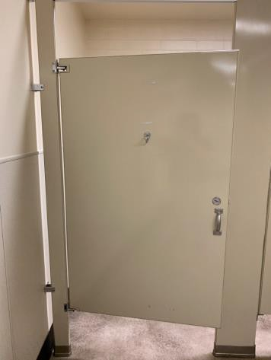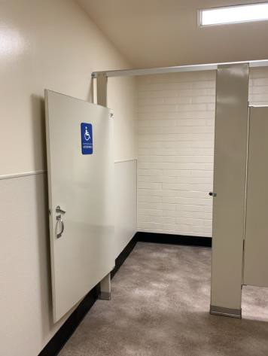

 | ID:  2751 | Facility:  Fort Boise Community Center

Location: Women’s Restroom
Schedule: 2021
Estimated Cost: $100.00

Priority Score 5
Quick Fix: Yes
Built before ADA: Yes

VIOLATIONS
2010 ADA Standards for Accessible Design Codes: §604.7
The toilet paper dispenser is located out of the accessible reach range.

RECOMMENDATIONS
Remount the toilet paper dispenser to 7” minimum and 9” maximum in front of the water closet measured to the centerline of the dispenser.
The outlet of the dispenser shall be 15” minimum and 48” maximum above the floor and shall not be located behind.

PHOTOGRAPH(S) OF THIS LOCATION

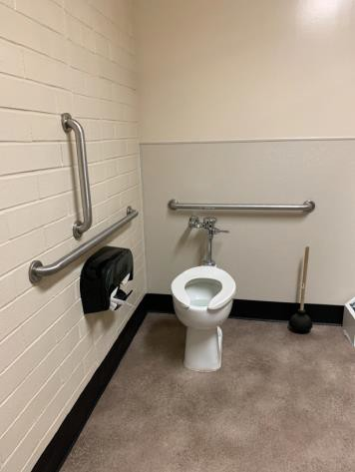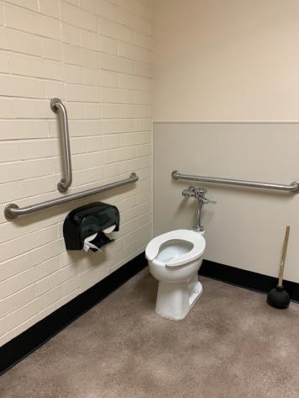

 | ID:  2753 | Facility:  Fort Boise Community Center

Location: Women’s Restroom
Schedule: 2021
Estimated Cost: $100.00

Priority Score 5
Quick Fix: Yes
Built before ADA: Yes

VIOLATIONS
2010 ADA Standards for Accessible Design Codes: §307.2
The paper towel dispenser protrudes 8" into the circulation space at 35.5" above the floor.

RECOMMENDATIONS
Recess the paper towel dispenser so it protrudes a maximum of 4" or place a cane detectable object beneath it.

PHOTOGRAPH(S) OF THIS LOCATION

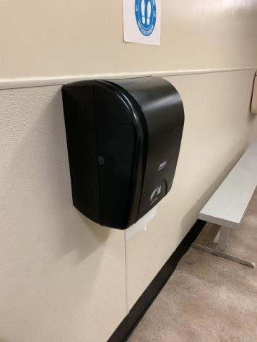

 | ID:  2752 | Facility:  Fort Boise Community Center

Location: Women’s Restroom
Schedule: 2021
Estimated Cost: $200.00

Priority Score 5
Quick Fix: Yes
Built before ADA: Yes

VIOLATIONS
2010 ADA Standards for Accessible Design Codes: §307.2, §308.2.1
The paper towel dispensers protrude 8" into the circulation space at 53.5" and 57.5" above the floor.
The paper towel dispensers are outside of the unobstructed forward reach range at 53.5" and 57.5" above the floor.

RECOMMENDATIONS
Recess the paper towel dispensers so they protrude a maximum of 4" or place a cane detectable object beneath them.
Lower the paper towel dispensers by 5.5" and 9.5" to meet the accessible reach range of 15" minimum and 48" maximum above the floor.

PHOTOGRAPH(S) OF THIS LOCATION

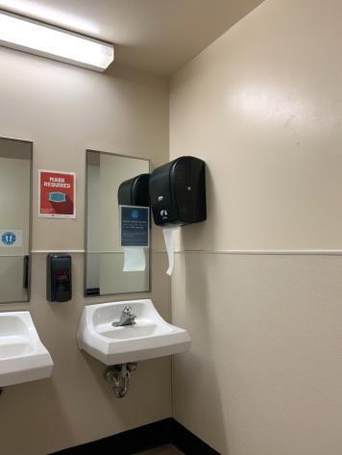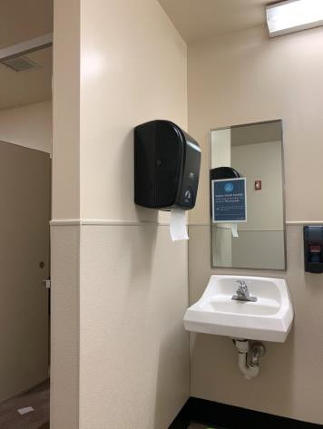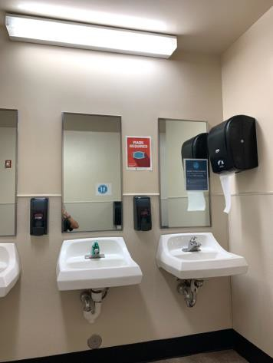

 | ID:  2747 | Facility:  Fort Boise Community Center

Location: Women’s Restroom
Schedule: 2021
Estimated Cost: $500.00

Priority Score 5
Quick Fix: Yes
Built before ADA: Yes

VIOLATIONS
2010 ADA Standards for Accessible Design Codes: §604.5.2
The rear grab bar is located 8" to the center of the toilet.

RECOMMENDATIONS
Remount the rear grab bar to extend from the centerline of the water closet 12" minimum on one side and 24" minimum on the other.

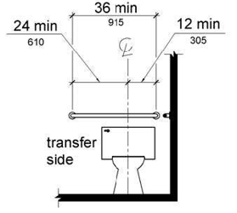

PHOTOGRAPH(S) OF THIS LOCATION

 | ID:  2750 | Facility:  Fort Boise Community Center

Location: Women’s Restroom
Schedule: 2022
Estimated Cost: $1,000.00

Priority Score 5
Quick Fix: No
Built before ADA: Yes

VIOLATIONS
2010 ADA Standards for Accessible Design Codes: §604.2
The toilet is located 20" from the sidewall.

RECOMMENDATIONS
Reposition the toilet to be within 16" minimum and 18" maximum from the sidewall.

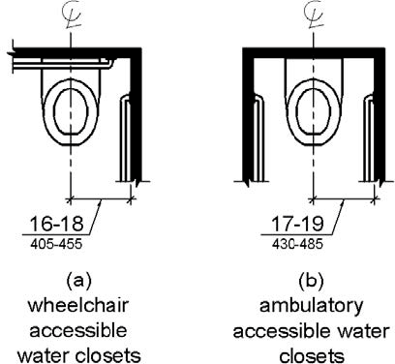

PHOTOGRAPH(S) OF THIS LOCATION

