City of Boise ADA Assessment

Appendix A –Foothills Learning Center

12/30/2020
Report #TO20-B009

Prepared by:
 | ID:  1698 | Facility:  Foothills Learning Center

Location: Learning Center
Schedule: 2021
Estimated Cost: $100.00

Priority Score 5
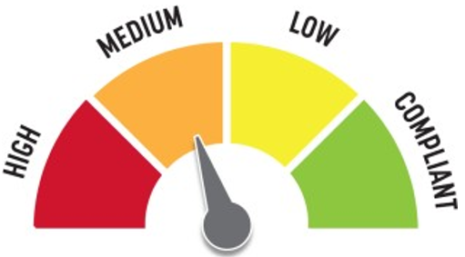
Quick Fix: Yes
Built before ADA: No

VIOLATIONS
2010 ADA Standards for Accessible Design Codes §307.2
The AED protrudes 6" into the circulation space at 27.75" above the floor.

RECOMMENDATIONS
Recess the AED so it protrudes a maximum of 4", lower it so the bottom edge is 27" maximum above the floor, or place a cane detectable object beneath it.

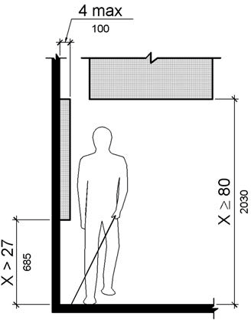

PHOTOGRAPH(S) OF THIS LOCATION

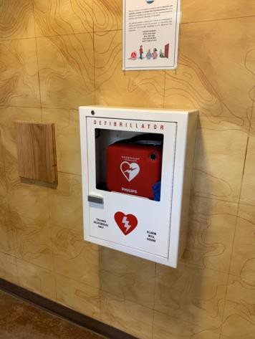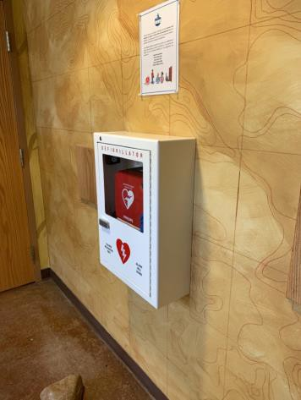

 | ID:  2 | Facility:  Foothills Learning Center

Location: Learning Center
Schedule: 2021
Estimated Cost: $500.00

Priority Score 0
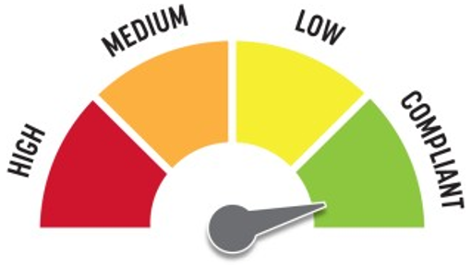
Quick Fix: Yes
Built before ADA: No

VIOLATIONS
2010 ADA Standards for Accessible Design Codes §305.2
The clear floor space in front of the exit button is 24" deep.

RECOMMENDATIONS
For the purposes of achieving greater accessibility and Human Centric Design, relocate the exit button closer to the door.

PHOTOGRAPH(S) OF THIS LOCATION

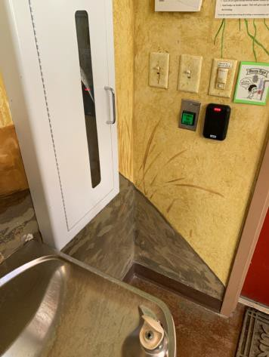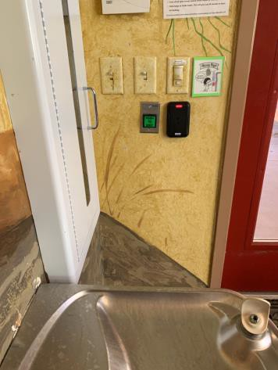

 | ID:  1700 | Facility:  Foothills Learning Center

Location: Learning Center
Schedule: 2022
Estimated Cost: $1,000.00

Priority Score 6
Quick Fix: No
Built before ADA: No

VIOLATIONS
2010 ADA Standards for Accessible Design Codes §211.2, §602.7
There is only one drinking fountain provided at 32" above the floor.

RECOMMENDATIONS
Install an additional drinking fountain at a minimum spout height of 38" and maximum of 43" above the floor.

PHOTOGRAPH(S) OF THIS LOCATION

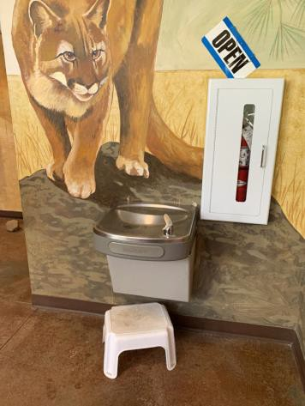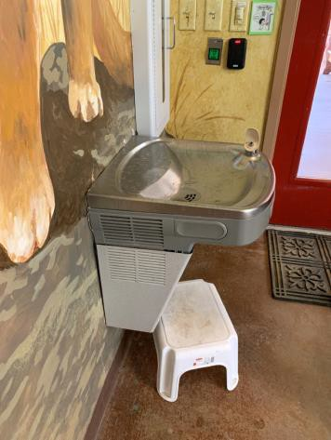

 | ID:  1685 | Facility:  Foothills Learning Center

Location: Learning Center Left Classroom
Schedule: 2021
Estimated Cost: $100.00

8

Priority Score 8
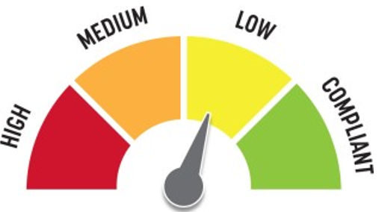
Quick Fix: Yes
Built before ADA: No

VIOLATIONS
2010 ADA Standards for Accessible Design Codes §308.2.1
The paper towel dispenser is outside of the unobstructed forward reach range at 52" above the floor.

RECOMMENDATIONS
Lower the paper towel dispenser by 4" to meet the accessible reach range of 15" minimum and 48" maximum above the floor.

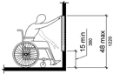

PHOTOGRAPH(S) OF THIS LOCATION

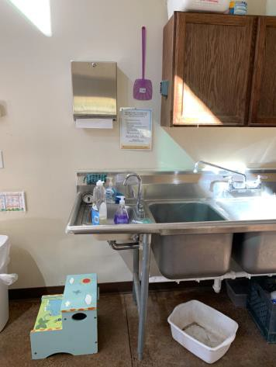

 | ID:  1691 | Facility:  Foothills Learning Center

Location: Learning Center Men’s Restroom
Schedule: 2021
Estimated Cost: $100.00

Priority Score 8
Quick Fix: Yes
Built before ADA: No

VIOLATIONS
2010 ADA Standards for Accessible Design Codes §308.2.1
The hook is outside of the unobstructed forward reach range at 49" above the floor.

RECOMMENDATIONS
Lower the hook by 1" to meet the accessible reach range of 48" maximum above the floor.

PHOTOGRAPH(S) OF THIS LOCATION

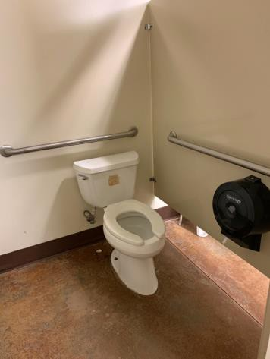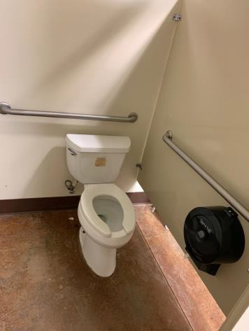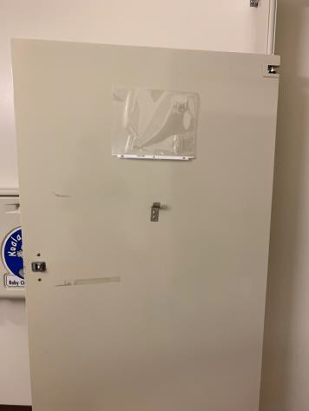

 | ID:  1692 | Facility:  Foothills Learning Center

Location: Learning Center Men’s Restroom
Schedule: 2021
Estimated Cost: $100.00

Priority Score 3
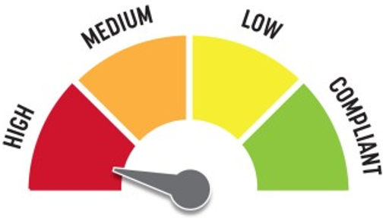
Quick Fix: Yes
Built before ADA: No

VIOLATIONS
2010 ADA Standards for Accessible Design Codes §216.2, §703
There is no tactile sign identifying the permanent room.

RECOMMENDATIONS
Install tactile signage on the latch side of the doorway at a height of 48” minimum to 60” maximum above the floor, identifying room by name or room number.
Signs shall be Braille with raised lettering and should be placed on the wall in the center of an 18"x18" clear floor space.

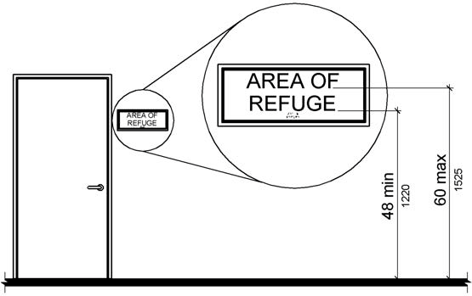

PHOTOGRAPH(S) OF THIS LOCATION

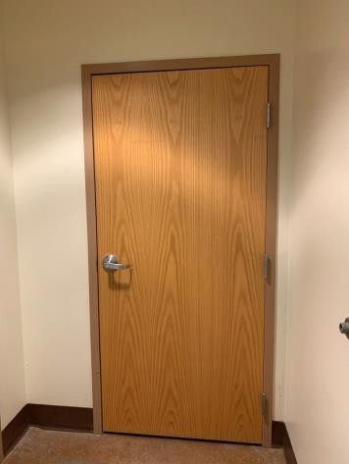

 | ID:  1688 | Facility:  Foothills Learning Center

Location: Learning Center Men’s Restroom
Schedule: 2022
Estimated Cost: $500.00

Priority Score 5
Quick Fix: Yes
Built before ADA: No

VIOLATIONS
2010 ADA Standards for Accessible Design Codes §604.5.2
The rear grab bar is 37" long and located 11" to the center of the toilet.

RECOMMENDATIONS
Relocate the rear grab bar so it extends from the centerline of the water closet 12" minimum on one side and 24" minimum on the other.

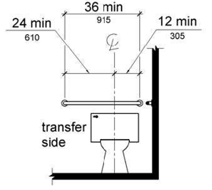

PHOTOGRAPH(S) OF THIS LOCATION

 | ID:  1689 | Facility:  Foothills Learning Center

Location: Learning Center Men’s Restroom
Schedule: 2022
Estimated Cost: $1,000.00

Priority Score 5
Quick Fix: No
Built before ADA: No

VIOLATIONS
2010 ADA Standards for Accessible Design Codes ICC A117.1 §604.5.1
The accessible water closet does not have a vertical grab bar.

RECOMMENDATIONS
Install an 18" long (minimum) vertical grab bar on the side wall. The grab bar shall be mounted with the bottom located at 39" minimum and 41" maximum above the floor.
The centerline of the vertical grab bar shall be located 39" minimum and 41" maximum from the real wall.

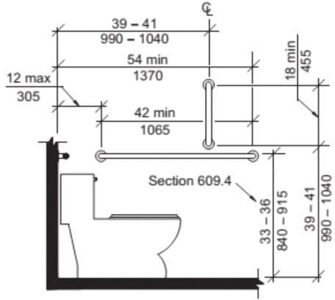

PHOTOGRAPH(S) OF THIS LOCATION

 | ID:  1683 | Facility:  Foothills Learning Center

Location: Learning Center Right Classroom
Schedule: 2021
Estimated Cost: $100.00

Priority Score 5
Quick Fix: Yes
Built before ADA: No

VIOLATIONS
2010 ADA Standards for Accessible Design Codes §307.2
The higher basket protrudes 4.75" into the circulation space.

RECOMMENDATIONS
Remount the lower basket directly underneath the higher basket to provide cane detectability.

PHOTOGRAPH(S) OF THIS LOCATION

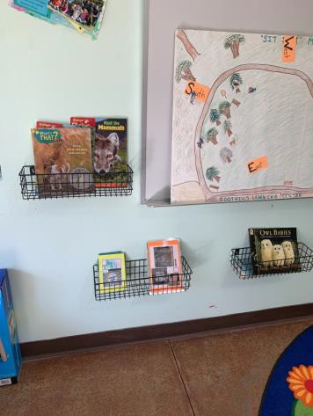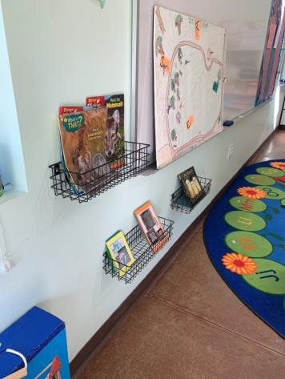

 | ID:  1682 | Facility:  Foothills Learning Center

Location: Learning Center Right Classroom
Schedule: 2021
Estimated Cost: $500.00

Priority Score 5
Quick Fix: Yes
Built before ADA: No

VIOLATIONS
2010 ADA Standards for Accessible Design Codes §403.5.1
The space between the two tables is 30" wide, making the route inaccessible.

RECOMMENDATIONS
Move the tables to widen the route to 36" wide minimum.

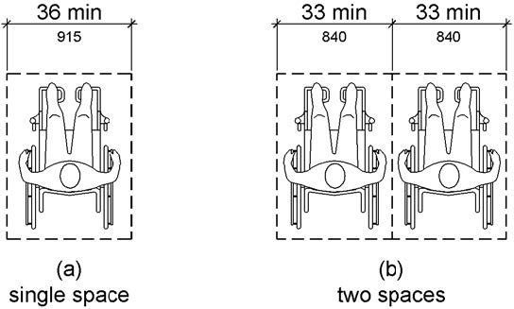

PHOTOGRAPH(S) OF THIS LOCATION

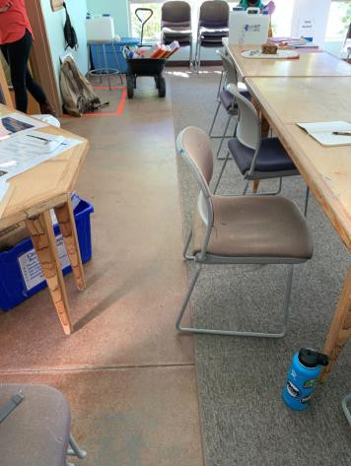

 | ID:  1693 | Facility:  Foothills Learning Center

Location: Learning Center Women’s Restroom
Schedule: 2021
Estimated Cost: $100.00

Priority Score 5
Quick Fix: Yes
Built before ADA: No

VIOLATIONS
2010 ADA Standards for Accessible Design Codes §604.8.1.2
The door to the accessible water closet is not self closing. Either self-closing hinges are not installed on the door or if installed, they are defective.

RECOMMENDATIONS
Install or reinstall self-closing hinges on the door to ensure that the door is self-closing per the ADA requirements.

PHOTOGRAPH(S) OF THIS LOCATION

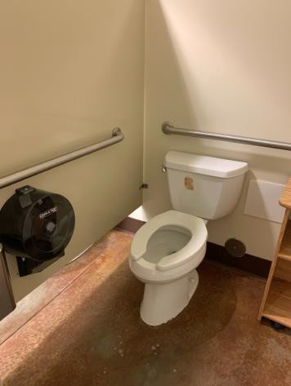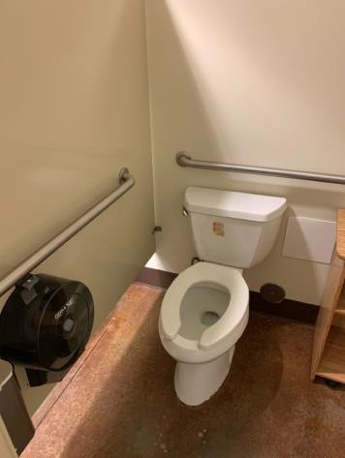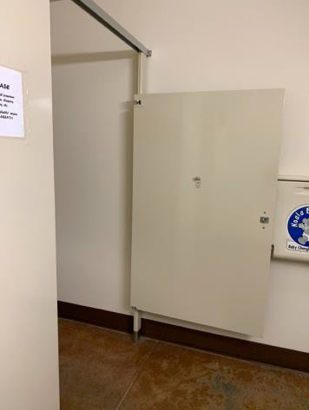

 | ID:  1697 | Facility:  Foothills Learning Center

Location: Learning Center Women’s Restroom
Schedule: 2021
Estimated Cost: $100.00

Priority Score 8
Quick Fix: Yes
Built before ADA: No

VIOLATIONS
2010 ADA Standards for Accessible Design Codes §308.2.1
The hook is outside of the unobstructed forward reach range at 49" above the floor.

RECOMMENDATIONS
Lower the hook by 1" to meet the accessible reach range of 48" maximum above the floor.

PHOTOGRAPH(S) OF THIS LOCATION

 | ID: | Facility:  Foothills Learning Center

Location: Learning Center Women’s Restroom
Schedule: 2021
Estimated Cost: $500.00

Priority Score 5
Quick Fix: Yes
Built before ADA: No

VIOLATIONS
2010 ADA Standards for Accessible Design Codes §604.5.2
The rear grab bar is 38" long and located 11" to the center of the toilet.

RECOMMENDATIONS
Relocate the rear grab bar so it extends from the centerline of the water closet 12" minimum on one side and 24" minimum on the other.

PHOTOGRAPH(S) OF THIS LOCATION

 | ID:  1695 | Facility:  Foothills Learning Center

Location: Learning Center Women’s Restroom
Schedule: 2022
Estimated Cost: $1,000.00

Priority Score 5
Quick Fix: No
Built before ADA: No

VIOLATIONS
2010 ADA Standards for Accessible Design Codes ICC A117.1 §604.5.1
The accessible water closet does not have a vertical grab bar.

RECOMMENDATIONS
Install an 18" long (minimum) vertical grab bar on the side wall. The grab bar shall be mounted with the bottom located at 39" minimum and 41" maximum above the floor.
The centerline of the vertical grab bar shall be located 39" minimum and 41" maximum from the real wall.

PHOTOGRAPH(S) OF THIS LOCATION

 | ID: | Facility:  Foothills Learning Center

Location: Office Building
Schedule: 2021
Estimated Cost: $100.00

Priority Score 8
Quick Fix: Yes
Built before ADA: No

VIOLATIONS
2010 ADA Standards for Accessible Design Codes §308.2.2
The paper towel dispenser is outside of the obstructed forward reach range at 54.25" above the floor.

RECOMMENDATIONS
Lower the paper towel dispenser by 10.25" to meet the accessible reach range of 44" maximum above the floor.

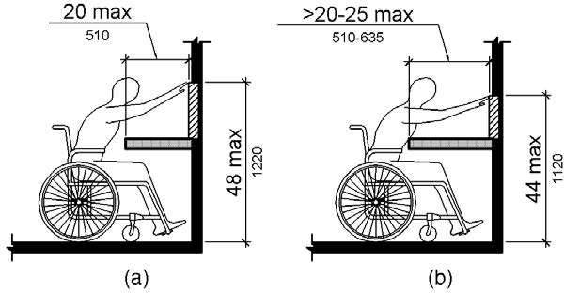

PHOTOGRAPH(S) OF THIS LOCATION

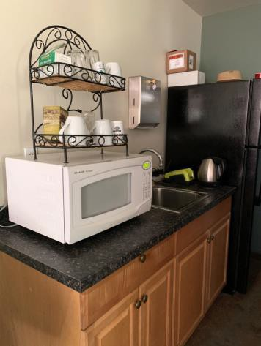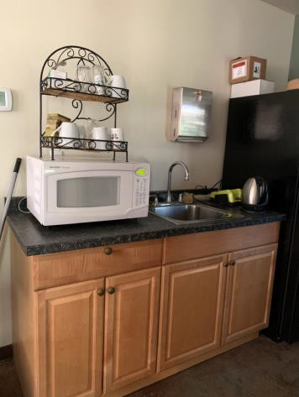

 | ID:  1701 | Facility:  Foothills Learning Center

Location: Office Building
Schedule: 2021
Estimated Cost: $100.00

Priority Score 5
Quick Fix: Yes
Built before ADA: No

VIOLATIONS
2010 ADA Standards for Accessible Design Codes §307.2
The first aid box protrudes 5.75" into the circulation space at 44" above the floor.

RECOMMENDATIONS
Recess the first aid box so it protrudes a maximum of 4", lower it so the bottom edge is 27" maximum above the floor, or place a cane detectable object beneath it.

PHOTOGRAPH(S) OF THIS LOCATION

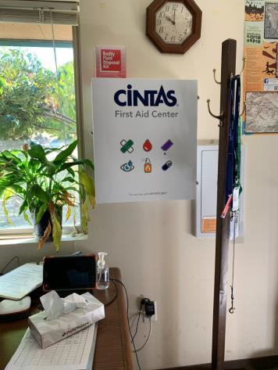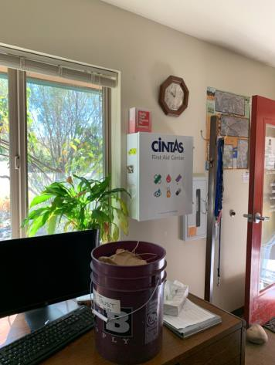

 | ID:  1702 | Facility:  Foothills Learning Center

Location: Office Building
Schedule: 2021
Estimated Cost: $300.00

Priority Score 3
Quick Fix: Yes
Built before ADA: No

VIOLATIONS
2010 ADA Standards for Accessible Design Codes §216.2, §703
There are no tactile signs identifying the permanent rooms.

RECOMMENDATIONS
Install tactile signage on the latch side of the doorway at a height of 48” minimum to 60” maximum above the floor, identifying room by name or room number.
Signs shall be Braille with raised lettering and should be placed on the wall in the center of an 18"x18" clear floor space.

PHOTOGRAPH(S) OF THIS LOCATION

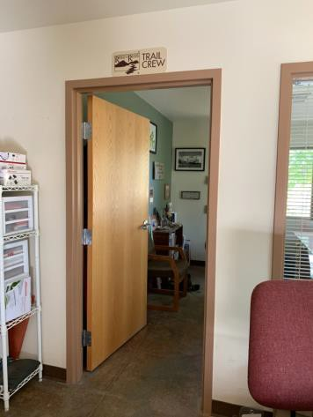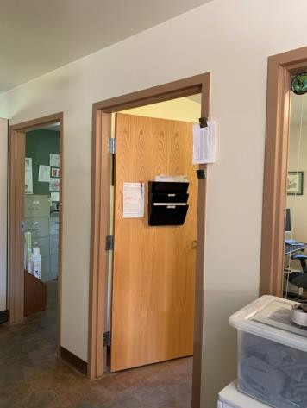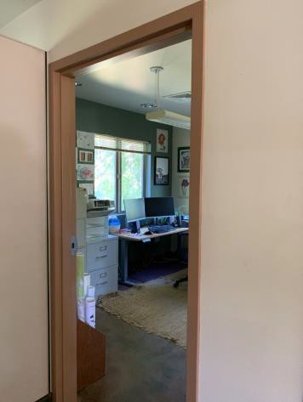

 | ID:  1686 | Facility:  Foothills Learning Center

Location: Office Building
Schedule: 2023
Estimated Cost: $1,000.00

Priority Score 8
Quick Fix: No
Built before ADA: No

VIOLATIONS
2010 ADA Standards for Accessible Design Codes §306.3, §902.3
The dining and work surface counter and sink are 36.25" above the floor.

RECOMMENDATIONS
A 30" long portion of the dining and work surface must be no higher than 34” above the floor.
Provide knee clearance that is a minimum of 11" deep at 9" above the floor and 8" deep.

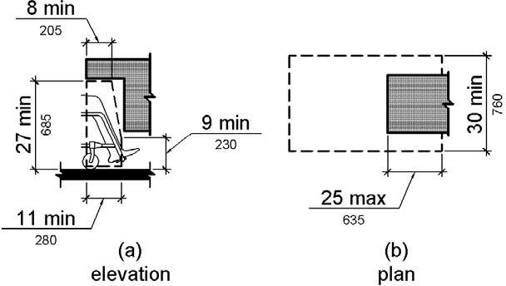

PHOTOGRAPH(S) OF THIS LOCATION

 | ID:  1681 | Facility:  Foothills Learning Center

Location: Outdoor Program Area
Schedule: 2021
Estimated Cost: $20,000.00

Priority Score 3
Quick Fix: No
Built before ADA: No

VIOLATIONS
2010 ADA Standards for Accessible Design Codes §403.3, §302.1, §305
There is not a firm, stable, and slip resistant route to three picnic tables, three benches, a garbage can, and the nature play area.
The outdoor program area path near the garden has a 12.6% running slope.

RECOMMENDATIONS
Construct a firm, stable, and slip resistant accessible route with a maximum cross slope of 2% and maximum running slope of 5%. At least one accessible route shall connect the learning center with all accessible spaces and elements.
Reconstruct the route to reduce the running slope to a maximum of 5%. Ensure that the cross slope is a maximum of 2%.

PHOTOGRAPH(S) OF THIS LOCATION

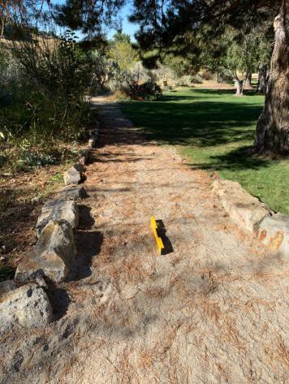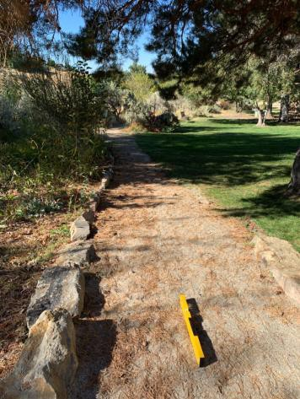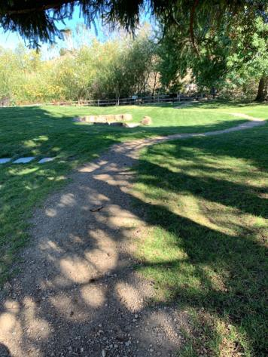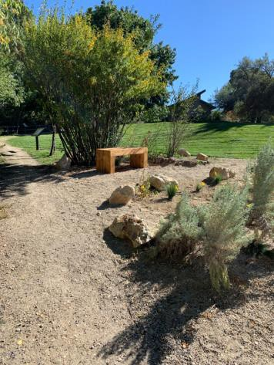

 | ID:  1673 | Facility:  Foothills Learning Center

Location: Parking
Schedule: 2021
Estimated Cost: $2,000.00

Priority Score 3
Quick Fix: No
Built before ADA: No

VIOLATIONS
2010 ADA Standards for Accessible Design Codes §208.2
There are no accessible parking spaces as the current space is made of gravel.

RECOMMENDATIONS
Install an accessible parking space that is a minimum of 132" wide. Ensure the ground surface is stable, firm, and slip resistant.
Install a 60" wide access aisle connecting to an accessible route. Install a sign 60" above the ground.

PHOTOGRAPH(S) OF THIS LOCATION

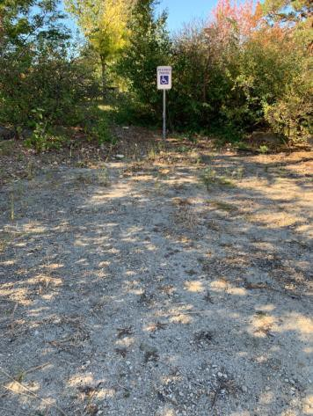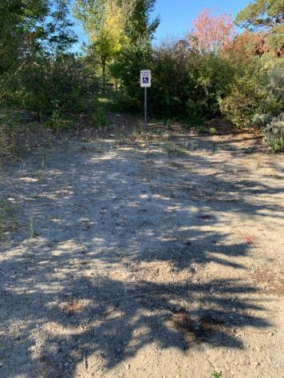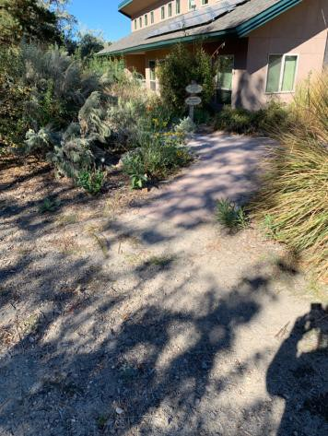

 | ID:  1676 | Facility:  Foothills Learning Center

Location: Picnic Table at the Front of the Learning Center
Schedule: 2021
Estimated Cost: $5,000.00

Priority Score 3
Quick Fix: No
Built before ADA: No

VIOLATIONS
2010 ADA Standards for Accessible Design Codes §302.1, §305
There is not a firm, stable, and slip resistant route to the picnic tables and garbage can.

RECOMMENDATIONS
Construct a firm, stable, and slip resistant accessible route with maximum cross and running slopes of 2% and 5% respectively.
Install an accessible picnic table at a minimum height of 28" and maximum of 34". Provide knee clearance that is a minimum of 11" deep at 9" above the floor and 8" deep.

PHOTOGRAPH(S) OF THIS LOCATION

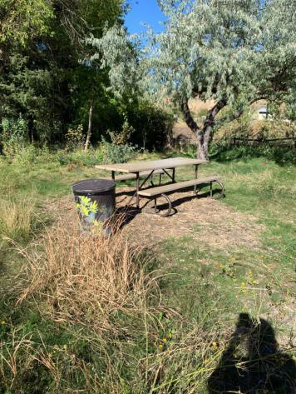

 | ID:  1713 | Facility:  Foothills Learning Center

Location: Trail Maintenance
Schedule: 2021
Estimated Cost: $200.00

Priority Score 7
Quick Fix: Yes
Built before ADA: No

VIOLATIONS
2010 ADA Standards for Accessible Design Codes , §309.4, §216.2, §703
The door knob requires twisting of the wrist. There is no tactile sign identifying the permanent room.

RECOMMENDATIONS
Replace the door knob with a lever handle that can be operated with a closed fist and without twisting the wrist.
Install tactile signage on the latch side of the doorway at a height of 48” minimum to 60” maximum above the floor, identifying room by name or room number.

PHOTOGRAPH(S) OF THIS LOCATION

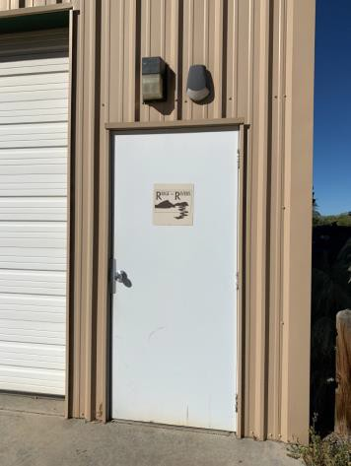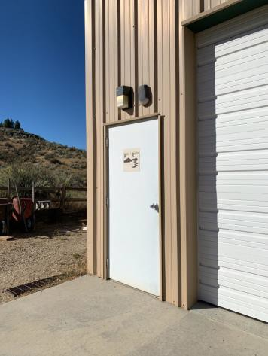

 | ID:  1712 | Facility:  Foothills Learning Center

Location: Trail Maintenance Restroom
Schedule: 2022
Estimated Cost: $100.00

Priority Score 7
Quick Fix: Yes
Built before ADA: No

VIOLATIONS
2010 ADA Standards for Accessible Design Codes §603.3
The mirror is too high to be accessible at 42" above the floor.

RECOMMENDATIONS
Lower the mirror its bottom edge is a maximum height of 40" above the floor.

PHOTOGRAPH(S) OF THIS LOCATION

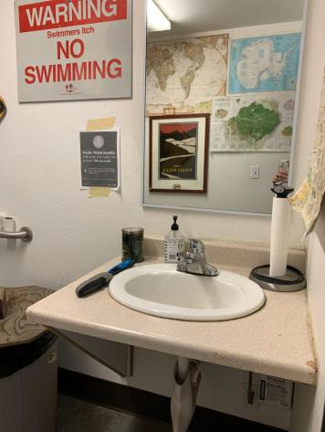

 | ID:  1709 | Facility:  Foothills Learning Center

Location: Trail Maintenance Restroom
Schedule: 2021
Estimated Cost: $100.00

Priority Score 5
Quick Fix: Yes
Built before ADA: No

VIOLATIONS
2010 ADA Standards for Accessible Design Codes §604.8.1.2
The door to the accessible water closet is not self closing. Either self-closing hinges are not installed on the door or if installed, they are defective.

RECOMMENDATIONS
Install or reinstall self-closing hinges on the door to ensure that the door is self-closing per the ADA requirements.

PHOTOGRAPH(S) OF THIS LOCATION

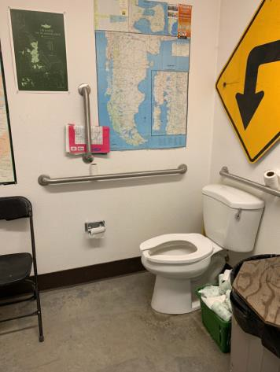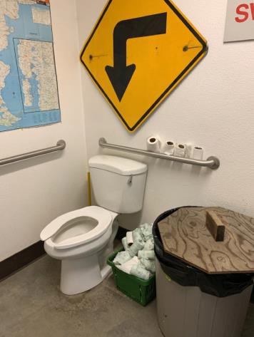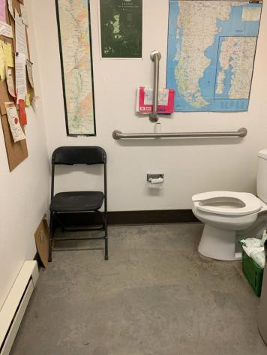

 | ID:  1707 | Facility:  Foothills Learning Center

Location: Trail Maintenance Restroom
Schedule: 2021
Estimated Cost: $500.00

Priority Score 5
Quick Fix: Yes
Built before ADA: No

VIOLATIONS
2010 ADA Standards for Accessible Design Codes §604.5.1
The side grab bar is located 10" from the rear wall.

RECOMMENDATIONS
Remount the side grab bar 12" maximum from the rear wall and extending 54" minimum from the rear wall.

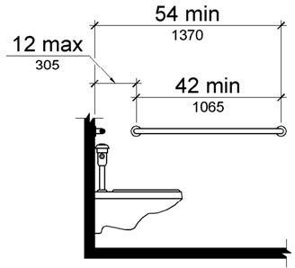

PHOTOGRAPH(S) OF THIS LOCATION

