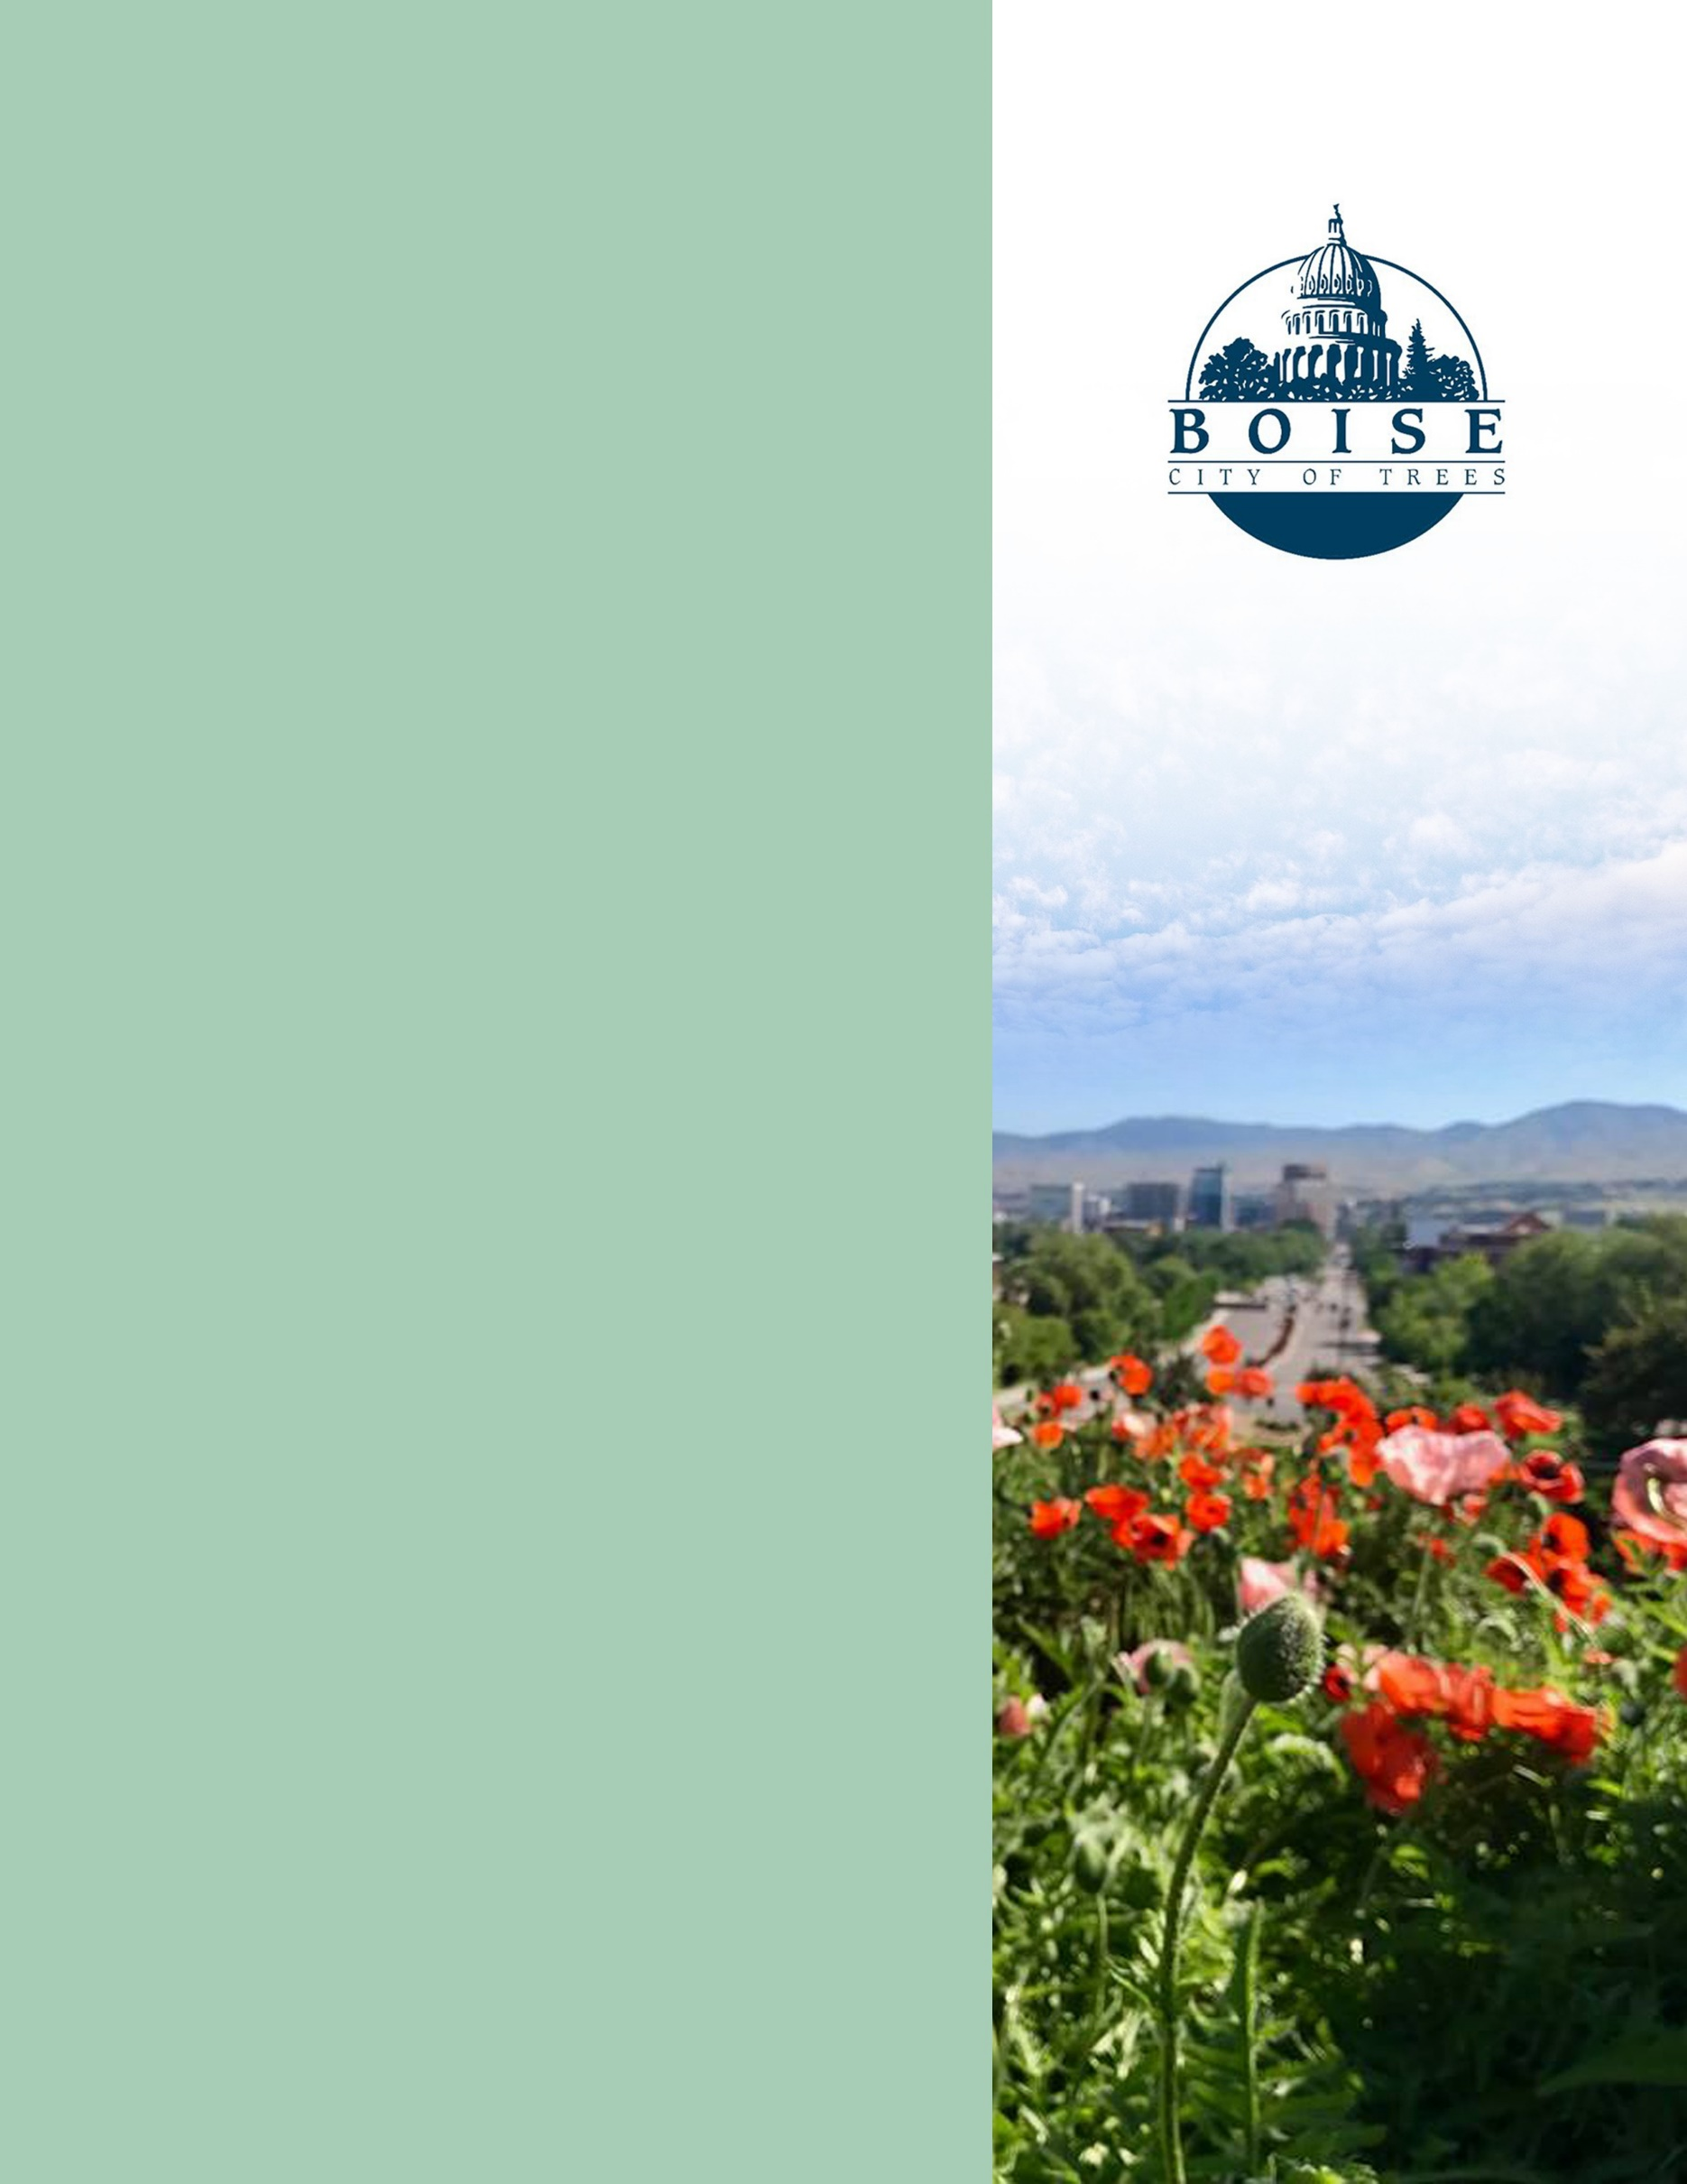

City of Boise ADA Assessment

Appendix A –Watershed Treatment Plant

05/05/2021
Report #TO21-B026

Prepared by:
 | ID:  1746 | Facility:  Boise Watershed Treatment Plant

Location: Administration Break Room
Schedule: 2021
Estimated Cost: $100.00

Priority Score 8
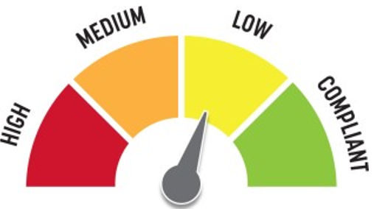
Quick Fix: No
Built before ADA: No

VIOLATIONS
2010 ADA Standards for Accessible Design Codes §308.2.1
The paper towel dispenser is outside of the obstructed forward reach range at 58" above the floor.

RECOMMENDATIONS
Lower the paper towel dispenser by 10" to meet the accessible reach range of 48" maximum above the floor.

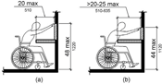

PHOTOGRAPH(S) OF THIS LOCATION
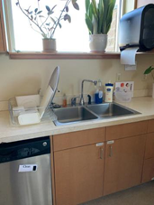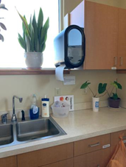

 | ID:  1744 | Facility:  Boise Watershed Treatment Plant

Location: Administration Break Room
Schedule: 2022
Estimated Cost: $1,000.00

Priority Score 5
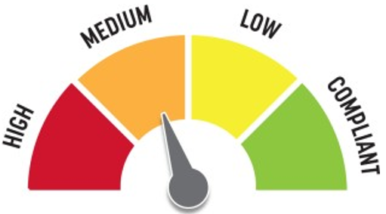Quick Fix: No
Built before ADA: No

VIOLATIONS
2010 ADA Standards for Accessible Design Codes §902.3, §306.3.3
There is no knee clearance underneath the sink.
The dining and work surface counter is 34.75" above the floor.

RECOMMENDATIONS
Provide knee clearance underneath the counter at the sink that is a minimum of 11" deep at 9" above the floor and 8" deep at 27" above the floor.
A portion of the dining and work surface must be no higher than 34" above the floor.

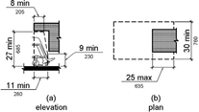

PHOTOGRAPH(S) OF THIS LOCATION

 | ID:  1747 | Facility:  Boise Watershed Treatment Plant

Location: Administration Break Room
Schedule: 2023
Estimated Cost: $3,000.00

Priority Score 8
Quick Fix: No
Built before ADA: No

VIOLATIONS
2010 ADA Standards for Accessible Design Codes §308.2.1
The vending machine controls are outside of the unobstructed forward reach at 60.5" above the floor.

RECOMMENDATIONS
Lower the vending machine controls by 12.5" to meet the accessible reach range of 15" minimum and 48" maximum above the floor.
This may require replacing the vending machine

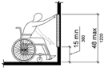

PHOTOGRAPH(S) OF THIS LOCATION
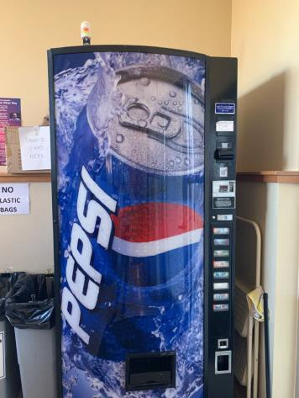

 | ID:  1748 | Facility:  Boise Watershed Treatment Plant

Location: Administration Conference Room
Schedule: 2021
Estimated Cost: $100.00

Priority Score 5
Quick Fix: Yes
Built before ADA: No

VIOLATIONS
2010 ADA Standards for Accessible Design Codes §307.2
The TV protrudes 5.5" into the circulation space at 74" above the floor.

RECOMMENDATIONS
Recess the TV so it protrudes a maximum of 4", raise it so the bottom edge is 80" maximum above the floor, or place a cane detectable object beneath it.

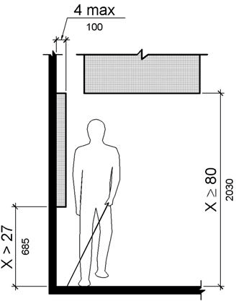

PHOTOGRAPH(S) OF THIS LOCATION
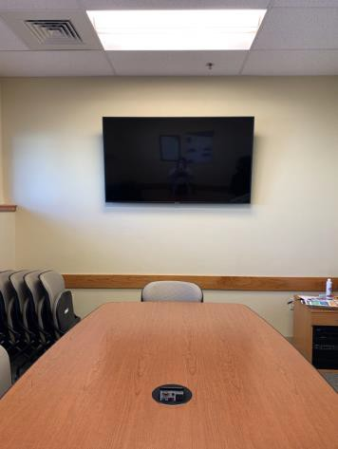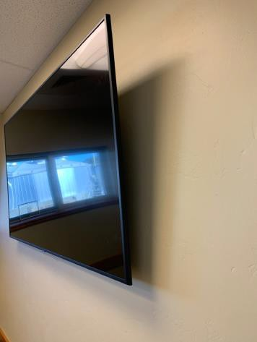
 | ID:  1739 | Facility:  Boise Watershed Treatment Plant

Location: Administration Restroom
Schedule: 2021
Estimated Cost: $100.00

Priority Score 8
Quick Fix: Yes
Built before ADA: No

VIOLATIONS
2010 ADA Standards for Accessible Design Codes §308.2.1
The toilet seat covers are outside of the obstructed forward reach range at 59" above the floor.

RECOMMENDATIONS
Lower the toilet seat covers container by 11" to meet the accessible reach range of 48" maximum above the floor and ensure it is at least 12" above the rear grab bar.

PHOTOGRAPH(S) OF THIS LOCATION
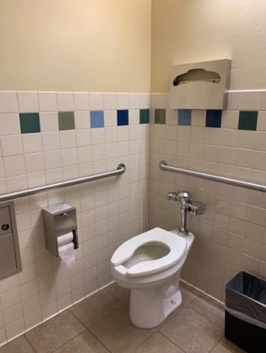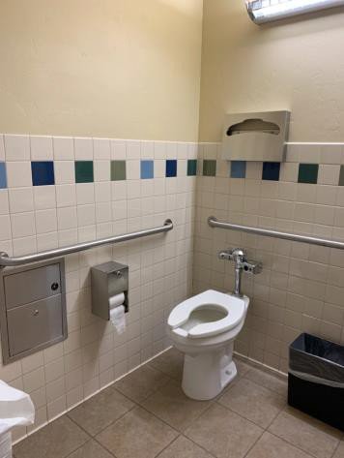
 | ID:  1741 | Facility:  Boise Watershed Treatment Plant

Location: Administration Restroom
Schedule: 2021
Estimated Cost: $100.00

Priority Score 7
Quick Fix: Yes
Built before ADA: No

VIOLATIONS
2010 ADA Standards for Accessible Design Codes §603.3
The mirror is too high to be accessible at 51" above the floor.

RECOMMENDATIONS
Lower the mirror so its bottom edge is a maximum height of 40" above the floor.

PHOTOGRAPH(S) OF THIS LOCATION
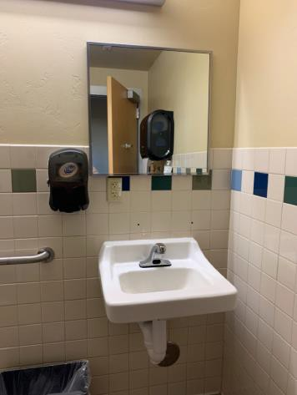
 | ID:  1742 | Facility:  Boise Watershed Treatment Plant

Location: Administration Restroom
Schedule: 2021
Estimated Cost: $100.00

Priority Score 8
Quick Fix: Yes
Built before ADA: No

VIOLATIONS
2010 ADA Standards for Accessible Design Codes §308.2.1
The paper towel dispenser is outside of the unobstructed forward reach range at 54" above the floor.

RECOMMENDATIONS
Lower the paper towel dispenser by 6" to meet the accessible reach range of 48" maximum above the floor.
This will require moving the changing table or the paper towel dispenser to another location.

PHOTOGRAPH(S) OF THIS LOCATION
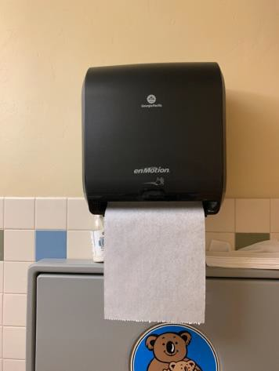
 | ID:  1749 | Facility:  Boise Watershed Treatment Plant

Location: Administration Restroom
Schedule: 2021
Estimated Cost: $100.00

Priority Score 5
Quick Fix: No
Built before ADA: No

VIOLATIONS
2010 ADA Standards for Accessible Design Codes §307.2
The first aid box protrudes 6.75" into the circulation space at 40.5" above the floor.

RECOMMENDATIONS
Recess the first aid box so it protrudes a maximum of 4" or place a cane detectable object beneath it.

PHOTOGRAPH(S) OF THIS LOCATION
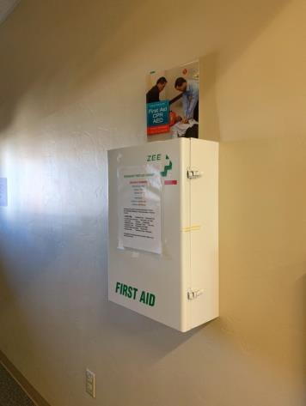

 | ID:  1738 | Facility:  Boise Watershed Treatment Plant

Location: Administration Restroom
Schedule: 2021
Estimated Cost: $500.00

Priority Score 5
Quick Fix: Yes
Built before ADA: No

VIOLATIONS
2010 ADA Standards for Accessible Design Codes §604.5.1
The side grab bar is located 11.5" from the rear wall.

RECOMMENDATIONS
Remount the side grab bar 12" maximum from the rear wall and extending 54" minimum from the rear wall.

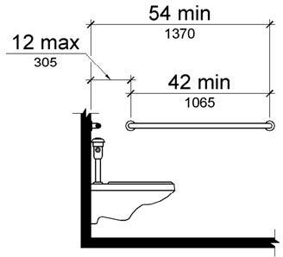

PHOTOGRAPH(S) OF THIS LOCATION
 | ID:  1736 | Facility:  Boise Watershed Treatment Plant

Location: Administration Restroom
Schedule: 2022
Estimated Cost: $1,000.00

Priority Score 5
Quick Fix: No
Built before ADA: No

VIOLATIONS
2010 ADA Standards for Accessible Design Codes ICC A1117.1 §604.5.1

RECOMMENDATIONS
Install an 18" long (minimum) vertical grab bar on the side wall. The grab bar shall be mounted with the bottom located at 39" minimum and 41" maximum above the floor.
The centerline of the vertical grab bar shall be located 39" minimum and 41" maximum from the rear wall.

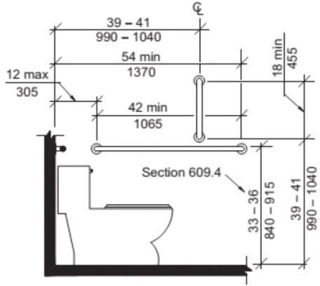

PHOTOGRAPH(S) OF THIS LOCATION

 | ID:  1751 | Facility:  Boise Watershed Treatment Plant

Location: Administration Restroom Closest to Exit
Schedule: 2021
Estimated Cost: $100.00

Priority Score 8
Quick Fix: Yes
Built before ADA: No

VIOLATIONS
2010 ADA Standards for Accessible Design Codes §308.2.1
The paper towel dispenser is outside of the unobstructed forward reach range at 54" above the floor.

RECOMMENDATIONS
Lower the paper towel dispenser by 6" to meet the accessible reach range of 48" maximum above the floor.
This will require moving the changing table or the paper towel dispenser to another location.

PHOTOGRAPH(S) OF THIS LOCATION
 | ID:  1753 | Facility:  Boise Watershed Treatment Plant

Location: Administration Restroom Closest to Exit
Schedule: 2021
Estimated Cost: $500.00

Priority Score 5
Quick Fix: Yes
Built before ADA: No

VIOLATIONS
2010 ADA Standards for Accessible Design Codes §604.5.1
The side grab bar is located 11.5" from the rear wall.

RECOMMENDATIONS
Remount the side grab bar 12" maximum from the rear wall and extending 54" minimum from the rear wall.

PHOTOGRAPH(S) OF THIS LOCATION
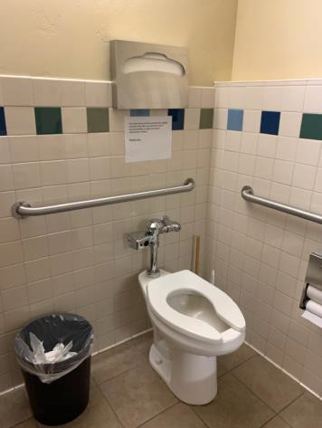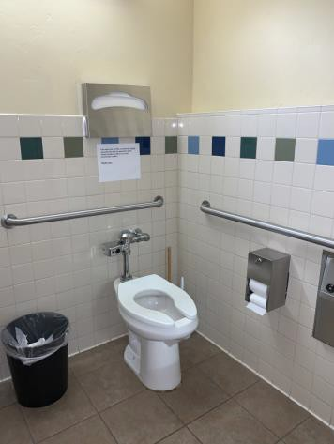
 | ID:  1752 | Facility:  Boise Watershed Treatment Plant

Location: Administration Restroom Closest to Exit
Schedule: 2022
Estimated Cost: $1,000.00

Priority Score 5
Quick Fix: No
Built before ADA: No

VIOLATIONS
2010 ADA Standards for Accessible Design Codes ICC A117 §604.5.1
The accessible water closet does not have a vertical grab bar.

RECOMMENDATIONS
Install an 18" long (minimum) vertical grab bar on the side wall. The grab bar shall be mounted with the bottom located at 39" minimum and 41" maximum above the floor.
The centerline of the vertical grab bar shall be located 39" minimum and 41" maximum from the rear wall.

PHOTOGRAPH(S) OF THIS LOCATION
 | ID:  1754 | Facility:  Boise Watershed Treatment Plant

Location: Administration Restroom Closest to Exit
Schedule: 2022
Estimated Cost: $1,000.00

Priority Score 5
Quick Fix: No
Built before ADA: No

VIOLATIONS
2010 ADA Standards for Accessible Design Codes §604.2
The centerline of the toilet is located 19" from the sidewall.

RECOMMENDATIONS
Reposition the centerline of the toilet to be within 16" minimum and 18" maximum from the sidewall.

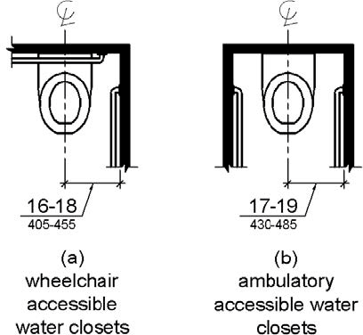

PHOTOGRAPH(S) OF THIS LOCATION
 | ID:  1836 | Facility:  Boise Watershed Treatment Plant

Location: Aeration Basins
Schedule: 2022
Estimated Cost: $1,000.00

Priority Score 5
Quick Fix: No
Built before ADA: No

VIOLATIONS
2010 ADA Standards for Accessible Design Codes §303.2
There is a 0.75" and 1" change in level.

RECOMMENDATIONS
Resurface the pathway to reduce the change in level to less than 0.25" or 0.5" if beveled.

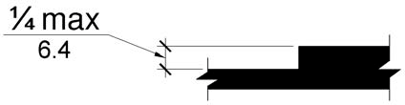

PHOTOGRAPH(S) OF THIS LOCATION
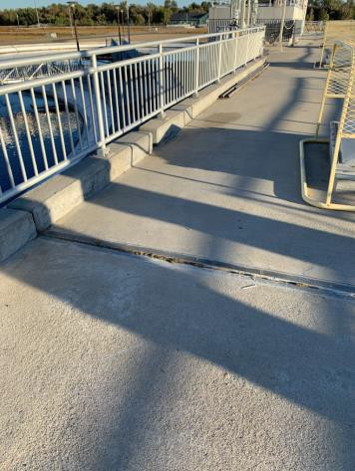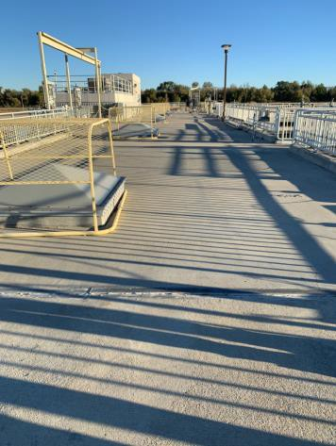
 | ID:  1837 | Facility:  Boise Watershed Treatment Plant

Location: Aeration Basins
Schedule: 2022
Estimated Cost: $10,000.00

Priority Score 6
Quick Fix: No
Built before ADA: No

VIOLATIONS
2010 ADA Standards for Accessible Design Codes §505.2, §405.2
Although this ramp is designed for vehicles, tours are led here to go to the Aeration Basins. The running slope of the ramp is 9.2%. There are no handrails.

RECOMMENDATIONS
Reconstruct the ramp to reduce the running slope to a maximum of 8.3% or consider allowing the patron's vehicle or an accessible golf cart traverse the ramp when needed.
Install handrails at a minimum height of 34” and maximum of 38” above the ground. Make sure there are adequate handrail extensions both at the top and bottom of the handrail.

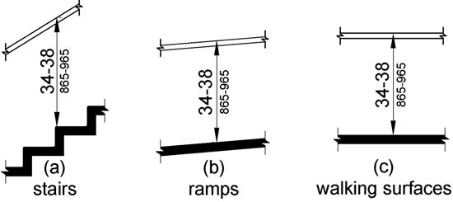

PHOTOGRAPH(S) OF THIS LOCATION
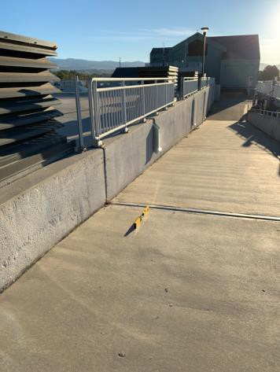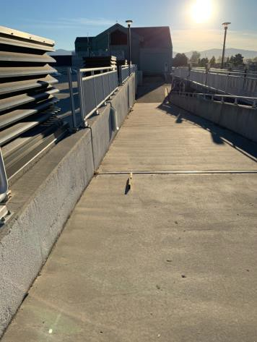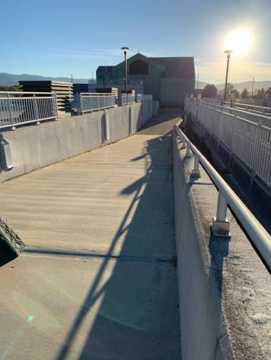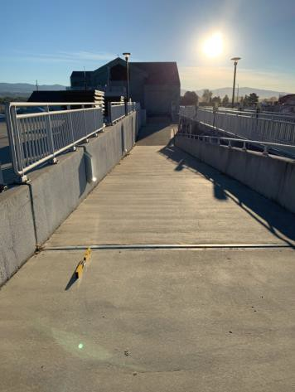

 | ID:  1731 | Facility:  Boise Watershed Treatment Plant

Location: Education Building
Schedule: 2021
Estimated Cost: $100.00

Priority Score 5
Quick Fix: Yes
Built before ADA: No

VIOLATIONS
2010 ADA Standards for Accessible Design Codes §307.2
The card scanner protrudes 8.5" into the circulation space at 38" above the floor.

RECOMMENDATIONS
Recess the card scanner so it protrudes a maximum of 4" or place a cane detectable object beneath it.

PHOTOGRAPH(S) OF THIS LOCATION
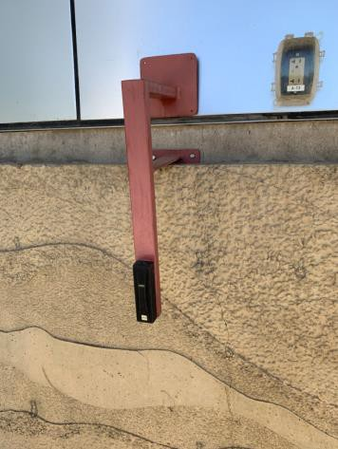

 | ID: | Facility:

Location:
Schedule:
Estimated Cost:

Priority Score 8
Quick Fix: Yes
Built before ADA: No

VIOLATIONS
2010 ADA Standards for Accessible Design Codes §308.2.1
The hooks are outside of the unobstructed forward reach range at 54" above the floor.

RECOMMENDATIONS
Lower at least one of the hooks by 6" to meet the accessible reach range of 48" maximum above the floor.

PHOTOGRAPH(S) OF THIS LOCATION
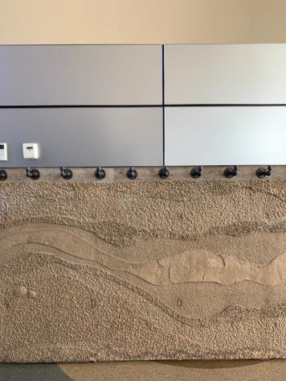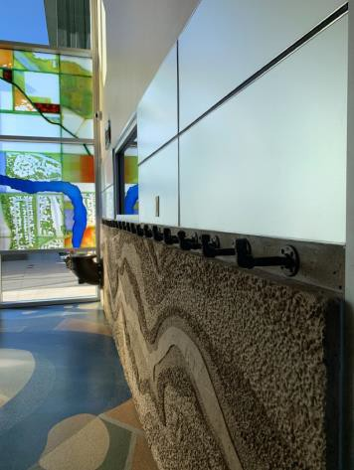
 | ID:  1783 | Facility:  Boise Watershed Treatment Plant

Location: Education Building
Schedule: 2021
Estimated Cost: $100.00

Priority Score 5
Quick Fix: Yes
Built before ADA: No

VIOLATIONS
2010 ADA Standards for Accessible Design Codes §307.2, §308.2.1
The AED is outside of the unobstructed forward reach range at 49" above the floor. The AED protrudes 6" into the circulation space at 49" above the floor.

RECOMMENDATIONS
Lower the AED by 1" to meet the accessible reach range of 48" maximum above the floor.
Recess the AED so it protrudes a maximum of 4" or place a cane detectable object beneath it.

PHOTOGRAPH(S) OF THIS LOCATION
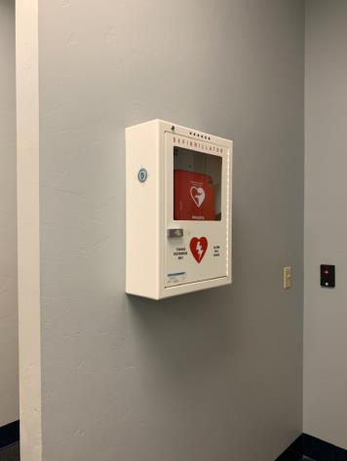
 | ID:  1784 | Facility:  Boise Watershed Treatment Plant

Location: Education Building
Schedule: 2022
Estimated Cost: $1,000.00

Priority Score 6
Quick Fix: No
Built before ADA: No

VIOLATIONS
2010 ADA Standards for Accessible Design Codes §602.7
The height of the tall drinking fountain is not compliant at 36.75" above the floor.

RECOMMENDATIONS
Raise the existing tall drinking fountain in order to comply with the 38" minimum to 43" maximum spout height above the floor.

PHOTOGRAPH(S) OF THIS LOCATION
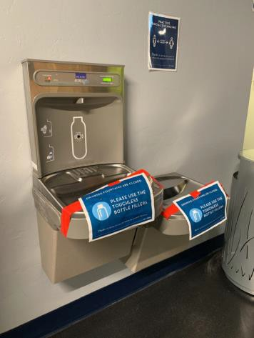
 | ID:  1760 | Facility:  Boise Watershed Treatment Plant

Location: Education Building
Schedule: 2023
Estimated Cost: $10,000.00

Priority Score 8
Quick Fix: No
Built before ADA: No

VIOLATIONS
2010 ADA Standards for Accessible Design Codes §707
The 15 interactive touch screens do not have any sound or tactile components.
Therefore, a visually impaired person would not be able to access the information provided by the kiosk.

RECOMMENDATIONS
Since a fully touch screen interface can never be made fully ADA compliant, either replace the unit with an accessible one or provide an alternative accessible version.

PHOTOGRAPH(S) OF THIS LOCATION
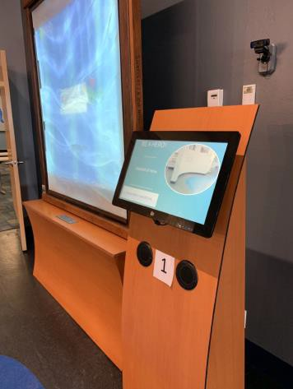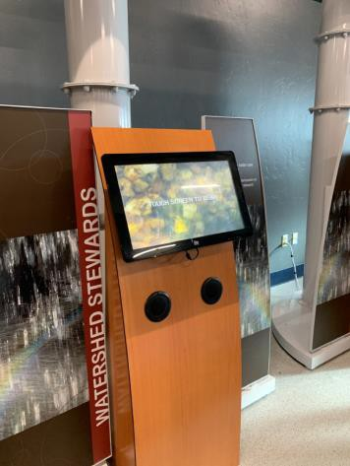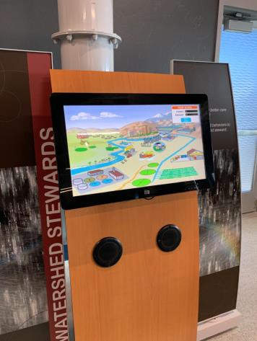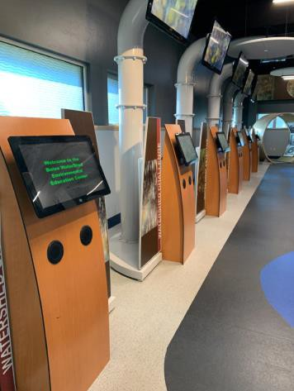
 | ID:  1764 | Facility:  Boise Watershed Treatment Plant

Location: Education Building Classroom
Schedule: 2021
Estimated Cost: $100.00

Priority Score 8
Quick Fix: Yes
Built before ADA: No

VIOLATIONS
2010 ADA Standards for Accessible Design Codes §308.2.1
The hand sanitizer dispenser is outside of the unobstructed forward reach range at 54" above the floor.

RECOMMENDATIONS
Lower the hand sanitizer dispenser by 6" to meet the accessible reach range of 48" maximum above the floor.

PHOTOGRAPH(S) OF THIS LOCATION
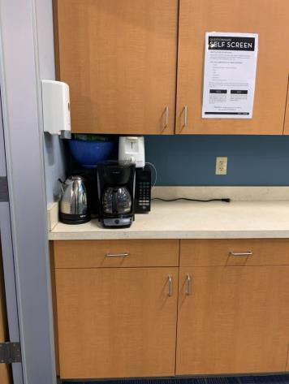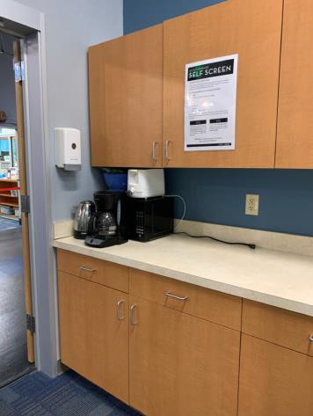
 | ID:  1766 | Facility:  Boise Watershed Treatment Plant

Location: Education Building Classroom
Schedule: 2021
Estimated Cost: $100.00

Priority Score 8
Quick Fix: Yes
Built before ADA: No

VIOLATIONS
2010 ADA Standards for Accessible Design Codes §308.2.1
The paper towel dispenser is outside of the unobstructed forward reach range at 56" above the floor.

RECOMMENDATIONS
Lower the paper towel dispenser by 8" to meet the accessible reach range of 48" maximum above the floor.

PHOTOGRAPH(S) OF THIS LOCATION
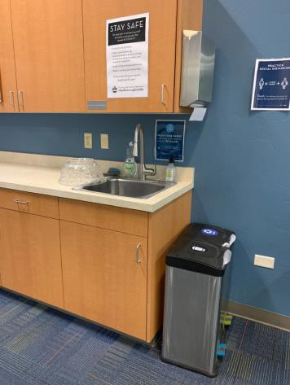

 | ID:  1763 | Facility:  Boise Watershed Treatment Plant

Location: Education Classroom Building
Schedule: 2022
Estimated Cost: $1,000.00

Priority Score 5
Quick Fix: No
Built before ADA: No

VIOLATIONS
2010 ADA Standards for Accessible Design Codes §606.3, §306.3.3
The sink is 36" above the floor.
There is no knee clearance underneath the sink.

RECOMMENDATIONS
Lower the sink to the maximum height of 34" above the floor.
Provide knee clearance underneath the counter at the sink that is a minimum of 11" deep at 9" above the floor and 8" deep at 27" above the floor.

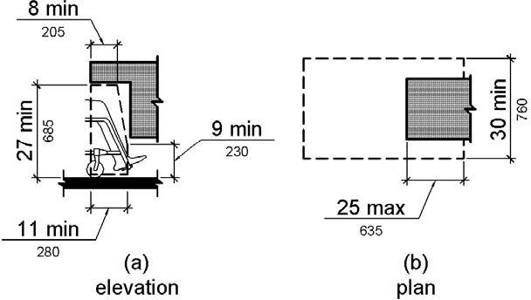

PHOTOGRAPH(S) OF THIS LOCATION
 | ID:  1786 | Facility:  Boise Watershed Treatment Plant

Location: Education Building Entrance
Schedule: 2021
Estimated Cost: $100.00

Priority Score 5
Quick Fix: Yes
Built before ADA: No

VIOLATIONS
2010 ADA Standards for Accessible Design Codes §307.2
The card swipe protrudes 8.5" into the circulation space at 38" above the floor.

RECOMMENDATIONS
Recess the card swipe so it protrudes a maximum of 4" or place a cane detectable object beneath it.

PHOTOGRAPH(S) OF THIS LOCATION
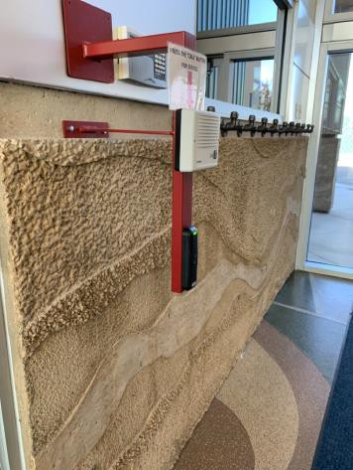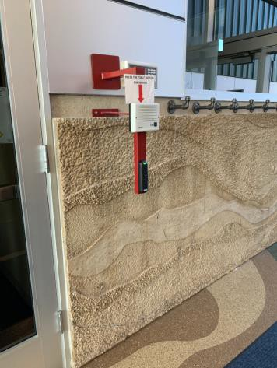
 | ID:  1787 | Facility:  Boise Watershed Treatment Plant

Location: Education Building Entrance
Schedule: 2022
Estimated Cost: $1,000.00

Priority Score 6
Quick Fix: No
Built before ADA: No

VIOLATIONS
2010 ADA Standards for Accessible Design Codes §211.2, §602.71
There is only one drinking fountain provided at 36" above the floor.

RECOMMENDATIONS
Install an additional drinking fountain at a minimum spout height of 38" and a maximum of 43" above the floor.

PHOTOGRAPH(S) OF THIS LOCATION
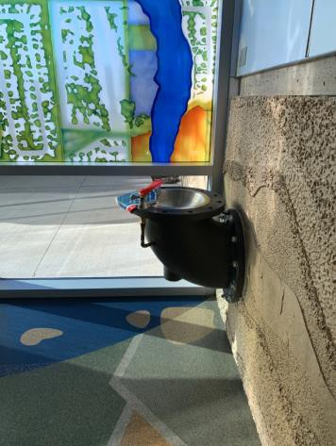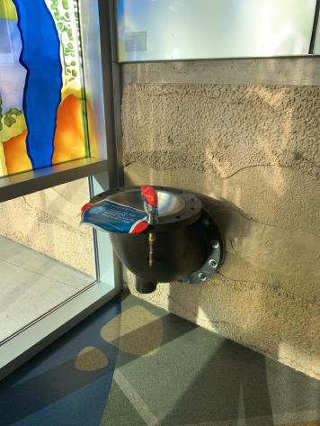
 | ID:  1755 | Facility:  Boise Watershed Treatment Plant

Location: Education Building Entrance
Schedule: 2021
Estimated Cost: $1,000.00

Priority Score 0
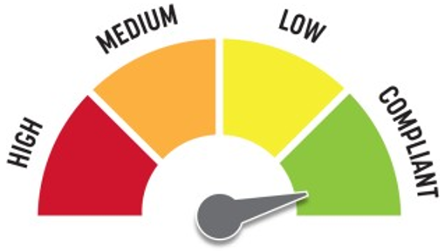
Quick Fix: No
Built before ADA: No

VIOLATIONS
2010 ADA Standards for Accessible Design Codes §902.3
The interactive table is 41" above the floor.

RECOMMENDATIONS
The height of the interactive table is not directly specified in the ADA, but it would be more accessible to users in wheelchairs if its top were a max of 34" above the floor.

PHOTOGRAPH(S) OF THIS LOCATION
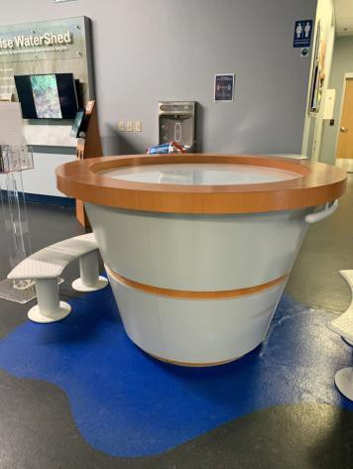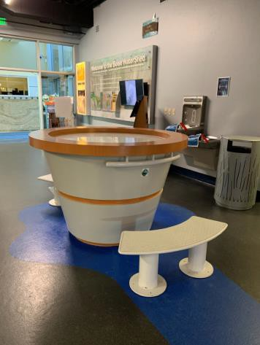
 | ID:  1757 | Facility:  Boise Watershed Treatment Plant

Location: Education Building Library
Schedule: 2021
Estimated Cost: $100.00

Priority Score 8
Quick Fix: Yes
Built before ADA: No

VIOLATIONS
2010 ADA Standards for Accessible Design Codes §308.3.1
The objects are outside of the unobstructed side reach range at 50" above the floor.

RECOMMENDATIONS
Lower the suggestion box by 2" to meet the accessible reach range of 48" maximum above the floor.

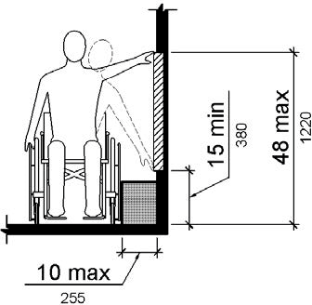

PHOTOGRAPH(S) OF THIS LOCATION
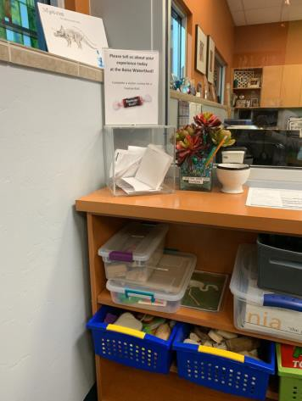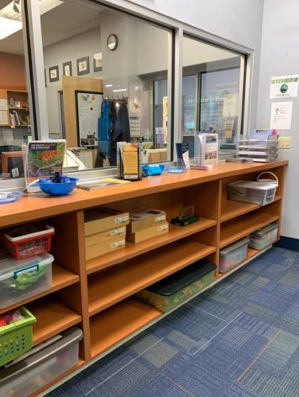
 | ID:  1758 | Facility:  Boise Watershed Treatment Plant

Location: Education Building Library
Schedule: 2021
Estimated Cost: $200.00

Priority Score 5
Quick Fix: Yes
Built before ADA: No

VIOLATIONS
2010 ADA Standards for Accessible Design Codes §307.2
The TVs protrude 9" into the circulation space at 32.5" above the floor.

RECOMMENDATIONS
Recess the TVs so they protrude a maximum of 4", lower them so the bottom edge is 27" maximum above the floor, or place a cane detectable object beneath them.

PHOTOGRAPH(S) OF THIS LOCATION
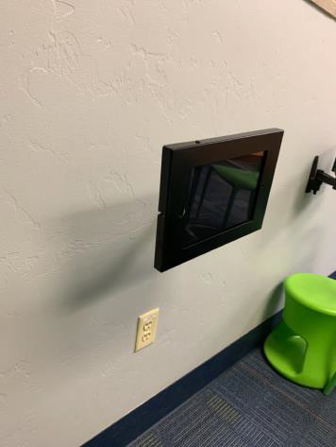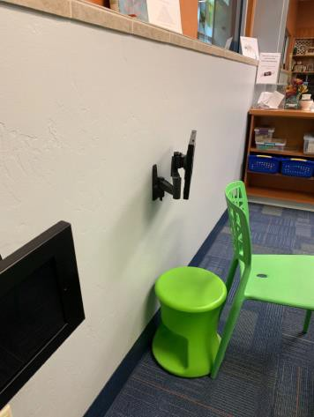
 | ID:  1778 | Facility:  Boise Watershed Treatment Plant

Location: Education Building Men's Restroom
Schedule: 2021
Estimated Cost: $100.00

Priority Score 5
Quick Fix: Yes
Built before ADA: No

VIOLATIONS
2010 ADA Standards for Accessible Design Codes §604.8.1.2
The door to the accessible water closet is not self closing. Either self-closing hinges are not installed on the door or if installed, they are defective.

RECOMMENDATIONS
Install or reinstall self-closing hinges on the door to ensure that the door is self-closing per the ADA requirements.

PHOTOGRAPH(S) OF THIS LOCATION
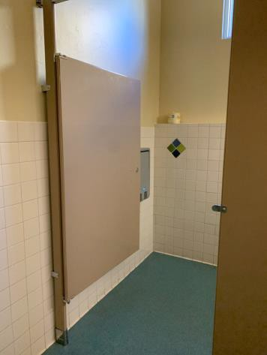
 | ID:  1779 | Facility:  Boise Watershed Treatment Plant

Location: Education Building Men's Restroom
Schedule: 2021
Estimated Cost: $100.00

Priority Score 8
Quick Fix: Yes
Built before ADA: No

VIOLATIONS
2010 ADA Standards for Accessible Design Codes §308.2.1
The toilet seat covers are outside of the unobstructed forward reach range at 52" above the floor.

RECOMMENDATIONS
Lower the toilet seat covers by 4" to meet the accessible reach range of 48" maximum above the floor.

PHOTOGRAPH(S) OF THIS LOCATION
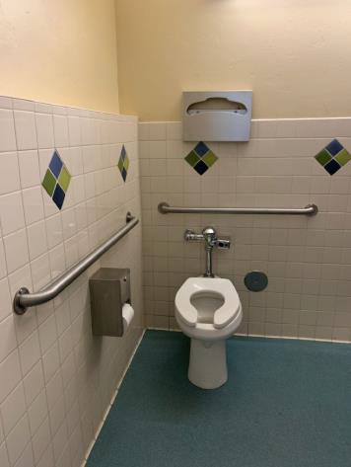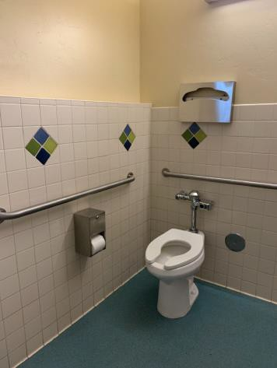
 | ID:  1780 | Facility:  Boise Watershed Treatment Plant

Location: Education Building Men's Restroom
Schedule: 2021
Estimated Cost: $100.00

Priority Score 5
Quick Fix: Yes
Built before ADA: No

VIOLATIONS
2010 ADA Standards for Accessible Design Codes §307.2
The hand dryer protrudes 8.25" into the circulation space at 47" above the floor.

RECOMMENDATIONS
Recess the hand dryer so it protrudes a maximum of 4" or place a cane detectable object beneath it.

PHOTOGRAPH(S) OF THIS LOCATION
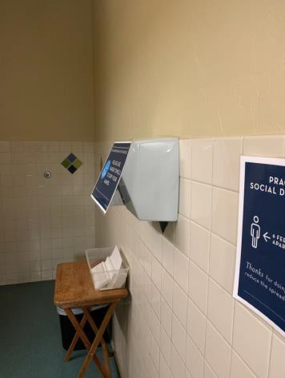

 | ID:  1781 | Facility:  Boise Watershed Treatment Plant

Location: Education Building Men's Restroom
Schedule: 2021
Estimated Cost: $100.00

Priority Score 7
Quick Fix: Yes
Built before ADA: No

VIOLATIONS
2010 ADA Standards for Accessible Design Codes §603.3
The mirror is too high to be accessible at 46.5" above the floor.

RECOMMENDATIONS
Lower the mirror so its bottom edge is a maximum height of 40" above the floor.

PHOTOGRAPH(S) OF THIS LOCATION
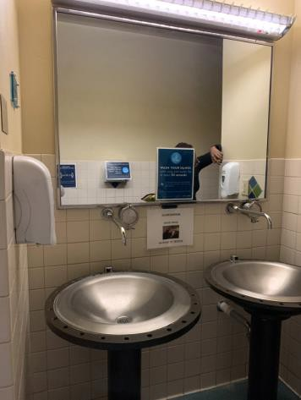
 | ID:  1775 | Facility:  Boise Watershed Treatment Plant

Location: Education Building Men's Restroom
Schedule: 2022
Estimated Cost: $1,000.00

Priority Score 5
Quick Fix: No
Built before ADA: No

VIOLATIONS
2010 ADA Standards for Accessible Design Codes ICC A117 §604.5.1
The accessible water closet does not have a vertical grab bar.

RECOMMENDATIONS
Install an 18" long (minimum) vertical grab bar on the side wall. The grab bar shall be mounted with the bottom located at 39" minimum and 41" maximum above the floor.
The centerline of the vertical grab bar shall be located 39" minimum and 41" maximum from the rear wall.

PHOTOGRAPH(S) OF THIS LOCATION
 | ID:  1776 | Facility:  Boise Watershed Treatment Plant

Location: Education Building Men's Restroom
Schedule: 2022
Estimated Cost: $1,000.00

Priority Score 5
Quick Fix: No
Built before ADA: No

VIOLATIONS
2010 ADA Standards for Accessible Design Codes §604.2
The centerline of the toilet is located 19" from the sidewall.

RECOMMENDATIONS
Reposition the centerline of the toilet to be within 16" minimum and 18" maximum from the sidewall.

PHOTOGRAPH(S) OF THIS LOCATION

 | ID:  1733 | Facility:  Boise Watershed Treatment Plant

Location: Education Building Outdoor Seating Area
Schedule: 2021
Estimated Cost: $100.00

Priority Score 5
Quick Fix: Yes
Built before ADA: No

VIOLATIONS
2010 ADA Standards for Accessible Design Codes §307.2
The card scanner protrudes 9" into the circulation space at 38.75" above the floor.

RECOMMENDATIONS
Recess the card scanner so it protrudes a maximum of 4" or place a cane detectable object beneath it.

PHOTOGRAPH(S) OF THIS LOCATION
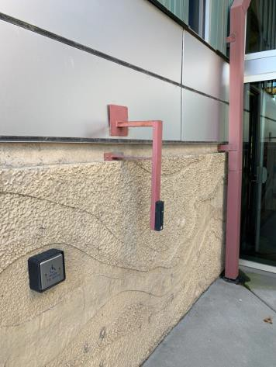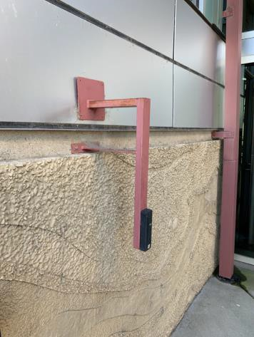
 | ID:  1735 | Facility:  Boise Watershed Treatment Plant

Location: Education Building Outdoor Seating Area
Schedule: 2021
Estimated Cost: $1,000.00

Priority Score 6
Quick Fix: No
Built before ADA: No

VIOLATIONS
2010 ADA Standards for Accessible Design Codes §211.2, §602.7
There is only one drinking fountain provided at 36" above the floor.

RECOMMENDATIONS
Install an additional drinking fountain at a minimum spout height of 38" and maximum of 43" above the floor.

PHOTOGRAPH(S) OF THIS LOCATION
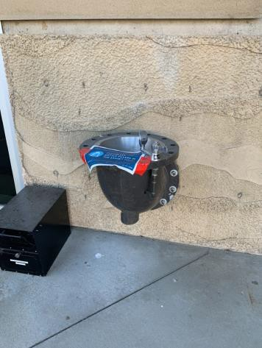
 | ID:  1734 | Facility:  Boise Watershed Treatment Plant

Location: Education Building Outdoor Seating Area
Schedule: 2021
Estimated Cost: $3,000.00

Priority Score 3
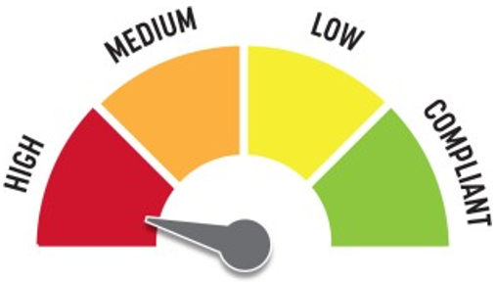
Quick Fix: No
Built before ADA: No

VIOLATIONS
2010 ADA Standards for Accessible Design Codes §226.1, §902, §305, §306
The provided picnic table does not have an accessible clear space for a wheelchair user.

RECOMMENDATIONS
Add/replace picnic tables so that at least 5% of the seating is wheelchair accessible.
Ensure that the wheelchair accessible seating has a clear floor space of 30" x 48" with a slope not steeper than 2% and that the tables have sufficient knee and toe clearance.

PHOTOGRAPH(S) OF THIS LOCATION
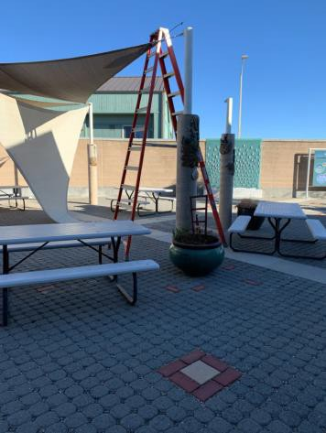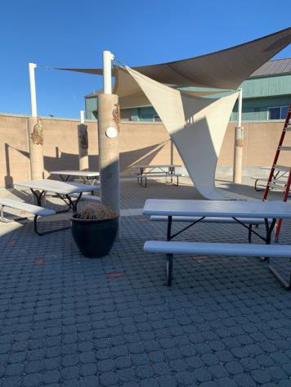
 | ID:  1726 | Facility:  Boise Watershed Treatment Plant

Location: Education Building Parking
Schedule: 2021
Estimated Cost: $200.00

Priority Score 8
Quick Fix: Yes
Built before ADA: No

VIOLATIONS
2010 ADA Standards for Accessible Design Codes §502.6
The parking signs identifying the accessible parking space do not meet the minimum height requirement of 60" from the ground.

RECOMMENDATIONS
Reinstall the accessible parking signs at each accessible space at a minimum height of 60" above the ground.

PHOTOGRAPH(S) OF THIS LOCATION
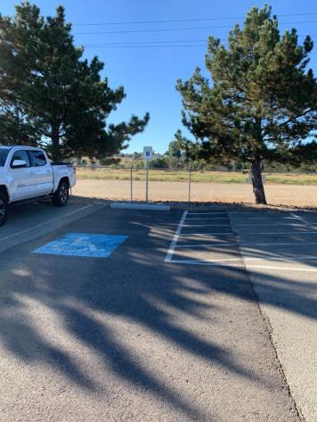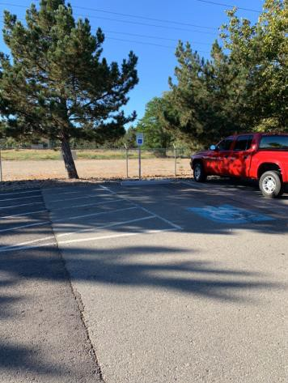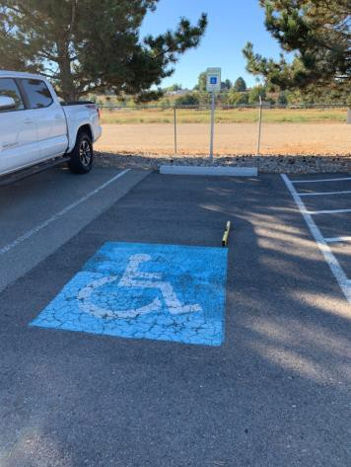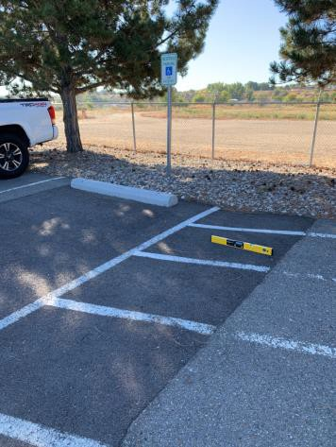
 | ID:  1725 | Facility:  Boise Watershed Treatment Plant

Location: Education Building Parking
Schedule: 2021
Estimated Cost: $5,000.00

Priority Score 3
Quick Fix: No
Built before ADA: No

VIOLATIONS
2010 ADA Standards for Accessible Design Codes §502.4
The accessible car parking space has a 2.8% slope at the top. The accessible van parking space has a 3% slope at the bottom.
The access aisle has a 2.7% slope down towards the accessible van parking space.

RECOMMENDATIONS
Reconstruct the parking spaces and access aisle to reduce the slope to a maximum of 2% in all directions.

PHOTOGRAPH(S) OF THIS LOCATION
 | ID:  1788 | Facility:  Boise Watershed Treatment Plant

Location: Education Building Ramp
Schedule: 2022
Estimated Cost: $2,500.00

Priority Score 7
Quick Fix: No
Built before ADA: No

VIOLATIONS
2010 ADA Standards for Accessible Design Codes §405.2
The temporary ramp has a running slope of 27.5%.

RECOMMENDATIONS
Construct a ramp with a maximum slope of 8.3% and a maximum cross slope of 2%.

PHOTOGRAPH(S) OF THIS LOCATION
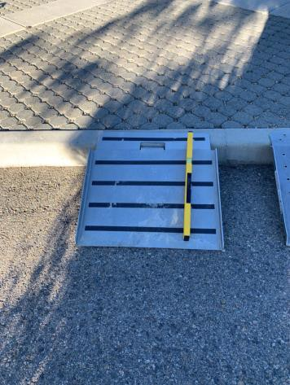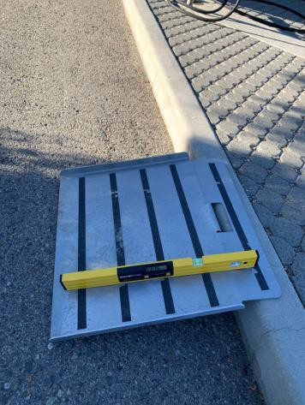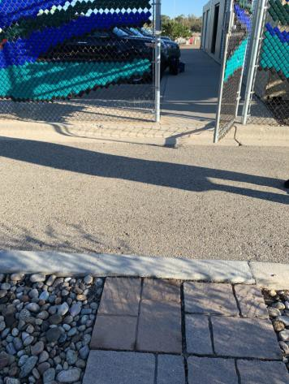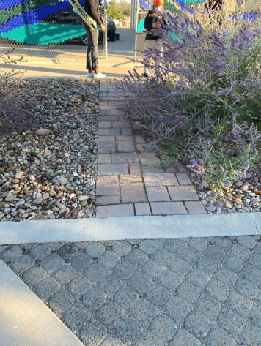
 | ID:  1770 | Facility:  Boise Watershed Treatment Plant

Location: Education Building Women's Restroom
Schedule: 2021
Estimated Cost: $100.00

Priority Score 5
Quick Fix: Yes
Built before ADA: No

VIOLATIONS
2010 ADA Standards for Accessible Design Codes §609.3
The space between the grab bar and toilet seat cover dispenser is 7.25"

RECOMMENDATIONS
Relocate the toilet seat cover dispenser to a location that is at least a distance of 12" or greater above the grab bar. Ensure that the toilet seat cover dispenser is not greater than 48" above the floor.

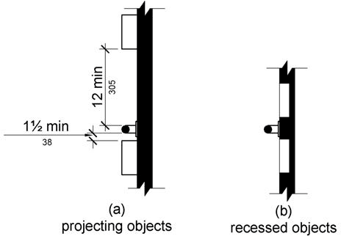

PHOTOGRAPH(S) OF THIS LOCATION
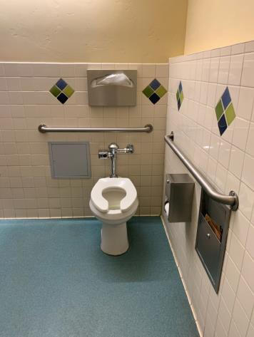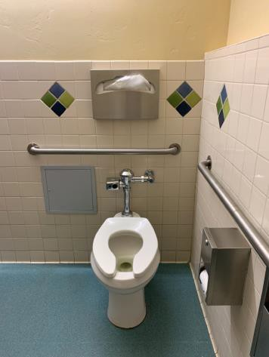
 | ID:  1771 | Facility:  Boise Watershed Treatment Plant

Location: Education Building Women's Restroom
Schedule: 2021
Estimated Cost: $100.00

Priority Score 8
Quick Fix: Yes
Built before ADA: No

VIOLATIONS
2010 ADA Standards for Accessible Design Codes §308.2.1
The toilet seat covers are outside of the unobstructed forward reach range at 51" above the floor.

RECOMMENDATIONS
Lower the toilet seat covers by 3" to meet the accessible reach range of 48" maximum above the floor.

PHOTOGRAPH(S) OF THIS LOCATION
 | ID:  1773 | Facility:  Boise Watershed Treatment Plant

Location: Education Building Women's Restroom
Schedule: 2021
Estimated Cost: $100.00

Priority Score 7
Quick Fix: Yes
Built before ADA: No

VIOLATIONS
2010 ADA Standards for Accessible Design Codes §603.3
The mirror is too high to be accessible at 46.5" above the floor.

RECOMMENDATIONS
Lower the mirror so its bottom edge is a maximum height of 40" above the floor.

PHOTOGRAPH(S) OF THIS LOCATION
 | ID:  1774 | Facility:  Boise Watershed Treatment Plant

Location: Education Building Women's Restroom
Schedule: 2021
Estimated Cost: $100.00

Priority Score 5
Quick Fix: Yes
Built before ADA: No

VIOLATIONS
2010 ADA Standards for Accessible Design Codes §307.2
The hand dryer protrudes 8.5" into the circulation space at 47" above the floor.

RECOMMENDATIONS
Recess the hand dryer so it protrudes a maximum of 4" or place a cane detectable object beneath it.

PHOTOGRAPH(S) OF THIS LOCATION
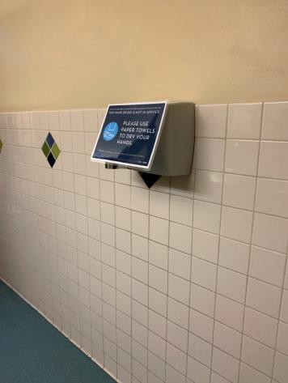
 | ID:  1767 | Facility:  Boise Watershed Treatment Plant

Location: Education Building Women's Restroom
Schedule: 2022
Estimated Cost: $1,000.00

Priority Score 5
Quick Fix: No
Built before ADA: No

VIOLATIONS
2010 ADA Standards for Accessible Design Codes ICC A117.1 §604.5.1
The accessible water closet does not have a vertical grab bar.

RECOMMENDATIONS
Install an 18" long (minimum) vertical grab bar on the side wall. The grab bar shall be mounted with the bottom located at 39" minimum and 41" maximum above the floor.
The centerline of the vertical grab bar shall be located 39" minimum and 41" maximum from the rear wall.

PHOTOGRAPH(S) OF THIS LOCATION
 | ID:  1769 | Facility:  Boise Watershed Treatment Plant

Location: Education Building Women's Restroom
Schedule: 2022
Estimated Cost: $1,000.00

Priority Score 5
Quick Fix: No
Built before ADA: No

VIOLATIONS
2010 ADA Standards for Accessible Design Codes §604.2
The centerline of the toilet is located 18.5" from the sidewall.

RECOMMENDATIONS
Reposition the centerline of the toilet to be within 16" minimum and 18" maximum from the sidewall.

PHOTOGRAPH(S) OF THIS LOCATION

 | ID:  1743 | Facility:  Boise Watershed Treatment Plant

Location: Entire Facility
Schedule: 2021
Estimated Cost: $2,900.00

Priority Score 3
Quick Fix: No
Built before ADA: No

VIOLATIONS
2010 ADA Standards for Accessible Design Codes §216.2, §703
There is no tactile signage identifying 29 permanent rooms.

RECOMMENDATIONS
Install tactile signage on the latch side of the doorway at a height of 48” minimum to 60” maximum above the floor, identifying room by name or room number.
Signs shall be Braille with raised lettering and should be placed on the wall in the center of an 18"x18" clear floor space.

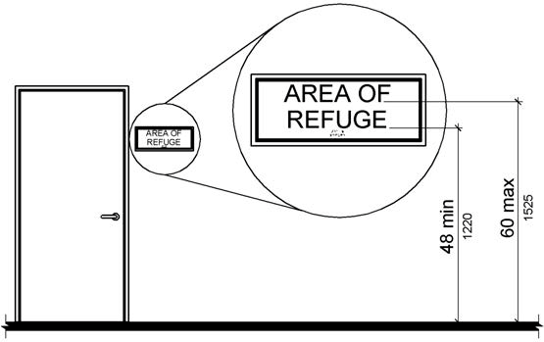

PHOTOGRAPH(S) OF THIS LOCATION
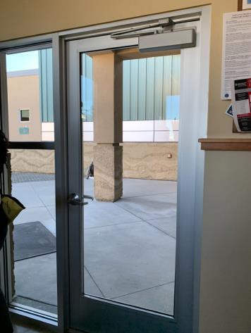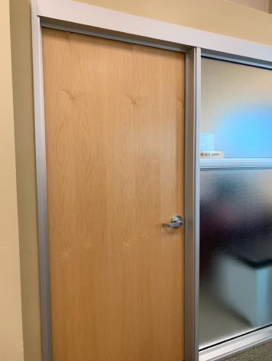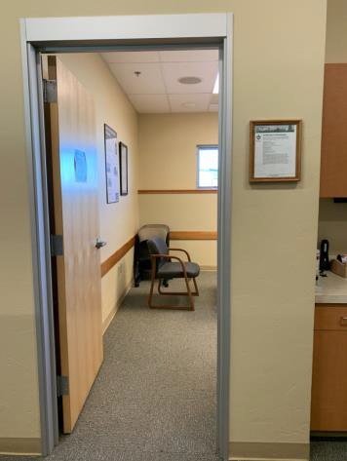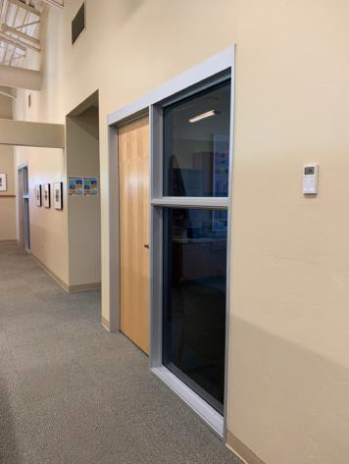

 | ID:  1839 | Facility:  Boise Watershed Treatment Plant

Location: Head Works Building
Schedule: 2021
Estimated Cost: $100.00

Priority Score 9
Quick Fix: Yes
Built before ADA: No

VIOLATIONS
2010 ADA Standards for Accessible Design Codes §502.6
The accessible parking sign is 58.75" above the ground.

RECOMMENDATIONS
Remount the accessible parking sign at a minimum height of 60" above the ground.

PHOTOGRAPH(S) OF THIS LOCATION
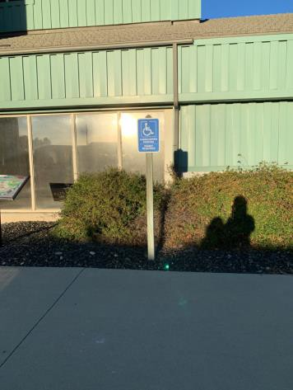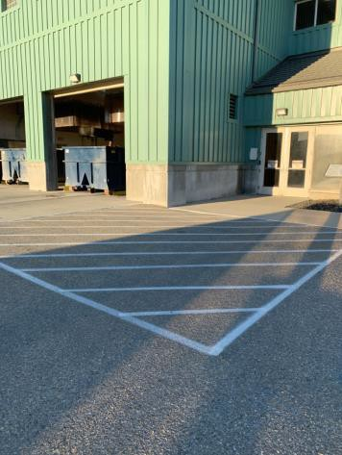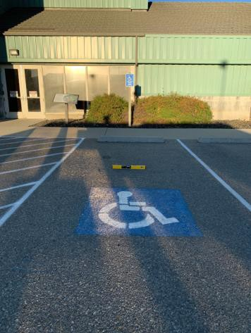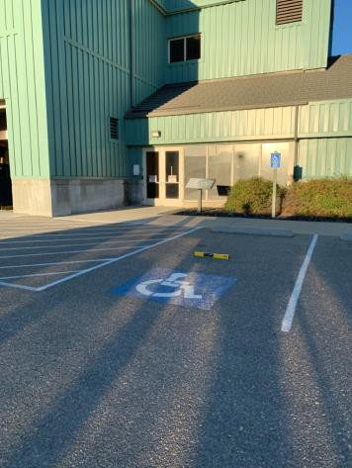

 | ID:  1842 | Facility:  Boise Watershed Treatment Plant

Location: Head Works Building
Schedule: 2021
Estimated Cost: $100.00

Priority Score 8
Quick Fix: Yes
Built before ADA: No

VIOLATIONS
2010 ADA Standards for Accessible Design Codes §308.2.1
The exit button is outside of the unobstructed forward reach range at 49.5" above the floor.

RECOMMENDATIONS
Lower the exit button by 1.5" to meet the accessible reach range of 48" maximum above the floor.

PHOTOGRAPH(S) OF THIS LOCATION
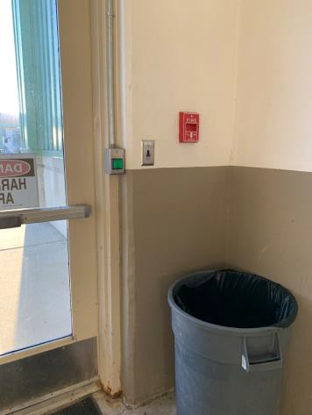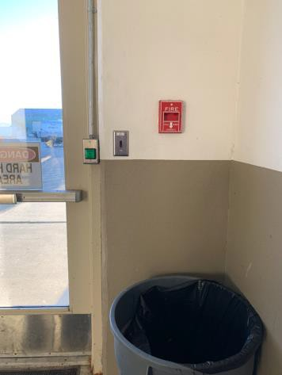
 | ID:  1843 | Facility:  Boise Watershed Treatment Plant

Location: Head Works Building
Schedule: 2021
Estimated Cost: $100.00

Priority Score 8
Quick Fix: Yes
Built before ADA: No

VIOLATIONS
2010 ADA Standards for Accessible Design Codes §308.2.1
The light switch is outside of the unobstructed forward reach range at 51" above the floor.

RECOMMENDATIONS
Lower the light switch by 3" to meet the accessible reach range of 48" maximum above the floor.

PHOTOGRAPH(S) OF THIS LOCATION
 | ID:  1844 | Facility:  Boise Watershed Treatment Plant

Location: Head Works Building
Schedule: 2021
Estimated Cost: $100.00

Priority Score 8
Quick Fix: Yes
Built before ADA: No

VIOLATIONS
2010 ADA Standards for Accessible Design Codes §308.2.1
The fire alarm is outside of the unobstructed forward reach range at 55" above the floor.

RECOMMENDATIONS
Lower the fire alarm by 7" to meet the accessible reach range of 48" maximum above the floor.

PHOTOGRAPH(S) OF THIS LOCATION
 | ID:  1845 | Facility:  Boise Watershed Treatment Plant

Location: Head Works Building
Schedule: 2021
Estimated Cost: $100.00

Priority Score 8
Quick Fix: Yes
Built before ADA: No

VIOLATIONS
2010 ADA Standards for Accessible Design Codes §308.2.1
The light switch is outside of the unobstructed forward reach range at 50" above the floor.

RECOMMENDATIONS
Lower the light switch by 2" to meet the accessible reach range of 48" maximum above the floor.

PHOTOGRAPH(S) OF THIS LOCATION
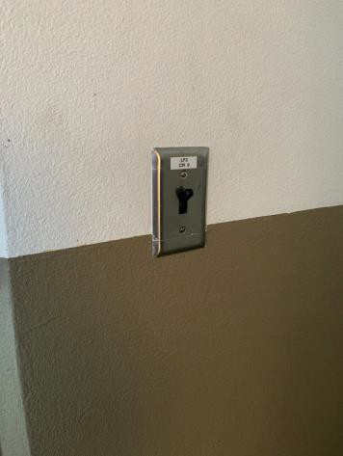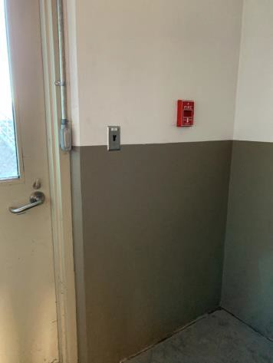
 | ID:  1846 | Facility:  Boise Watershed Treatment Plant

Location: Head Works Building
Schedule: 2021
Estimated Cost: $100.00

Priority Score 8
Quick Fix: Yes
Built before ADA: No

VIOLATIONS
2010 ADA Standards for Accessible Design Codes §308.2.1
The fire alarm is outside of the unobstructed forward reach range at 54" above the floor.

RECOMMENDATIONS
Lower the fire alarm by 6" to meet the accessible reach range of 48" maximum above the floor.

PHOTOGRAPH(S) OF THIS LOCATION
 | ID:  1848 | Facility:  Boise Watershed Treatment Plant

Location: Head Works Building
Schedule: 2021
Estimated Cost: $100.00

Priority Score 5
Quick Fix: Yes
Built before ADA: No

VIOLATIONS
2010 ADA Standards for Accessible Design Codes §307.2.1, §308.2.1
The first aid box is outside of the unobstructed forward reach range at 48.5" above the floor. The first aid box protrudes 5.5" into the circulation space at 48.5" above the floor.

RECOMMENDATIONS
Lower the first aid box by 0.5" to meet the accessible reach range of 48" maximum above the floor.
Recess the first aid box so it protrudes a maximum of 4" or place a cane detectable object beneath it.

PHOTOGRAPH(S) OF THIS LOCATION
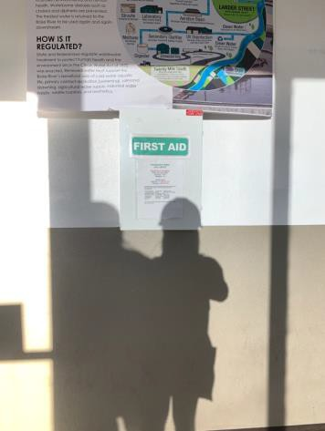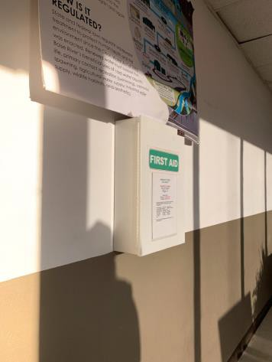
 | ID:  1847 | Facility:  Boise Watershed Treatment Plant

Location: Head Works Building
Schedule: 2021
Estimated Cost: $300.00

Priority Score 3
Quick Fix: Yes
Built before ADA: No

VIOLATIONS
2010 ADA Standards for Accessible Design Codes §216.2, §216.4, §703
There is no tactile sign identifying two permanent room. Doors serving as exits are not marked by tactile signage.

RECOMMENDATIONS
Install tactile signage on the latch side of the doorway at a height of 48” minimum to 60” maximum above the floor, identifying room by name or room number.
Place a tactile exit sign, that complies with §703.1, §703.2 and §703.5, identifying the exit doors. Signs shall be Braille with raised lettering and should be placed on the wall in the center of an 18"x18" clear floor space.

PHOTOGRAPH(S) OF THIS LOCATION
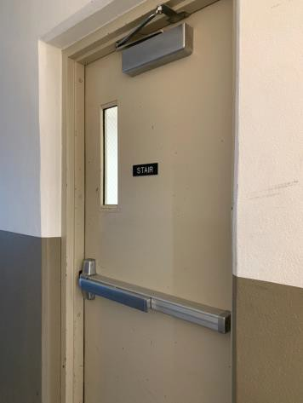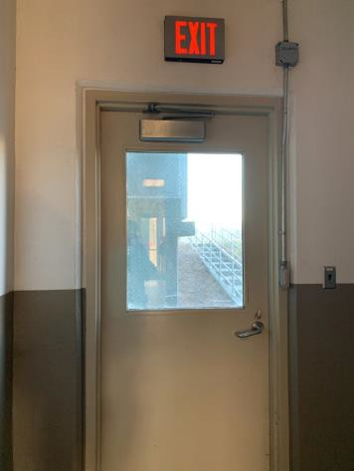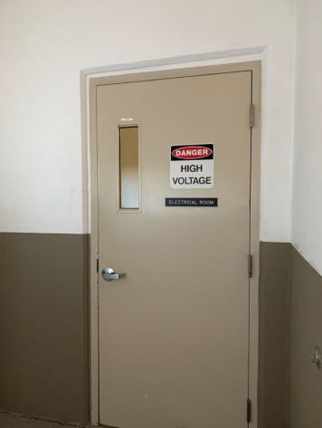

 | ID:  1840 | Facility:  Boise Watershed Treatment Plant

Location: Head Works Building
Schedule: 2022
Estimated Cost: $1,000.00

Priority Score 5
Quick Fix: No
Built before ADA: No

VIOLATIONS
2010 ADA Standards for Accessible Design Codes §303.2.1
There is a 0.75" change in level.

RECOMMENDATIONS
Resurface the pathway to reduce the change in level to less than 0.25" or 0.5" if beveled.

PHOTOGRAPH(S) OF THIS LOCATION
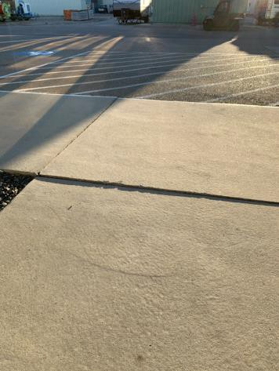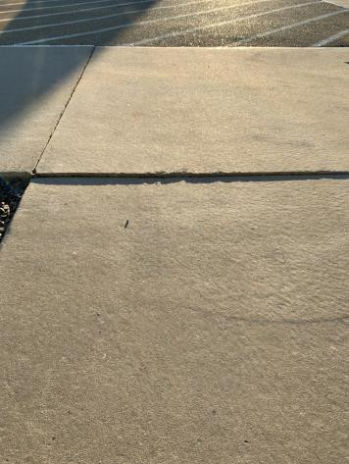
 | ID:  1841 | Facility:  Boise Watershed Treatment Plant

Location: Head Works Building
Schedule: 2022
Estimated Cost: $1,000.00

Priority Score 5
Quick Fix: No
Built before ADA: No

VIOLATIONS
2010 ADA Standards for Accessible Design Codes §303.2
There is a 0.75" change in level.

RECOMMENDATIONS
Resurface the pathway to reduce the change in level to less than 0.25" or 0.5" if beveled.

PHOTOGRAPH(S) OF THIS LOCATION
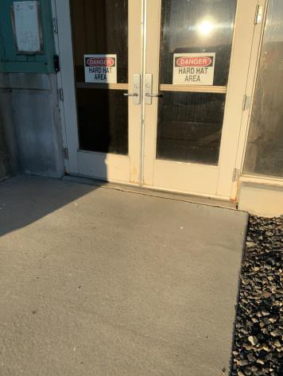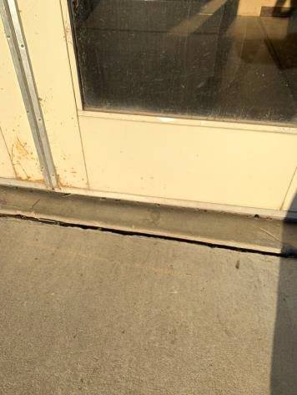

 | ID:  1838 | Facility:  Boise Watershed Treatment Plant

Location: Head Works Building
Schedule: 2021
Estimated Cost: $2,500.00

Priority Score 3
Quick Fix: No
Built before ADA: No

VIOLATIONS
2010 ADA Standards for Accessible Design Codes §502.4
The parking space has a 4% slope.

RECOMMENDATIONS
Reconstruct the parking space to reduce the slope to a maximum of 2% in all directions.

PHOTOGRAPH(S) OF THIS LOCATION

 | ID:  1729 | Facility:  Boise Watershed Treatment Plant

Location: Laboratory Parking
Schedule: 2021
Estimated Cost: $100.00

Priority Score 9
Quick Fix: Yes
Built before ADA: No

VIOLATIONS
2010 ADA Standards for Accessible Design Codes §502.6
The parking sign identifying the accessible parking space does not meet the minimum height requirement of 60" from the ground.

RECOMMENDATIONS
Install an accessible parking sign at each accessible space at a minimum height of 60" above the ground centered to the parking space.

PHOTOGRAPH(S) OF THIS LOCATION
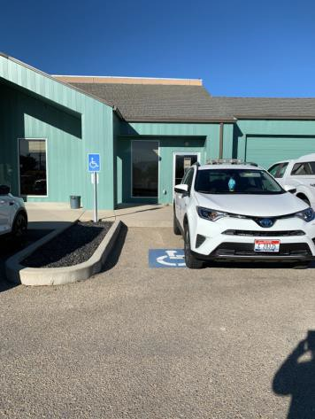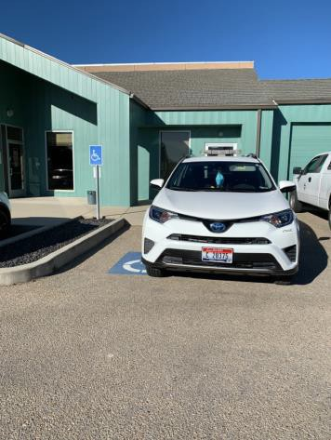
 | ID:  1727 | Facility:  Boise Watershed Treatment Plant

Location: Laboratory Parking
Schedule: 2023
Estimated Cost: $1,000.00

Priority Score 9
Quick Fix: No
Built before ADA: No

VIOLATIONS
2010 ADA Standards for Accessible Design Codes §502
There are no markings on the left side of the accessible parking space.

RECOMMENDATIONS
Stripe the left side of the accessible parking space.

PHOTOGRAPH(S) OF THIS LOCATION
 | ID:  1728 | Facility:  Boise Watershed Treatment Plant

Location: Laboratory Parking
Schedule: 2021
Estimated Cost: $1,000.00

Priority Score 3
Quick Fix: No
Built before ADA: No

VIOLATIONS
2010 ADA Standards for Accessible Design Codes §502.3
There is no access aisle.

RECOMMENDATIONS
Install an access aisle connecting the accessible parking spaces to an accessible route. Each access aisle shall be 60” wide.

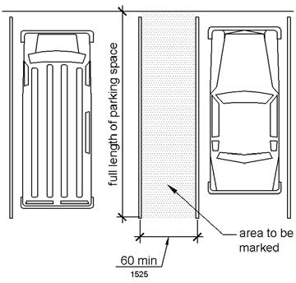

PHOTOGRAPH(S) OF THIS LOCATION
 | ID: | Facility:

Location:
Schedule:
Estimated Cost:

Priority Score 3
Quick Fix: Yes
Built before ADA: No

VIOLATIONS
2010 ADA Standards for Accessible Design Codes §216.2, §703
There is no tactile sign identifying the permanent room.

RECOMMENDATIONS
Install tactile signage on the latch side of the doorway at a height of 48” minimum to 60” maximum above the floor, identifying room by name or room number.
Signs shall be Braille with raised lettering and should be placed on the wall in the center of an 18"x18" clear floor space.

PHOTOGRAPH(S) OF THIS LOCATION
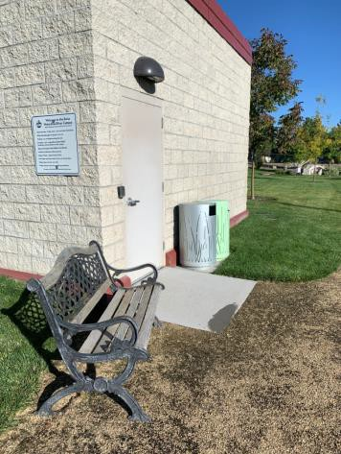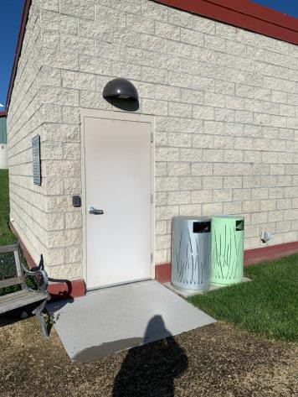
 | ID:  1715 | Facility:  Boise Watershed Treatment Plant

Location: Nature Garden
Schedule: 2021
Estimated Cost: $5,000.00

Priority Score 3
Quick Fix: No
Built before ADA: No

VIOLATIONS
2010 ADA Standards for Accessible Design Codes §226.1, §902, §305, §306
The tables are located in the grass, therefore not accessible.
The provided picnic table does not have an accessible clear space for a wheelchair user.

RECOMMENDATIONS
Construct a firm, stable, and slip resistant accessible route with a maximum cross slope of 2% and maximum running slope of 5%. Add/replace picnic tables so that at least 5% of the seating is wheelchair accessible.
Ensure that the wheelchair accessible seating has a clear floor space of 30" x 48" with a slope not steeper than 2% and that the tables have sufficient knee and toe clearance.

PHOTOGRAPH(S) OF THIS LOCATION
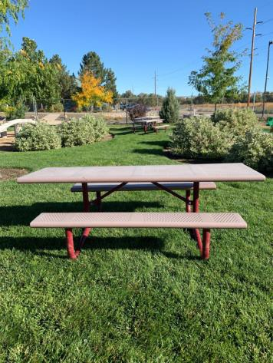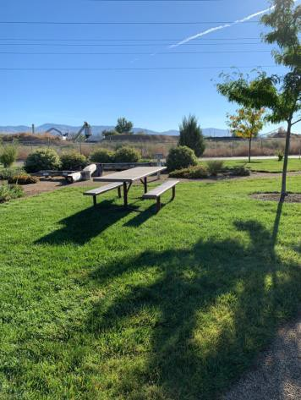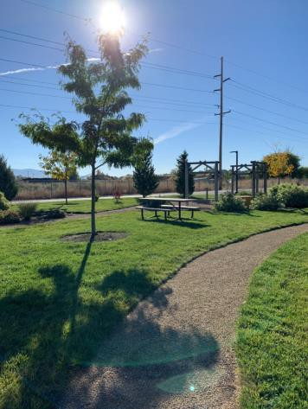
 | ID:  1716 | Facility:  Boise Watershed Treatment Plant

Location: Nature Garden
Schedule: 2021
Estimated Cost:$5,000.00

Priority Score 3
Quick Fix: No
Built before ADA: No

VIOLATIONS
2010 ADA Standards for Accessible Design Codes §302.1, §305
There is not a firm, stable, and slip resistant route to the bench or garbage can.

RECOMMENDATIONS
Construct a firm, stable, and slip resistant accessible route with a maximum cross slope of 2% and maximum running slope of 5%. Or relocate the bench and garbage can adjacent to a level stable, firm, and slip resistant accessible route.

PHOTOGRAPH(S) OF THIS LOCATION
 | ID:  1714 | Facility:  Boise Watershed Treatment Plant

Location: Nature Garden
Schedule: 2021
Estimated Cost: $10,000.00

Priority Score 3
Quick Fix: No
Built before ADA: No

VIOLATIONS
2010 ADA Standards for Accessible Design Codes §302.1, §305, ASTM F1951-99
None of the play pockets are accessible.

RECOMMENDATIONS
Replace the mulch with an accessible playground surface material such as pour-in-place rubber, rubber tiles, artificial grass, or engineered wood fiber.

PHOTOGRAPH(S) OF THIS LOCATION
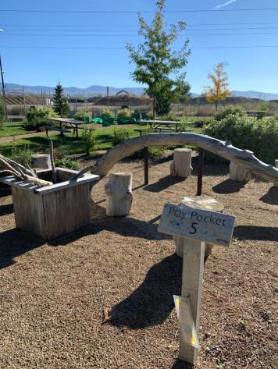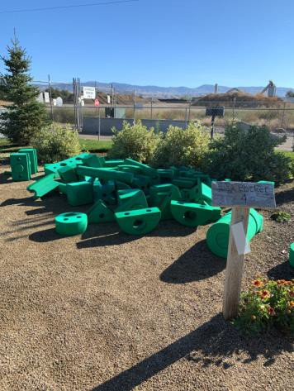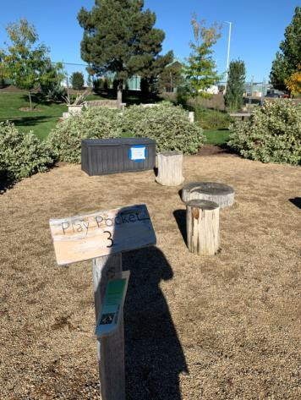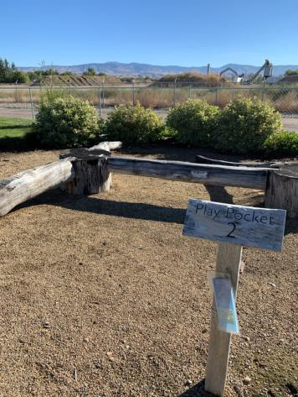
 | ID:  1718 | Facility:  Boise Watershed Treatment Plant

Location: Nature Garden
Schedule: 2021
Estimated Cost: $20,000.00

Priority Score 3
Quick Fix: No
Built before ADA: No

VIOLATIONS
2010 ADA Standards for Accessible Design Codes §302.1
The path is not stable, firm, and slip resistant rendering the amenities inaccessible to persons with disabilities.

RECOMMENDATIONS
Replace the gravel with an accessible playground surface material such as pour-in-place rubber, rubber tiles, artificial grass, or engineered wood fiber.
Ensure all amenities are located either on or directly adjacent to the new accessible surface.

PHOTOGRAPH(S) OF THIS LOCATION
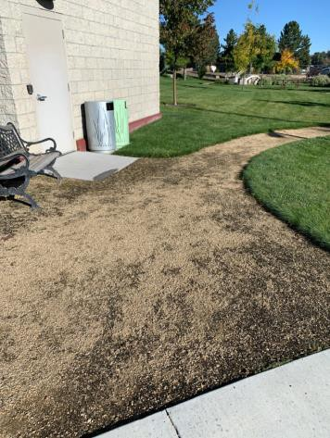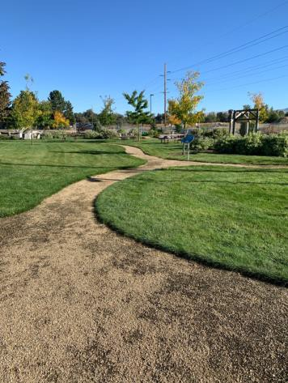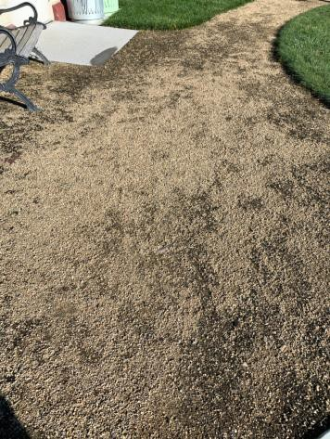
 | ID:  1793 | Facility:  Boise Watershed Treatment Plant

Location: New Head Works Plant
Schedule: 2022
Estimated Cost: $1,000.00

Priority Score 5
Quick Fix: No
Built before ADA: No

VIOLATIONS
2010 ADA Standards for Accessible Design Codes §303.2
There is a 1.75" change in level.

RECOMMENDATIONS
Resurface the pathway to reduce the change in level to less than 0.25" or 0.5" if beveled.

PHOTOGRAPH(S) OF THIS LOCATION
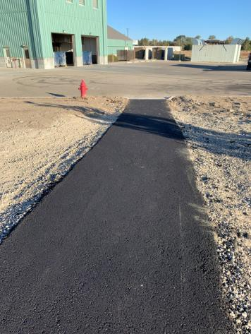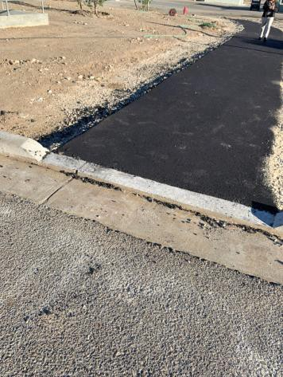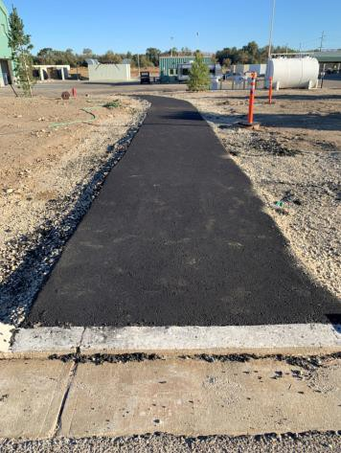
 | ID:  1791 | Facility:  Boise Watershed Treatment Plan

Location: New Head Works Path
Schedule: 2022
Estimated Cost: $2,000.00

Priority Score 5
Quick Fix: No
Built before ADA: No

VIOLATIONS
2010 ADA Standards for Accessible Design Codes §303.2
The bottom of the newly built path has a 0.75" change in level.

RECOMMENDATIONS
Resurface the pathway to reduce the change in level to less than 0.25" or 0.5" if beveled.
Pave a level landing with a minimum length of 60" and as wide as the ramp with a maximum slope shall be 2% in all directions.

PHOTOGRAPH(S) OF THIS LOCATION
 | ID:  1790 | Facility:  Boise Watershed Treatment Plant

Location: New Head Works Path
Schedule: 2021
Estimated Cost: $5,000.00

Priority Score 3
Quick Fix: No
Built before ADA: No

VIOLATIONS
2010 ADA Standards for Accessible Design Codes §403.3
The newly built path has a running slope of 8.9%.

RECOMMENDATIONS
Reconstruct the route to reduce the running slope to a maximum of 5% or resurface the route to maximum slope to 8.3% making it a ramp.
Install handrails at a minimum height of 34" and maximum of 38" above the ground. Make sure there are adequate handrail extensions both at the top and bottom of the handrail.

PHOTOGRAPH(S) OF THIS LOCATION

 | ID:  1826 | Facility:  Boise Watershed Treatment Plant

Location: Operations Building Entrance
Schedule: 2021
Estimated Cost: $100.00

Priority Score 5
Quick Fix: Yes
Built before ADA: No

VIOLATIONS
2010 ADA Standards for Accessible Design Codes §307.2
The sunscreen dispenser protrudes 6.75" into the circulation space at 34.5" above the floor.

RECOMMENDATIONS
Recess the sunscreen dispenser so it protrudes a maximum of 4" or place a cane detectable object beneath it.

PHOTOGRAPH(S) OF THIS LOCATION
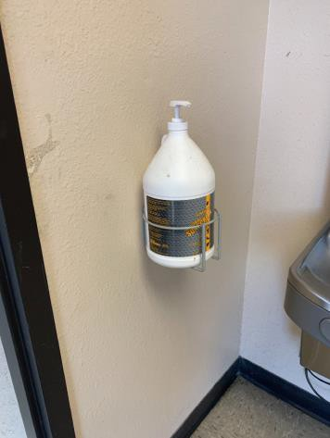
 | ID:  1827 | Facility:  Boise Watershed Treatment Plant

Location: Operations Building Entrance
Schedule: 2021
Estimated Cost: $100.00

Priority Score 5
Quick Fix: Yes
Built before ADA: No

VIOLATIONS
2010 ADA Standards for Accessible Design Codes §307.2
The first aid box protrudes 5.75" into the circulation space at 47" above the floor.

RECOMMENDATIONS
Recess the first aid box so it protrudes a maximum of 4" or place a cane detectable object beneath it.

PHOTOGRAPH(S) OF THIS LOCATION
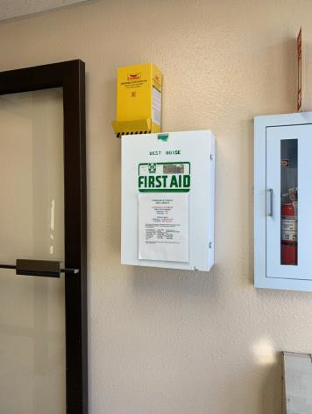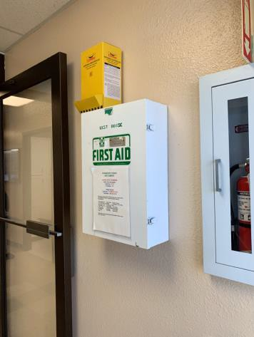
 | ID:  1829 | Facility:  Boise Watershed Treatment Plant

Location: Operations Building Entrance
Schedule: 2021
Estimated Cost: $500.00

Priority Score 3
Quick Fix: Yes
Built before ADA: No

VIOLATIONS
2010 ADA Standards for Accessible Design Codes §302.3
There is a 1" gap that is 0.75" deep at the entrance.

RECOMMENDATIONS
Fill in the gap.

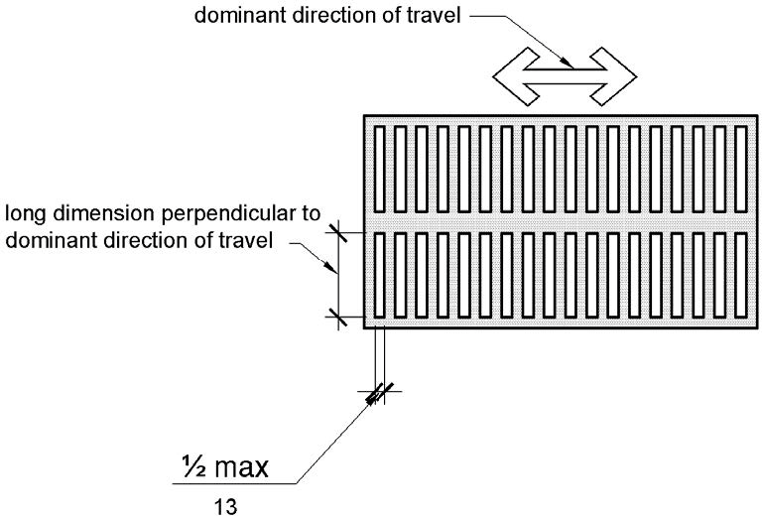

PHOTOGRAPH(S) OF THIS LOCATION
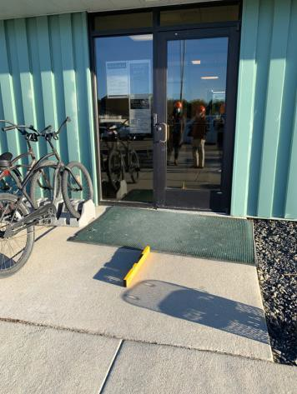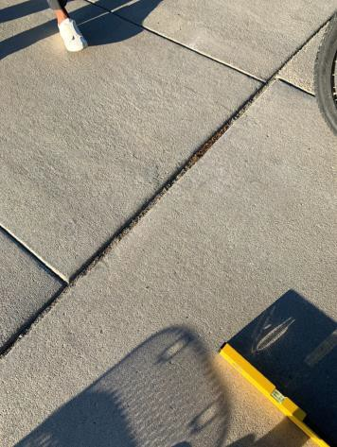
 | ID:  1825 | Facility:  Boise Watershed Treatment Plant

Location: Operations Building Entrance
Schedule: 2022
Estimated Cost: $1,000.00

Priority Score 6
Quick Fix: No
Built before ADA: No

VIOLATIONS
2010 ADA Standards for Accessible Design Codes §211.2, §602.7
There is only one drinking fountain provided at 33.5" above the floor.

RECOMMENDATIONS
Install an additional drinking fountain at a minimum spout height of 38" and maximum of 43" above the floor.

PHOTOGRAPH(S) OF THIS LOCATION
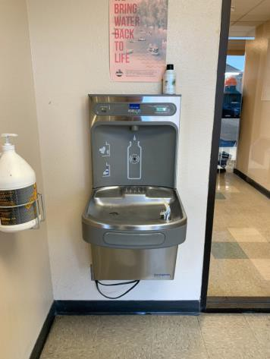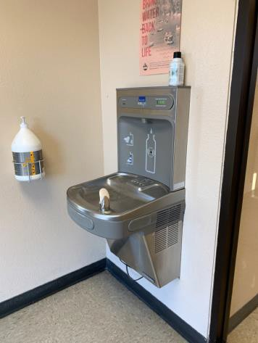
 | ID:  1828 | Facility:  Boise Watershed Treatment Plant

Location: Operations Building Entrance
Schedule: 2021
Estimated Cost: $2,500.00

Priority Score 3
Quick Fix: No
Built before ADA: No

VIOLATIONS
2010 ADA Standards for Accessible Design Codes §404.2.4.4
The entrance has a 3.6% slope.

RECOMMENDATIONS
Reconstruct the entryway to reduce the running slope to a maximum of 2% in all directions for a distance of 60" perpendicular to the entryway.

PHOTOGRAPH(S) OF THIS LOCATION
 | ID:  1821 | Facility:  Boise Watershed Treatment Plant

Location: Operations Building Laundry
Schedule: 2021
Estimated Cost: $100.00

Priority Score 7
Quick Fix: Yes
Built before ADA: No

VIOLATIONS
2010 ADA Standards for Accessible Design Codes §309.4
The door knob requires twisting of the wrist.

RECOMMENDATIONS
Replace the door knob with a lever handle that can be operated with a closed fist and without twisting the wrist.

PHOTOGRAPH(S) OF THIS LOCATION
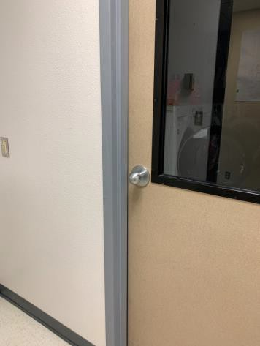
 | ID:  1823 | Facility:  Boise Watershed Treatment Plant

Location: Operations Building Laundry
Schedule: 2021
Estimated Cost: $100.00

Priority Score 8
Quick Fix: Yes
Built before ADA: No

VIOLATIONS
2010 ADA Standards for Accessible Design Codes §308.2.1
The paper towel dispenser is outside of the unobstructed forward reach range at 52" above the floor.

RECOMMENDATIONS
Lower the paper towel dispenser by 4" to meet the accessible reach range of 48" maximum above the floor.

PHOTOGRAPH(S) OF THIS LOCATION
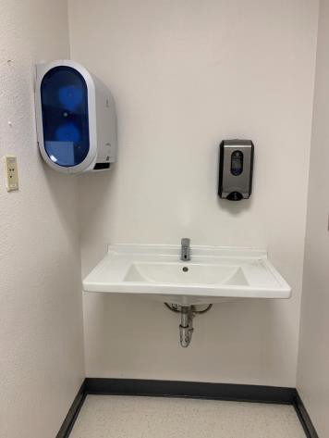
 | ID:  1824 | Facility:  Boise Watershed Treatment Plant

Location: Operations Building Laundry
Schedule: 2021
Estimated Cost: $100.00

Priority Score 7
Quick Fix: Yes
Built before ADA: No

VIOLATIONS
2010 ADA Standards for Accessible Design Codes §606.5
The pipes under the sink are not covered.

RECOMMENDATIONS
Wrap the pipes beneath the sink with soft protective wrap or plastic.

PHOTOGRAPH(S) OF THIS LOCATION
 | ID:  1798 | Facility:  Boise Watershed Treatment Plant

Location: Operations Building Men's Restroom
Schedule: 2021
Estimated Cost: $100.00

Priority Score 8
Quick Fix: Yes
Built before ADA: No

VIOLATIONS
2010 ADA Standards for Accessible Design Codes §308.2.1
The hooks are outside of the unobstructed forward reach range at 72.5" above the floor.

RECOMMENDATIONS
Lower at least one of the hooks by 24.5" to meet the accessible reach range of 48" maximum above the floor.

PHOTOGRAPH(S) OF THIS LOCATION
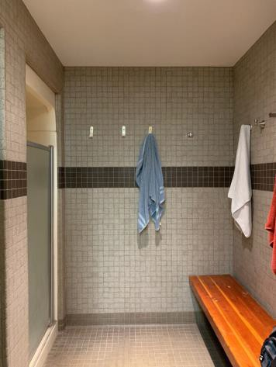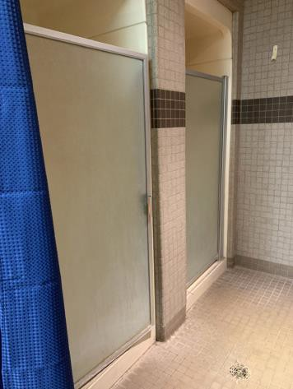
 | ID:  1802 | Facility:  Boise Watershed Treatment Plant

Location: Operations Building Men's Restroom
Schedule: 2021
Estimated Cost: $100.00

Priority Score 8
Quick Fix: Yes
Built before ADA: No

VIOLATIONS
2010 ADA Standards for Accessible Design Codes §308.2.1
The hooks are outside of the unobstructed forward reach range at 71" above the floor.

RECOMMENDATIONS
Lower at least one of the hooks by 23" to meet the accessible reach range of 48" maximum above the floor.

PHOTOGRAPH(S) OF THIS LOCATION

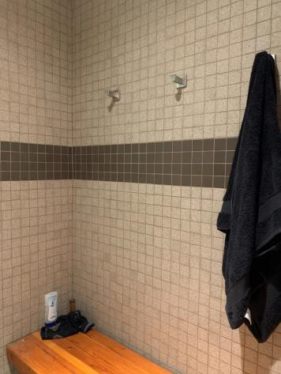
 | ID:  1805 | Facility:  Boise Watershed Treatment Plant

Location: Operations Building Men's Restroom
Schedule: 2021
Estimated Cost: $100.00

Priority Score 5
Quick Fix: Yes
Built before ADA: No

VIOLATIONS
2010 ADA Standards for Accessible Design Codes §609.3
The space between the grab bar and the toilet seat cover dispenser is 10".

RECOMMENDATIONS
Relocate the toilet seat cover dispenser to a location that is at least a distance of 12" or greater above the grab bar. Ensure that the toilet seat cover dispenser is not greater than 48" above the floor.

PHOTOGRAPH(S) OF THIS LOCATION
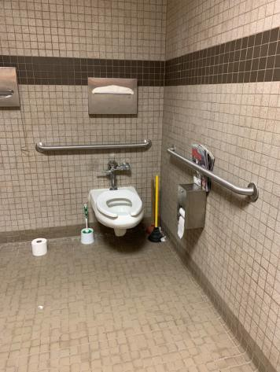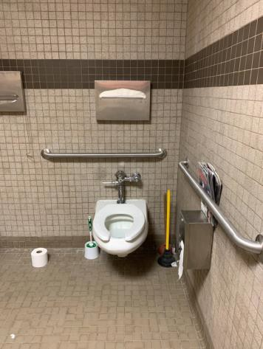
 | ID:  1809 | Facility:  Boise Watershed Treatment Plant

Location: Operations Building Men's Restroom
Schedule: 2021
Estimated Cost: $100.00

Priority Score 7
Quick Fix: Yes
Built before ADA: No

VIOLATIONS
2010 ADA Standards for Accessible Design Codes 603.3
The mirror is too high to be accessible at 52" above the floor.

RECOMMENDATIONS
Lower the mirror so its bottom edge is a maximum height of 40" above the floor.

PHOTOGRAPH(S) OF THIS LOCATION
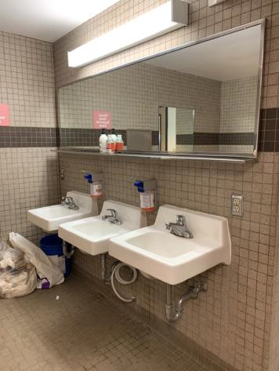
 | ID:  1810 | Facility:  Boise Watershed Treatment Plant

Location: Operations Building Men's Restroom
Schedule: 2021
Estimated Cost: $100.00

Priority Score 7
Quick Fix: Yes
Built before ADA: No

VIOLATIONS
2010 ADA Standards for Accessible Design Codes §309.4
The door knob requires twisting of the wrist.

RECOMMENDATIONS
Replace the door knob with a lever handle that can be operated with a closed fist and without twisting the wrist.

PHOTOGRAPH(S) OF THIS LOCATION
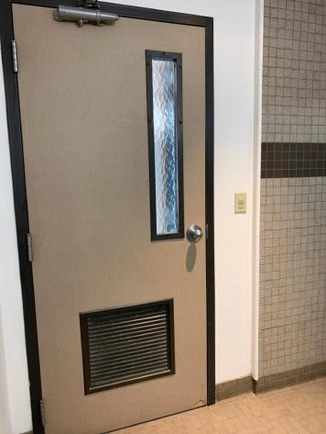
 | ID:  1811 | Facility:  Boise Watershed Treatment Plant

Location: Operations Building Men's Restroom
Schedule: 2021
Estimated Cost: $100.00

Priority Score 3
Quick Fix: Yes
Built before ADA: No

VIOLATIONS
2010 ADA Standards for Accessible Design Codes §216.2, §703
There is no tactile sign identifying the permanent room.

RECOMMENDATIONS
Install tactile signage on the latch side of the doorway at a height of 48” minimum to 60” maximum above the floor, identifying room by name or room number.
Signs shall be Braille with raised lettering and should be placed on the wall in the center of an 18"x18" clear floor space.

PHOTOGRAPH(S) OF THIS LOCATION
 | ID:  1808 | Facility:  Boise Watershed Treatment Plant

Location: Operations Building Men's Restroom
Schedule: 2021
Estimated Cost: $300.00

Priority Score 7
Quick Fix: Yes
Built before ADA: No

VIOLATIONS
2010 ADA Standards for Accessible Design Codes §606.5
The pipes under the sink are not covered.

RECOMMENDATIONS
Wrap the pipes beneath the sink with soft protective wrap or plastic.

PHOTOGRAPH(S) OF THIS LOCATION
 | ID:  1797 | Facility:  Boise Watershed Treatment Plant

Location: Operations Building Men's Restroom
Schedule: 2021
Estimated Cost: $400.00

Priority Score 5
Quick Fix: Yes
Built before ADA: No

VIOLATIONS
2010 ADA Standards for Accessible Design Codes §903.4
The benches do not have back support.

RECOMMENDATIONS
At least 5% of the seating must provide back support that is 42” long minimum and extends from a point 2” maximum above the seat surface to a point 18” minimum above the seat surface.
Back support shall be 2.5” maximum from the rear edge of the seat measured horizontally.

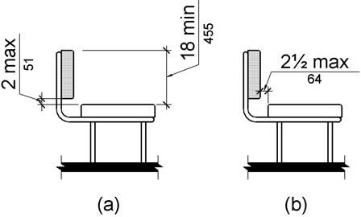

PHOTOGRAPH(S) OF THIS LOCATION
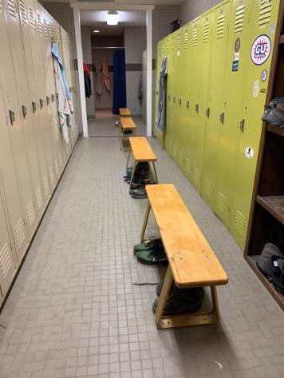
 | ID:  1803 | Facility:  Boise Watershed Treatment Plant

Location: Operations Building Men's Restroom
Schedule: 2022
Estimated Cost: $1,000.00

Priority Score 5
Quick Fix: No
Built before ADA: No

VIOLATIONS
2010 ADA Standards for Accessible Design Codes ICC A117.1 §604.5.1
The accessible water closet does not have a vertical grab bar.

RECOMMENDATIONS
Install an 18" long (minimum) vertical grab bar on the side wall. The grab bar shall be mounted with the bottom located at 39" minimum and 41" maximum above the floor.
The centerline of the vertical grab bar shall be located 39" minimum and 41" maximum from the rear wall.

PHOTOGRAPH(S) OF THIS LOCATION
 | ID:  1807 | Facility:  Boise Watershed Treatment Plant

Location: Operations Building Men's Restroom
Schedule: 2022
Estimated Cost: $1,000.00

Priority Score 5
Quick Fix: No
Built before ADA: No

VIOLATIONS
2010 ADA Standards for Accessible Design Codes §605.2
The low urinal is 18.25" above the floor.

RECOMMENDATIONS
Lower the urinal to a maximum height of 17" above the floor.

PHOTOGRAPH(S) OF THIS LOCATION
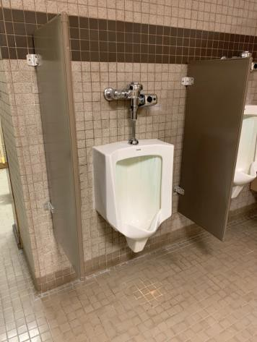
 | ID:  1806 | Facility:  Boise Watershed Treatment Plant

Location: Operations Building Men's Restroom
Schedule: 2021
Estimated Cost: $1,000.00

Priority Score 5
Quick Fix: No
Built before ADA: No

VIOLATIONS
2010 ADA Standards for Accessible Design Codes §604.4, §604.2
The toilet is located 19" from the sidewall. The toilet is 19.5" above the floor.

RECOMMENDATIONS
Reposition the toilet to be within 16" minimum and 18" maximum from the sidewall.
Lower the toilet seat to comply with the maximum height of 19” above the floor measured to the top of the seat.

PHOTOGRAPH(S) OF THIS LOCATION
 | ID:  1799 | Facility:  Boise Watershed Treatment Plant

Location: Operations Building Men's Restroom
Schedule: 2022
Estimated Cost: $10,000.00

Priority Score 6
Quick Fix: No
Built before ADA: No

VIOLATIONS
2010 ADA Standards for Accessible Design Codes §213.3.6
There is not an accessible shower provided.

RECOMMENDATIONS
Install at least one accessible shower complying with §607 or §608.

PHOTOGRAPH(S) OF THIS LOCATION
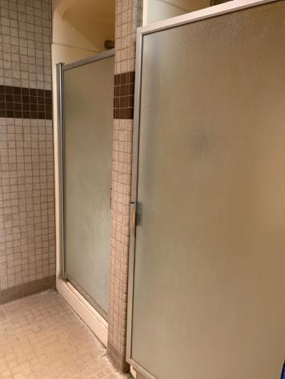
 | ID:  1833 | Facility:  Boise Watershed Treatment Plant

Location: Operations Building Parking
Schedule: 2021
Estimated Cost: $0.00

Priority Score 0
Quick Fix: Yes
Built before ADA: No

VIOLATIONS
2010 ADA Standards for Accessible Design Codes §502.3
The bicycles present an obstruction when parked in the access aisle.

RECOMMENDATIONS
Ensure that the bicycles are properly parked in the bike rack near the entrance.

PHOTOGRAPH(S) OF THIS LOCATION
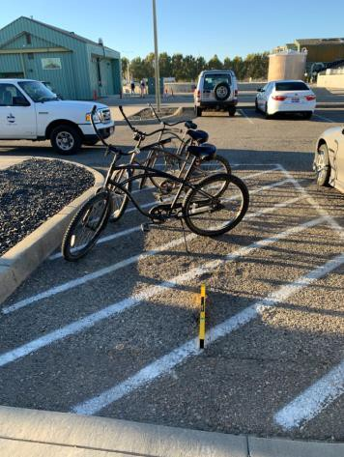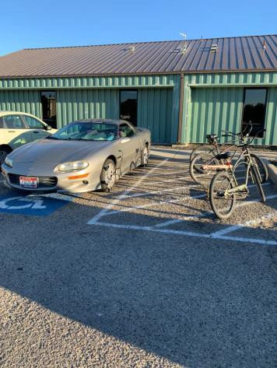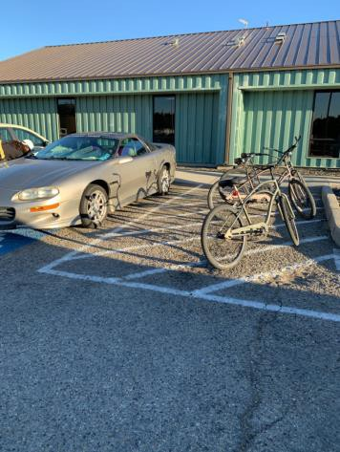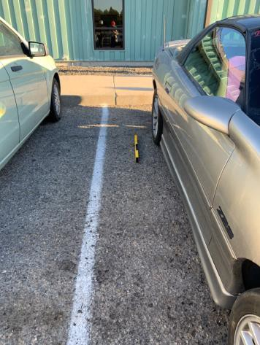
 | ID:  1835 | Facility:  Boise Watershed Treatment Plant

Location: Operations Building Parking
Schedule: 2021
Estimated Cost: $100.00

Priority Score 9
Quick Fix: Yes
Built before ADA: No

VIOLATIONS
2010 ADA Standards for Accessible Design Codes §502.6
There is no signage present identifying the accessible parking spaces.

RECOMMENDATIONS
Install an accessible parking sign at each accessible space at a minimum height of 60" above the ground.

PHOTOGRAPH(S) OF THIS LOCATION
 | ID:  1830 | Facility:  Boise Watershed Treatment Plant

Location: Operations Building Parking
Schedule: 2021
Estimated Cost: $1,000.00

Priority Score 3
Quick Fix: No
Built before ADA: No

VIOLATIONS
2010 ADA Standards for Accessible Design Codes §406.4
There is no level landing provided at the top of the curb ramp due to an 8.1% slope at the turning space.

RECOMMENDATIONS
Install a level landing at the top of the curb ramp with a minimum clear length of 36".

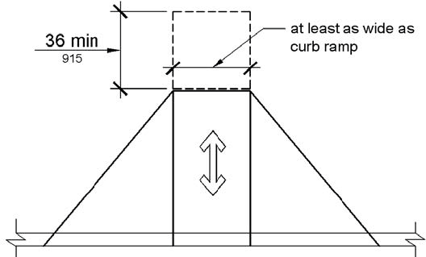

PHOTOGRAPH(S) OF THIS LOCATION

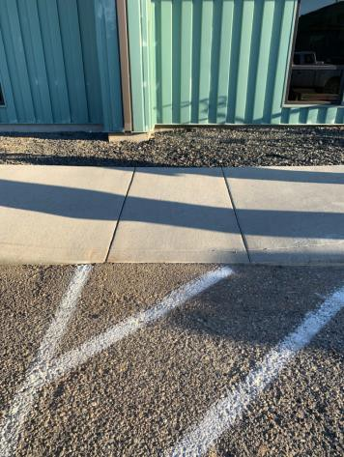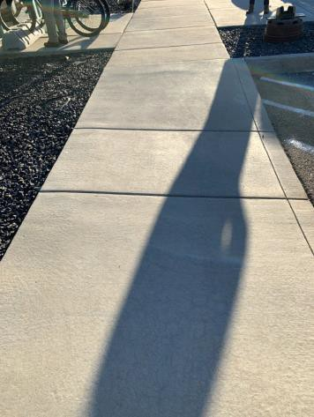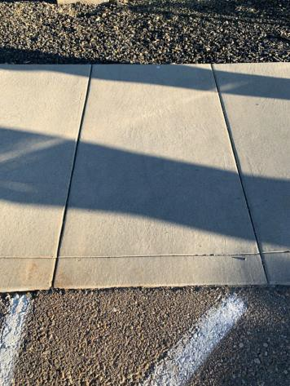
 | ID:  1834 | Facility:  Boise Watershed Treatment Plant

Location: Operations Building Parking
Schedule: 2021
Estimated Cost: $2,500.00

Priority Score 3
Quick Fix: No
Built before ADA: No

VIOLATIONS
2010 ADA Standards for Accessible Design Codes §502.4
The parking space and access aisle have a 2.7% slope and 4.1% slope.

RECOMMENDATIONS
Reconstruct the parking space and access aisle to reduce the slope to a maximum of 2% in all directions.

PHOTOGRAPH(S) OF THIS LOCATION
 | ID:  1813 | Facility:  Boise Watershed Treatment Plant

Location: Operations Building Women's Restroom
Schedule: 2021
Estimated Cost: $100.00

Priority Score 7
Quick Fix: Yes
Built before ADA: No

VIOLATIONS
2010 ADA Standards for Accessible Design Codes §603.3
The mirror is too high to be accessible at 49" above the floor.

RECOMMENDATIONS
Lower the mirror so its bottom edge is a maximum height of 40" above the floor.

PHOTOGRAPH(S) OF THIS LOCATION
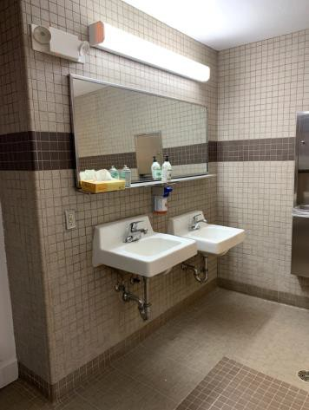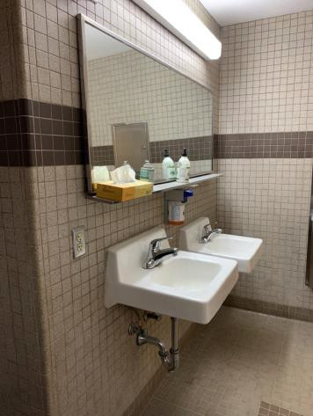
 | ID:  1814 | Facility:  Boise Watershed Treatment Plant

Location: Operations Building Women's Restroom
Schedule: 2021
Estimated Cost: $100.00

Priority Score 8
Quick Fix: Yes
Built before ADA: No

VIOLATIONS
2010 ADA Standards for Accessible Design Codes §308.2.1
The paper towel dispenser is outside of the unobstructed forward reach range at 50" above the floor.

RECOMMENDATIONS
Lower the paper towel dispenser by 2" to meet the accessible reach range of 48" maximum above the floor.

PHOTOGRAPH(S) OF THIS LOCATION
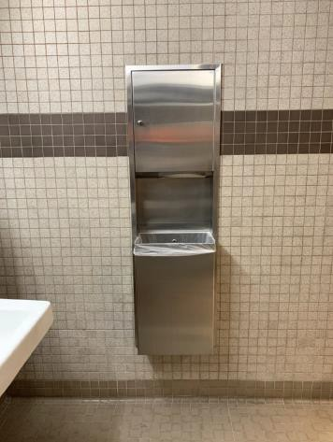
 | ID:  1815 | Facility:  Boise Watershed Treatment Plant

Location: Operations Building Women's Restroom
Schedule: 2021
Estimated Cost: $100.00

Priority Score 7
Quick Fix: Yes
Built before ADA: No

VIOLATIONS
2010 ADA Standards for Accessible Design Codes §309.4
The door knob requires twisting of the wrist.

RECOMMENDATIONS
Replace the door knob with a lever handle that can be operated with a closed fist and without twisting the wrist.

PHOTOGRAPH(S) OF THIS LOCATION
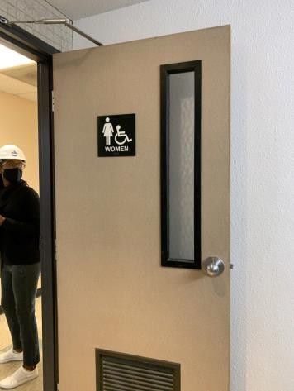
 | ID:  1815 | Facility:  Boise Watershed Treatment Plant

Location: Operations Building Women's Restroom
Schedule: 2021
Estimated Cost: $100.00

Priority Score 6
Quick Fix: Yes
Built before ADA: No

VIOLATIONS
2010 ADA Standards for Accessible Design Codes §703.4
The tactile sign identifying the room is not in the correct location.

RECOMMENDATIONS
Reinstall the sign on the latch side of the door at 48" minimum above the floor measured from the baseline of the lowest character and 60" maximum measured from the baseline of the highest character.

PHOTOGRAPH(S) OF THIS LOCATION
 | ID:  1820 | Facility:  Boise Watershed Treatment Plant

Location: Operations Building Women's Restroom
Schedule: 2021
Estimated Cost: $100.00

Priority Score 5
Quick Fix: Yes
Built before ADA: No

VIOLATIONS
2010 ADA Standards for Accessible Design Codes §604.8.1.2
The door to the accessible water closet is not self closing. Either self-closing hinges are not installed on the door or if installed, they are defective.

RECOMMENDATIONS
Install or reinstall self-closing hinges on the door to ensure that the door is self-closing per the ADA requirements.

PHOTOGRAPH(S) OF THIS LOCATION
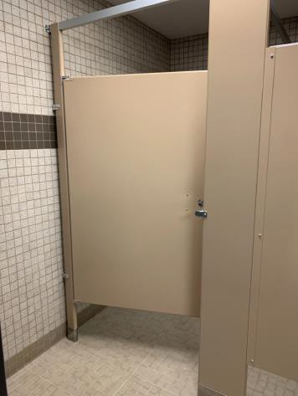
 | ID:  1812 | Facility:  Boise Watershed Treatment Plant

Location: Operations Building Women's Restroom
Schedule: 2021
Estimated Cost: $200.00

Priority Score 7
Quick Fix: Yes
Built before ADA: No

VIOLATIONS
2010 ADA Standards for Accessible Design Codes §606.5
The pipes under the sinks are not covered.

RECOMMENDATIONS
Wrap the pipes beneath the sinks with soft protective wrap or plastic.

PHOTOGRAPH(S) OF THIS LOCATION
 | ID:  1818 | Facility:  Boise Watershed Treatment Plant

Location: Operations Building Women's Restroom
Schedule: 2021
Estimated Cost: $500.00

Priority Score 5
Quick Fix: Yes
Built before ADA: No

VIOLATIONS
2010 ADA Standards for Accessible Design Codes §604.5.1
The side grab bar is located 11.5" from the rear wall.

RECOMMENDATIONS
Remount the side grab bar 12" maximum from the rear wall and extending 54" minimum from the rear wall.

PHOTOGRAPH(S) OF THIS LOCATION
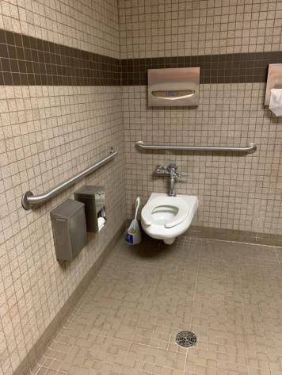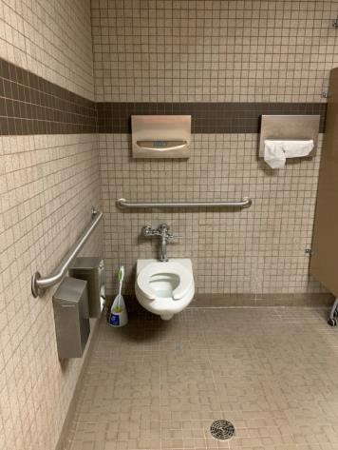
 | ID:  1817 | Facility:  Boise Watershed Treatment Plant

Location: Operations Building Women's Restroom
Schedule: 2022
Estimated Cost: $1,000.00

Priority Score 5
Quick Fix: No
Built before ADA: No

VIOLATIONS
2010 ADA Standards for Accessible Design Codes ICC A117.1 §604.5.1
The accessible water closet does not have a vertical grab bar.

RECOMMENDATIONS
Install an 18" long (minimum) vertical grab bar on the side wall. The grab bar shall be mounted with the bottom located at 39" minimum and 41" maximum above the floor.
The centerline of the vertical grab bar shall be located 39" minimum and 41" maximum from the rear wall.

PHOTOGRAPH(S) OF THIS LOCATION
 | ID:  1819 | Facility:  Boise Watershed Treatment Plant

Location: Operations Building Women's Restroom
Schedule: 2022
Estimated Cost: $1,000.00

Priority Score 5
Quick Fix: No
Built before ADA: No

VIOLATIONS
2010 ADA Standards for Accessible Design Codes §604.2
The centerline of the toilet is located 18.5" from the sidewall.

RECOMMENDATIONS
Reposition the centerline of the toilet to be within 16" minimum and 18" maximum from the sidewall.

PHOTOGRAPH(S) OF THIS LOCATION
 | ID:  1730 | Facility:  Boise Watershed Treatment Plant

Location: Ramp by Water Feature
Schedule: 2021
Estimated Cost: $2,500.00

Priority Score 3
Quick Fix: No
Built before ADA: No

VIOLATIONS
2010 ADA Standards for Accessible Design Codes §304.2
The turning space has a 5.3% slope.

RECOMMENDATIONS
Reconstruct the turning space to reduce the slope to the maximum allowable 2% in all directions.

PHOTOGRAPH(S) OF THIS LOCATION
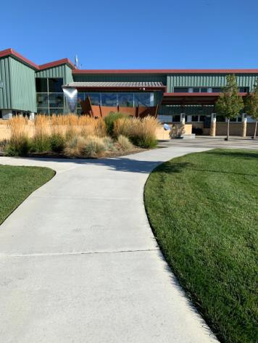
 | ID:  1720 | Facility:  Boise Watershed Treatment Plant

Location: The Boise River Pathway
Schedule: 2021
Estimated Cost: $5,000.00

Priority Score 3
Quick Fix: No
Built before ADA: No

VIOLATIONS
2010 ADA Standards for Accessible Design Codes §403.3
The running slope is 5.5%.

RECOMMENDATIONS
Resurface the route to reduce the running slope to a maximum of 5%.

PHOTOGRAPH(S) OF THIS LOCATION
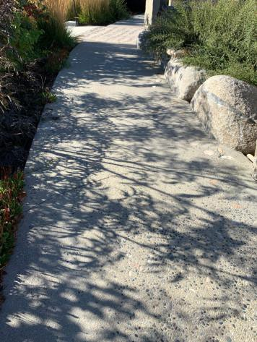
 | ID:  1723 | Facility:  Boise Watershed Treatment Plant

Location: Wetlands Simulation
Schedule: 2022
Estimated Cost: $1,000.00

Priority Score 5
Quick Fix: No
Built before ADA: No

VIOLATIONS
2010 ADA Standards for Accessible Design Codes §303.2
There is a 1" change in level.

RECOMMENDATIONS
Resurface the pathway to reduce the change in level to less than 0.25" or 0.5" if beveled.

PHOTOGRAPH(S) OF THIS LOCATION
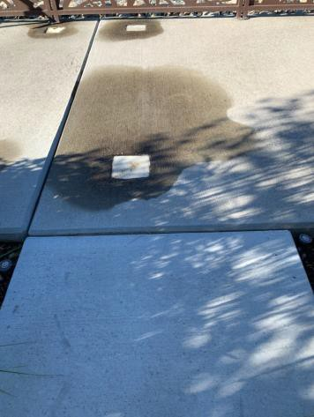
 | ID:  1721 | Facility:  Boise Watershed Treatment Plant

Location: Wetlands Simulation
Schedule: 2022
Estimated Cost: $5,000.00

Priority Score 0
Quick Fix: No
Built before ADA: No

VIOLATIONS
2010 ADA Standards for Accessible Design Codes §903.4, §903.2
The benches do not have clear floor space for a wheelchair user to access the bench. The benches do not have back support.

RECOMMENDATIONS
For the purposes of achieving greater accessibility and Human Centric Design, consider installing back support to some of the benches and pave a 30"x48" clear floor space at the end of some of the benches.

PHOTOGRAPH(S) OF THIS LOCATION
