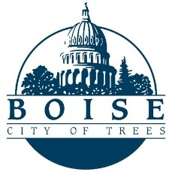

City of Boise
2022 Coronavirus Fiscal Recovery Grant Program
Attachment A: Risk Assessment Questionnaire

Please complete the questionnaire below and attach the requested supporting documentation.

- Describe your organization’s working knowledge of OMB’s Uniform Guidance (2 CFR 200), including any relevant training and/or implementation experience.
Click or tap here to enter text.
(3,000 Character Limit)

- Have previous audit reports contained any findings or internal control matters in the last two years? If so, provide an update on your organization’s Corrective Action Plan and resolution of the matters.
Click or tap here to enter text.
(3,000 Character Limit)

- What procedures does your organization have in place to allow parties to report allegations of fraud, program abuse, or criminal conduct related to any federal funds?
Click or tap here to enter text.
(1,000 Character Limit)

- Is your organization now, or has it ever been, debarred from receiving federal funding?
Choose an item.

- Required Attachments

- IRS determination letter
- Last two years’ IRS Form 990 or 990EZ
- Last two years’ independent audits and all forms of management letters from CPA (if available)
- Copy of any audit reports prepared as a result of a visit by a federal agency
- Insurance certificate for all forms of insurance (except employee benefits)
- Copy of your organization’s by-laws (for nonprofit organizations and HOAs)
- Copy of your Board of Directors roster (include names, addresses, phone numbers)
- Copy of your organization’s Conflict of Interest Policy
- Copy of your organization’s Nondiscrimination Policy
- Copy of your organization’s accounting policies and procedures that includes the documented controls of the organization’s cash disbursement, payroll, and cash receipts functions
- Copy of your organization’s procurement policies (if any contracts will be funded through this grant award)

